README
Guide to Impacts Analysis and CBA: data, calculations and results
EMI files address: https://www.emi.ea.govt.nz/Wholesale/Datasets/_AdditionalInformation/SupportingInformationAndAnalysis
2019 \ 20190709_TPM_2019 issues paper
- _README [This document]
- 2019_Proposal_Impacts_Modelling
- Trad.vSPD module
- Net.vSPD module
- Residual charge options module
- New Distributed generation adjustment module
- LCE rental refund module
- NgaWha adjustment module
Impacts Modelling – high level diagram of inputs and outputs
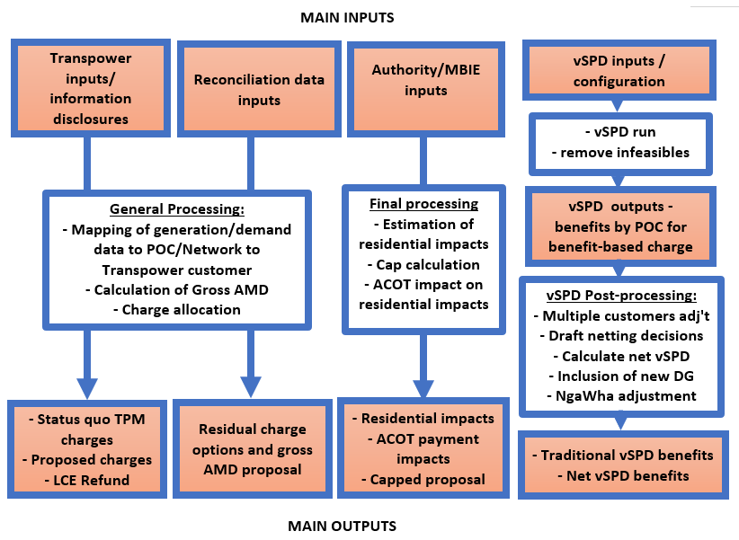
Impacts modelling inputs
Transpower inputs/information disclosures
- Current TPM charges: [Refer: file ‘2019 Proposal Impacts Modelling.xlsx’, sheet ‘Current TP charges’, columns B to F]
- Connection charges: [Refer: file ‘2019 Proposal Impacts Modelling.xlsx’, sheet ‘Current TP charges’, column B]
- Mapping location to customers: [Not provided. Provided in Transpower’s Commerce Commission information disclosures]
- Transpower revenue: [Refer: file ‘2019 Proposal Impacts Modelling.xlsx’, sheet ‘Forecast TPM Revenue’, cell B4]
- Benefit-based charge investment revenue: [Refer: file ‘2019 Proposal Impacts Modelling.xlsx’, sheet ‘Forecast TPM Revenue’, cells B19 to B33]
- Loss and constraint excess refunds: [Refer: file ‘LCE rental refund module.xlsx’, sheet ‘Summary’, cells C24 to C33; also see sheet titled ‘README’].
Reconciliation data inputs - 4 years of data – 1 July 2014 to 30 June 2018: [Refer directory titled ‘Residual_calculation_files’]
- Half-hourly, 250+ Points of connection (POCs), by Network:
  - Demand - 010 file: [Refer: 4 annual files titled ‘GR010_demand…’; also files titled ‘Demand 20…’]
  - Generation - 010 file: [Refer: 4 annual files titled ‘GR010_generation…’]
- Flows are gross of distributed generation (ie, distributed generation volume estimates are included in generation data).
vSPD inputs [All vSPD inputs refer: vSPD_Programs/vSPD_v3.0.3/Input]
- 4 years of data – 1 July 2014 to 30 June 2018
- Half-hourly metered data, 250+ POCs
- Half hourly prices
- Generator offers
- System Constraints
- Reserves
- Counterfactual configuration
- Loss and constraint excess allocation to branches: [Refer: file ‘LCE rental refund module.xlsx’, sheet ‘Branch_to_Projects’, columns A and B].
Authority information
- POC_Network to region mapping: [Refer: file ‘2019 Proposal Impacts Modelling.xlsx’, sheet ‘Reconciliation maps 15042019’, columns A and AD]
- Transmission region mapping: [Refer: file ‘2019 Proposal Impacts Modelling.xlsx’, sheet ‘Reconciliation maps 15042019’, columns A and AF]
- Generator plant information: [Refer: https://www.emi.ea.govt.nz/Wholesale/Datasets/Generation/Generation_fleet]. Note, this information is indicative only. Judgement was applied to determine generator status.
- Distributed generation information: [Refer: file ‘2019 Proposal Impacts Modelling.xlsx’, sheet ‘Reconciliation maps 15042019’, columns A, F, L to O, and T]
- Avoided cost of transmission (ACOT) payments: [Refer: file ‘2019 Proposal Impacts Modelling.xlsx’, sheet ‘ACOT’]
- Hydrology information: [Not provided].
Impacts modelling Processing
General Processing:
- Mapping of generation/demand data to POC/Network to Transpower customer: [Refer: file ‘2019 Proposal Impacts Modelling.xlsx’, sheet ‘Reconciliation maps 15042019’, columns A and F]
- Calculation of Gross AMD: [Refer directory titled ‘Residual_calculation_files’, file ‘Gross AMD Calculation.xlsx’
- Charge allocation: [Refer: file ‘2019 Proposal Impacts Modelling.xlsx’, sheet ‘Results’, columns B and E].
Final processing
- Estimation of residential impacts: [Refer: file ‘2019 Proposal Impacts Modelling.xlsx’, sheet ‘GRAPH Residential impacts’]
- Cap calculation: [Refer: file ‘2019 Proposal Impacts Modelling.xlsx’, sheet ‘Cap calculation revised’]
- ACOT impact on residential impacts: [Refer: file ‘2019 Proposal Impacts Modelling.xlsx’, sheet ‘ACOT’; also ‘GRAPH Residential impacts’, graph on cell Q42].
vSPD run results:
- Remove infeasible outcomes: [Refer: vSPD_Programs/vSPD_v3.0.3/Output for pre-removal of infeasibles and refer: vSPD_Programs/Post processing for outputs post removal of infeasibles.]
vSPD post processing calculations
- Multiple customers adj't: [Refer: Trad.vSPD module.xlsx, sheet titled ‘README’]
- Draft netting decisions: [Refer: file ‘2019 Proposal Impacts Modelling.xlsx’, sheet titled ‘Reconciliation maps 15042019’, columns A, F, and T]
- Calculate net vSPD: [Refer: Net.vSPD adjustment module.xlsx, sheet titled ‘README’]
- Inclusion of new DG: [Refer: New Distributed generation adjustment module.xlsx, sheet titled ‘README’]
- NgaWha adjustment: [Refer: NgaWha adjustment module.xlsx, sheet titled ‘README’].
Impacts modelling Outputs
- vSPD outputs - benefits by POC for benefit-based charge:
  - Excel friendly vSPD outputs: vSPD outputs are generally very large data files, which are too large to be opened in excel. In order to promote transparency, three vSPD output file types have been prepared specifically for analysis in excel. The files are in EMI [Refer: “vSPD_Excel_files” directory].
    - “node_benefits: This provides a summary of total benefits for each of the four years analysed, for each investment. Note that some investments have multiple cases. Files containing the term “Flexi” refer to variable VPO [virtual price offer], whereas files containing the term “500” refer to fixed VPO. Where there is no fixed or flexi term, no VPO was required. The main proposal is for flexi VPO. For the HVDC, the results the align with the proposal is “Flexi” with “no_reserve” [meaning that the reserve market has been switched off].
    - node_period_data: This provides half hourly benefit results at 8 points of connection (POCs), that are distributed around the grid. The files contain around 500k rows of data. The eight POCs are:
      - BEN2202 BEN0: South Island generator, Benmore
      - CPK0331: Wellington load
      - GLN0331: NZ Steel load
      - GLN0332 GLN0: NZ Steel generation
      - HLY2201 HLY5: Huntly generation
      - MPE1101: Northland load
      - PEN0331: Auckland load
      - TWI2201: Aluminium smelter, lower South Island.
    - vpo_period_data: This file provides half-hourly VPO prices and locations.
Refer to the file named “Illustrative benefit calculation” for an example of how the benefit calculations work. The vSPD output benefit calculation is replicated here. See ‘yellowed’ cells.
- Residual charge options and gross AMD proposal: [Refer: file ‘2019 Proposal Impacts Modelling.xlsx’, sheet ‘Results’, column E]
- LCE Refund: [Refer: file ‘2019 Proposal Impacts Modelling.xlsx’, sheet ‘Forecast TPM Revenue’, columns M and N]
- Status quo TPM charges (in $m and $/MWh): [Refer: file ‘2019 Proposal Impacts Modelling.xlsx’, sheet ‘Results’, column H]
- Proposed charges (in $m and $/MWh): [Refer: file ‘2019 Proposal Impacts Modelling.xlsx’, sheet ‘Results’, column F]
- Capped proposed charges (in $m and $/MWh): [Refer: file ‘2019 Proposal Impacts Modelling.xlsx’, sheet ‘Results’, columns G]
  - Alternative options modelled: [Refer: file ‘2019 Proposal Impacts Modelling.xlsx’, sheet ‘Results’, columns W3 to X11]
- Residential impacts (in $ per household per annum): [Refer: file ‘2019 Proposal Impacts Modelling.xlsx’, sheet ‘GRAPH Residential impacts’]
- ACOT payment impacts (in $ per household per annum): [Refer: file ‘2019 Proposal Impacts Modelling.xlsx’, sheet ‘ACOT’; also ‘GRAPH Residential impacts’, graph on cell Q42].
Post consultation outputs
- Bespoke adjustments (based on information in submissions).

