17 May 2006
Additional Spectra Sites

 |  | 17 May 2006
 |  | Additional Spectra Sites
 |  |  |  | Prepared By | C A Welch
 |  |  |  |  | D A Payne
 |  |  |  | Reviewed By | H J Freestone
 |  |  |  | Opus International Consultants Limited
 |  |  |  | Environmental
 |  |  |  | Level 9, Majestic Centre
 |  |  |  | 100 Willis Street, PO Box 12-003
 |  |  |  | Wellington, New Zealand
 |  |  |  | Telephone: |  | +64 4 471 7000
 |  |  |  | Facsimile: |  | +64 4 499 3699
 |  |  |  | Date: |  | 17 May 2006
Approved for |  |  |  | Reference: |  | 350435.00
issue to Client |  |  |  | Status: |  | Final
 |  |  |  | /tmp/lo/0000.doc
This document and its contents is the property of Opus International Consultants Limited.
Any unauthorised employment or reproduction, in full or part is forbidden.

© Opus International Consultants Limited 2006

Contents
1 Introduction 1
1.1 Spectra Series 1
2 Waiau River, Canterbury 2
2.1 Introduction 2
2.2 Clarence at Jollies 2
2.3 Waiau at Glenhope 5
2.4 Waiau at Marble Point 7
3 Ngaruroro River, Hawke’s Bay 9
3.1 Introduction 9
3.2 Ngaruroro at Whana Whana 9
3.3 Ngaruroro at Kuripapango 12
3.4 Ngaruroro at Chesterhope Bridge 14
4 Wairau River, Marlborough 16
4.1 Introduction 16
4.2 Wairau at Dip Flat 16
5 Hurunui River, Canterbury 19
5.1 Introduction 19
5.2 Hurunui at Mandamus 19
5.3 Hurunui at SH1 Bridge 22
6 Mohaka River, Hawke’s Bay 24
6.1 Introduction 24
6.2 Mohaka at Raupunga 24
7 Monowai 27
7.1 Introduction 27
7.2 Monowai Inflow 28
8 Summary 30
9 Recommendations 31
10 Reference List 33
11 Appendix A - Statistical Summaries - PCAL and PDIST Listings 34
11.1 Clarence at Jollies – 162107 (Item 1) 35
11.2 Waiau at Glenhope – 164604 (Item 1) 39
11.3 Waiau at Marble Point– 164602 (Item 1) 43
11.4 Ngaruroro at Whana Whana – 123103 (Item 1) 47
11.5 Ngaruroro at Kuripapango – 123104 (Item 1) 51
11.6 Ngaruroro at Chesterhope Bridge – 123150 (Item 1) 55
11.7 Wairau at Dip Flat – 160114 (Item 1) 59
11.8 Hurunui at Mandamus – 165104 (Item 1) 63
11.9 Hurunui at SH 1 Bridge – 165101 (Item 1) 67
11.10 Mohaka at Raupunga – 121801 (Item 1) 71
11.11 Monowai Inflow – 199540 (Item 1) 75

Introduction

Spectra Series
Spectra records have been assembled at a number of sites throughout New Zealand for proposed hydro-electric investigations. Opus has regularly provided the Electricity Commission (and its predecessors) with Spectra updates. The most recent report Generator Spectra Update – Issue 5 was completed in January 2006 to update flow data at all Spectra sites. A complete flow series was provided at all sites for the period between 1 July 1931 and 30 June 2005.
In our discussion with the Electricity Commission five further rivers have been identified where a complete record of flow data would be useful. These rivers are:
- Waiau River, Canterbury
- Ngaruroro River, Hawke’s Bay
- Wairau River, Marlborough
- Hurunui River, Canterbury
- Mohaka River, Hawke’s Bay
Complete flow records have been created at a number of sites on the above rivers for the period from 1 July 1931 to 30 June 2005. Few recording sites have data back to 1931 so the records have been extended through correlation with longer records. The Lake Waikaremoana inflow record was used to extend the Hawke’s Bay records; the Gowan at Lake Rotoroa record and statistical analyses have been used to extend the Marlborough and Canterbury records.
This report describes how each record was extended and details some of the quality checks used to ensure the extended flows represent actual flows in the Rivers. As with the Generator Spectra Update report monthly data (PCAL) listings and daily flow distribution tables (PDISTS) are included in Appendix A. These enable checks against computer files/new data to identify any substantial changes in data.

Waiau River, Canterbury

Introduction
Four possible hydro-power scheme sites have been identified along the Waiau River. These are the Clarence to Waiau Diversion, Upper Waiau, Mid Waiau and Lower Waiau. Spectra records have been developed at three sites within the catchment; these are: Clarence at Jollies (Clarence diversion), Waiau at Glenhope (Upper Waiau), and Waiau at Marble Point (Mid Waiau). The flow sites are shown in Figure 2.1. The Clarence diversion is important to a Waiau power scheme as flow from the Clarence catchment could be diverted into the Waiau catchment near Hamner Springs to maximise generation.
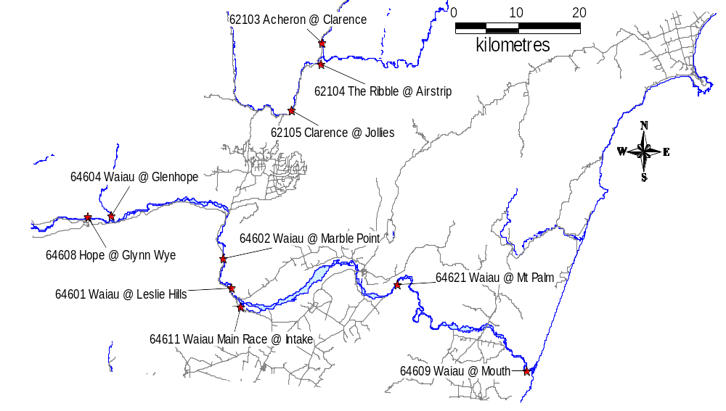
Figure 2.1 Waiau River Location diagram

Clarence at Jollies
The longest flow record in the vicinity of the Waiau River is the Clarence at Jollies recorder. This recorder extends back to 1960. The Clarence at Jollies recorder was correlated with the longer Gowan at Lake Rotoroa flow record to extend the Spectra series back to April 1934.
The best correlation was obtained through a flow distribution rating of the Gowan record (1934-1991). The distribution of flow in the resulting dataset is similar to the actual distribution of flow. However, the Gowan record is based on lake inflows so many flood peaks have been reduced. Actual data from the Clarence at Jollies record (1960 – 2005) replaces the rated data.
The first four years of record (1931-1934) were selected from average flows. The Works Consultancy Services Ltd produced a report in 1993 titled Trends in Flow Data for Manapouri Local Inflows, Mangahao, Cobb, Coleridge Inflows and Waikato Tributary Flows. Appendix III of the report specified ratios from sites throughout New Zealand of the mean annual inflow to the mean total record, since 1932. Ratios less than one indicated inflows to the site were less than average and hence a dryer year; ratios greater than one indicated inflows to the site were greater than average and hence a wetter year. The mean annual ratios at Lake Coleridge, which is the nearest site to the Waiau River, were 0.77, 0.65, and 1.05 during 1932, 1933, and 1934 respectively. 1932 and 1933 were dryer years than average.
The ratios were then applied to the total mean flow of the rated Clarence at Jollies record. Mean annual flows were determined for the three years and compared to annual flows from the entire record. Flows from years that had similar mean annual flows were replicated in the earlier record. Flows from 1956 are repeated in 1932, flows from 1969 are repeated in 1933 and flows in the first three months of 1953 are repeated in 1934.
The six months from 1 July 1931 to 31 December 1931 were replicated from the year 1936 with the mean annual flow nearest to the total record mean flow of 14.7 m³/s. 1936 has a mean flow of 14.8 m³/s.
Care was taken to maintain the water balance in the River. Table 2.1 details the mean flows during the record correlation phases. This flow has remained constant. Mean monthly flow values and the distribution of flow are displayed in Appendix A. A comparison plot showing the Clarence at Jollies flow and the Spectra rated record (prior to superimposing the actual record over the Spectra series) is displayed in Figure 2.2.
Table 2.1 Mean flow, Clarence at Jollies
Record | Record Length | Mean Flow (m³/s)
Clarence at Jollies (62105) | 1960-1999 | 14.9
Rated Clarence at Jollies* | 1960-1999 | 15.0
Rated Clarence at Jollies | 1931-2005 | 14.7
*Prior to superimposing the actual Clarence at Jollies record over the Spectra series

Although the mean flows compare well there is less flood peak amplitude in the correlated record 1931 to 1960. However, the overall water balance is good.

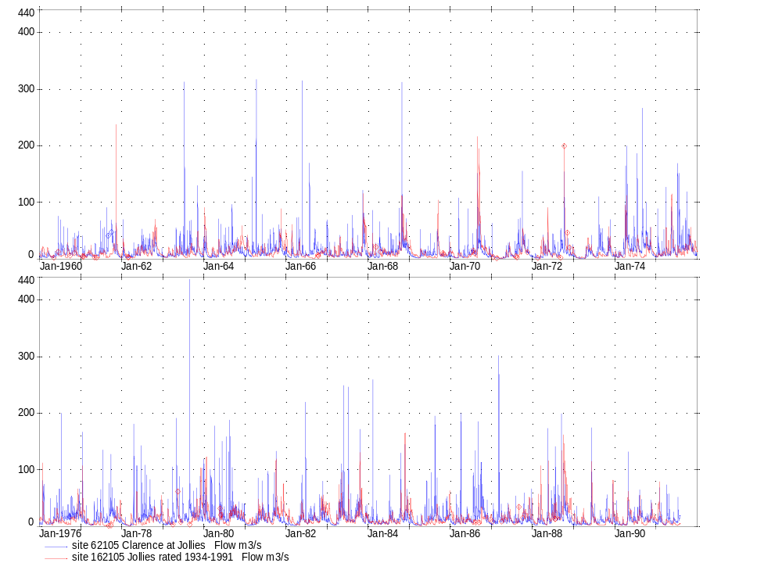
Figure 2.2 Comparison between the actual Clarence at Jollies record and the rated record used to extend the Spectra series

Waiau at Glenhope
The Waiau at Glenhope record begins in 1974. This record was extended back to 1931 through a distribution correlation with the extended Clarence at Jollies record. The distribution rating compared flow data over the period 1974 to 1999. The Glenhope site was not rated between July 1999 and September 2003. The correlated data from Clarence at Jollies filled this period. Actual data from the Waiau at Glenhope record is used when present.
Care was taken to maintain the water balance in the River. Table 2.2 details the mean flows during the record correlation phases. This flow has remained fairly constant. Mean monthly flow values and the distribution of flow are displayed in Appendix A. A comparison plot showing the Waiau at Glenhope flow and the Spectra rated record (prior to superimposing the actual record over the Spectra series) is displayed in Figure 2.3.
Table 2.2 Mean flow, Waiau at Glenhope
Record | Record Length | Mean Flow (m³/s)
Waiau at Glenhope | 1974-1999 | 35.8
Rated Waiau at Glenhope* | 1974-1999 | 35.7
Rated Waiau at Glenhope | 1931-2005 | 33.4
*Prior to superimposing the actual Waiau at Glenhope record over the Spectra series

There is less flood activity in the synthetic record (pre 1974) and this may, when combined with the low flow period in the 1930’s, produce an overall slightly lower long-term mean flow (2.3 m³/s (6%) lower). The monthly flows (Appendix A) contain annual flows that are very similar over the actual and synthetic record periods.

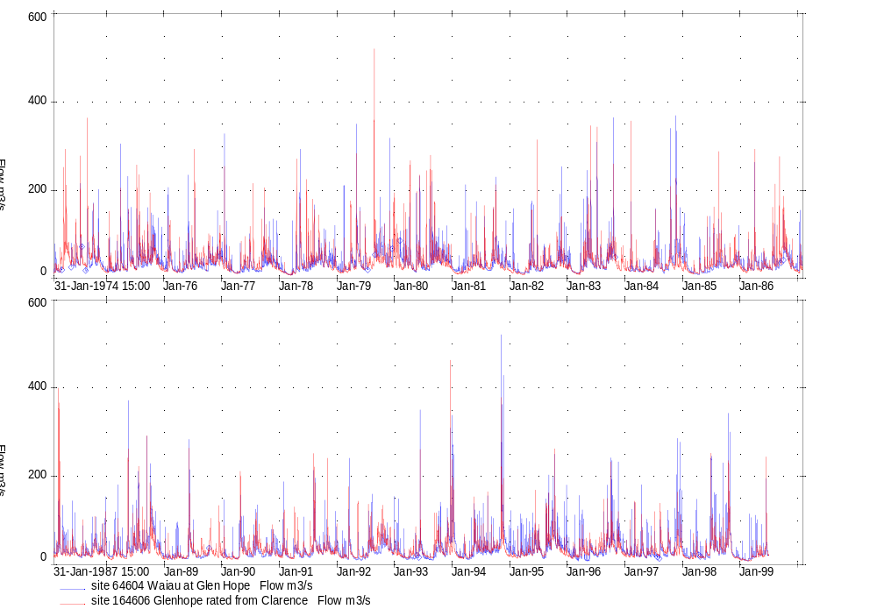
Figure 2.3 Comparison between the actual Waiau at Glenhope record and the rated record used to extend the Spectra series

Waiau at Marble Point
The Waiau at Marble Point record begins in 1967. This record was extended back to 1931 through a distribution correlation with the extended Clarence at Jollies record. The distribution rating compared flow data over the period 1967 to 2002. Data from February 2003 at the Marble Point site is provisional and was therefore not used in the distribution rating. Actual data from the Waiau at Marble Point record (1967 – 2005) is applied to the rated data.
Care was taken to maintain the water balance in the River. Table 2.3 details the mean flows during the record correlation phases. This flow has remained fairly constant. Mean monthly flow values and the distribution of flow are displayed in Appendix A. A comparison plot showing the Waiau at Marble Point flow and the Spectra rated record (prior to superimposing the actual record over the Spectra series) is displayed in Figure 2.4.
Table 2.3 Mean flow, Waiau at Marble Point
Record | Record Length | Mean Flow (m³/s)
Waiau at Marble Point | 1967-2002 | 98.7
Rated Waiau at Marble Point* | 1967-2002 | 98.8
Rated Waiau at Marble Point | 1931-2005 | 95.2
*Prior to superimposing the actual Waiau at Marble Point record over the Spectra series

The slightly lower mean flow for the longer record (1931 to 2005) is due to a dry period in the 1930’s and the reduced flood activity in the synthetic record. The monthly summary table (Appendix A) shows the annual maxima and minima for the actual and synthetic record periods are very similar.

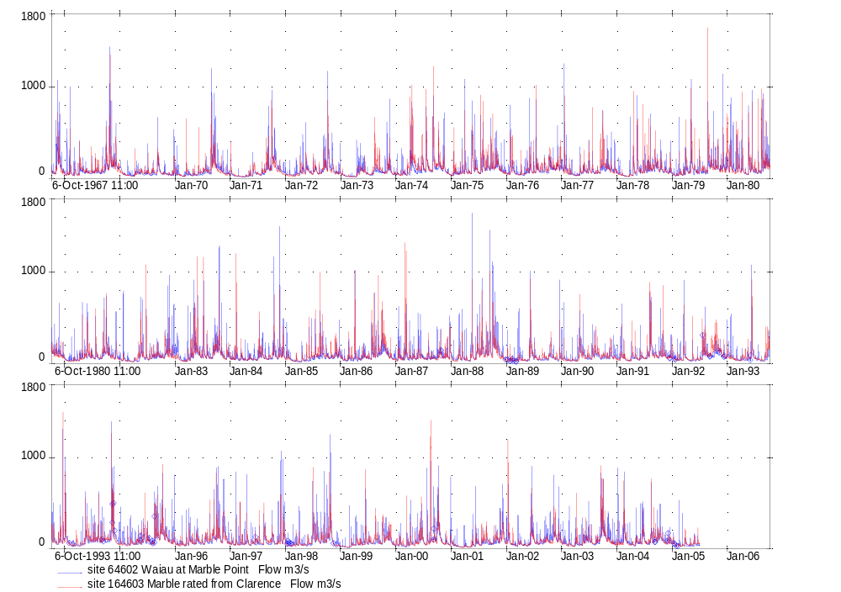
Figure 2.4 Comparison between the actual Waiau at Marble Point record and the rated record used to extend the Spectra series

Ngaruroro River, Hawke’s Bay

Introduction
In the previous Opus report Additional Spectra Investigations (September 2005), five possible hydro-power schemes were identified along the Ngaruroro River. Spectra series have been developed at three of the flow recording sites to represent flows at these schemes. Spectra series have been created at Ngaruroro at Whana Whana, Ngaruroro at Kuripapango and Ngaruroro at Chesterhope Bridge. These sites are shown in Figure 3.1.
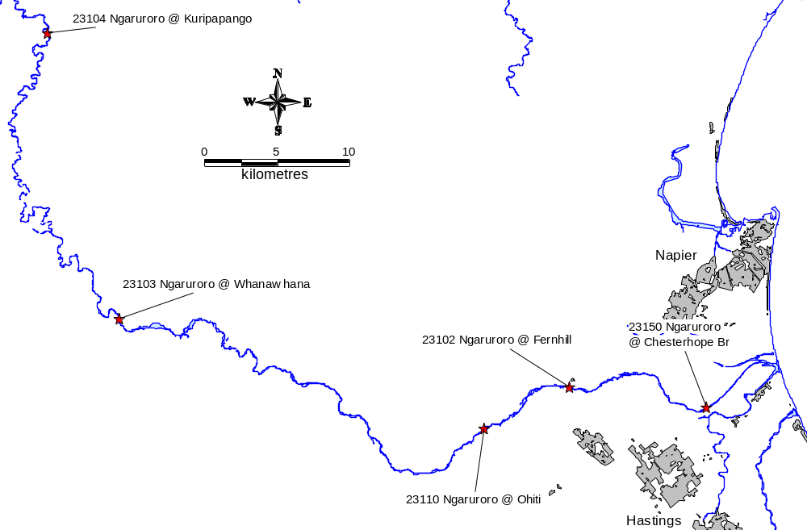
Figure 3.1 Ngaruroro River Location diagram

Ngaruroro at Whana Whana
The longest flow record in the vicinity of the Ngaruroro River is the Ngaruroro at Fernhill recorder. This record extends back to 1953. Unfortunately no gaugings were available at this site between 1974 and 2005 resulting in unreasonable flows. Consequently data from this period could not be used. The Ngaruroro at Whana Whana record, which extends back to 1960, is used instead. The Ngaruroro at Whana Whana recorder was correlated with the longer Lake Waikaremoana inflow record to extend the Spectra series back to July 1931.
The best correlation was obtained through a distribution rating of the Lake Waikaremona record (1960-2001). The distribution of flow in the resulting dataset is similar to the actual distribution of flow. The Ngaruroro at Whana Whana record is used from 1960 to present.
Inflow to Lake Waikaremoana is calculated from lake level and outflow data. The resulting Ngaruroro at Whana Whana rated record between 1931 and 1960 has some lake level characteristics, including a greater number of flood events.
Care was taken to maintain the water balance in the River. Table 3.1 details the mean flows during the record correlation phases. This flow has remained constant. Mean monthly flow values and the distribution of flow are displayed in Appendix A. A comparison plot showing the Ngaruroro at Whana Whana flow and the Spectra rated record (prior to superimposing the actual record over the Spectra series) is displayed in Figure 3.2.
Table 3.1 Mean flow, Ngaruroro at Whana Whana
Record | Record Length | Mean Flow (m³/s)
Ngaruroro at Whana Whana | 1960-2001 | 35.2
Rated Ngaruroro at Whana Whana* | 1960-2001 | 34.9
Rated Ngaruroro at Whana Whana | 1931-2005 | 35.4
*Prior to superimposing the actual Ngaruroro at Whana Whana record over the Spectra series

The monthly data displayed in Appendix A shows that there is slightly more variation in annual totals for the period of actual record. Also, summer flows in 1948 and 1954 are very low. In general the water balance (Table 3.1) is good.

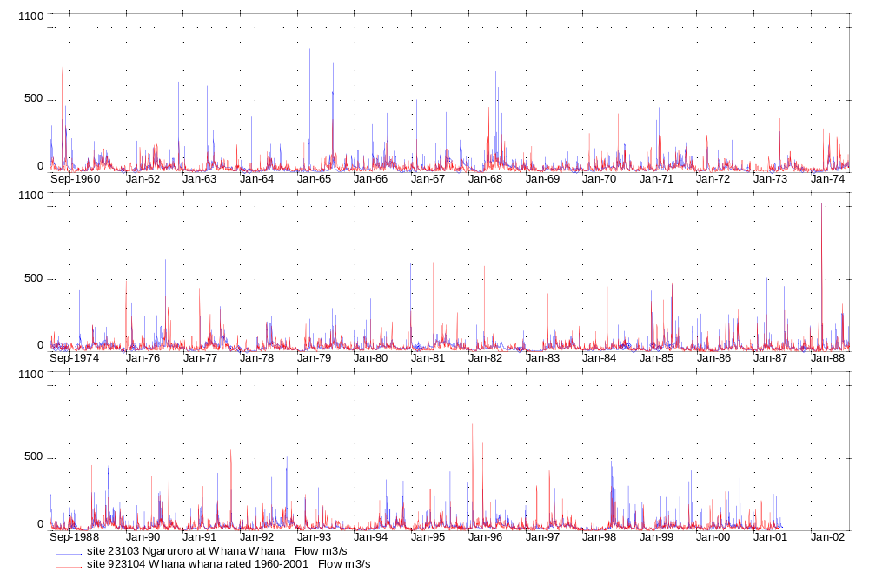
Figure 3.2 Comparison between the actual Ngaruroro at Whana Whana record and the rated record used to extend the Spectra series

Ngaruroro at Kuripapango
The Ngaruroro at Kuripapango record begins in 1963. This record was extended back to 1931 through a distribution correlation with the extended Ngaruroro at Whana Whana record. The distribution rating compared flow data over the period 1963 to 2005. Actual data from the Ngaruroro at Kuripapango record is applied to the rated data.
Care was taken to maintain the water balance in the River. Table 3.2 details the mean flows during the record correlation phases. Mean monthly flow values and the distribution of flow are displayed in Appendix A. A comparison plot showing the Ngaruroro at Kuripapango flow and the Spectra rated record (prior to superimposing the actual record over the Spectra series) is displayed in Figure 3.3.
Table 3.2 Mean flow, Ngaruroro at Kuripapango
Record | Record Length | Mean Flow (m³/s)
Ngaruroro at Kuripapango | 1963-2005 | 17.2
Rated Ngaruroro at Kuripapango* | 1963-2005 | 17.1
Rated Ngaruroro at Kuripapango | 1931-2005 | 17.7
*Prior to superimposing the actual Ngaruroro at Kuripapango record over the Spectra series

The monthly data in Appendix A confirmed the longer duration similarity between the synthetic and recorded data.

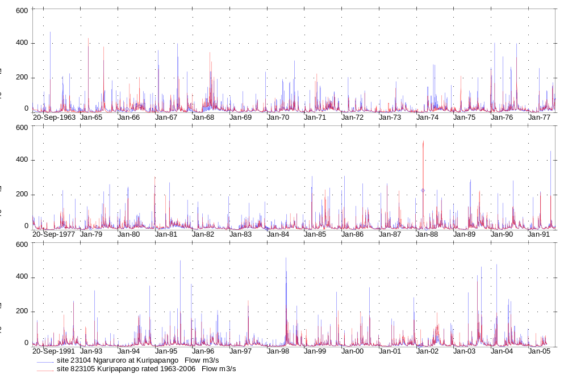
Figure 3.3 Comparison between the actual Ngaruroro at Kuripapango record and the rated record used to extend the Spectra series

Ngaruroro at Chesterhope Bridge
The Ngaruroro at Chesterhope Bridge record begins in 1976. This record was extended back to 1931 through a distribution correlation with the extended Ngaruroro at Whana Whana record. The distribution rating compared flow data over the period 1976 to 2006. Actual data from the Ngaruroro at Chesterhope Bridge record is applied to the rated data. Gaps in the Chesterhope Bridge record are filled from the synthetic data.
Care was taken to maintain the water balance in the River. Table 3.3 details the mean flows during the record correlation phases. Mean monthly flow values and the distribution of flow are displayed in Appendix A. A comparison plot showing the Ngaruroro at Chesterhope Bridge flow and the Spectra rated record (prior to superimposing the actual record over the Spectra series) is displayed in Figure 3.4.
Table 3.3 Mean flow, Ngaruroro at Chesterhope Bridge
Record | Record Length | Mean Flow (m³/s)
Ngaruroro at Chesterhope Br | 1976-2005 | 41.8
Rated Ngaruroro at Chesterhope Br* | 1976-2005 | 41.3
Rated Ngaruroro at Chesterhope Br | 1931-2005 | 43.8
*Prior to superimposing the actual Ngaruroro at Chesterhope Br record over the Spectra series

The Appendix A data showed very low summer flows in 1948 and 1954. The rest of the synthetic data is reasonable.

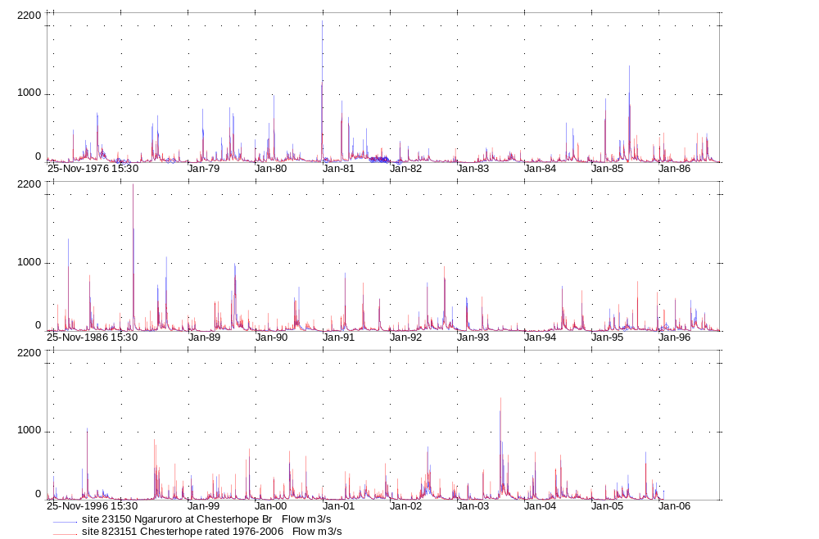
Figure 3.4 Comparison between the actual Ngaruroro at Chesterhope Bridge record and the rated record used to extend the Spectra series

Wairau River, Marlborough

Introduction
The proposed scheme in the Wairau River is an extension of TrustPower’s Branch River hydro-electric scheme. It would involve diverting water from the Wairau River into the existing Branch scheme through interconnecting canals and penstocks to new power stations. The tailrace of the last station would be approximately 25 km southwest of Blenheim. The Wairau at Dip Flat record is important for this scheme.
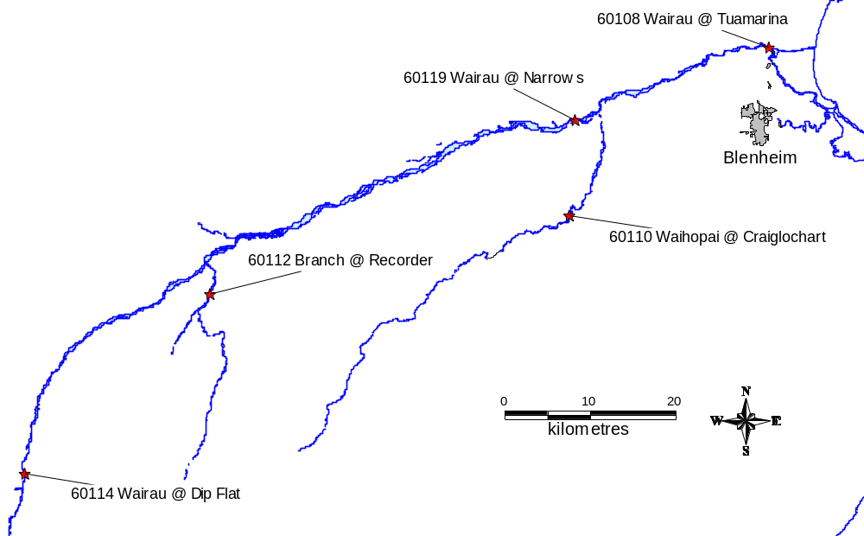
Figure 4.1 Wairau River Location diagram.

Wairau at Dip Flat
The longest flow record in the vicinity of the Wairau River is the Wairau at Dip Flat recorder. This record extends back to 1951. The Wairau at Dip Flat recorder was correlated with the Gowan at Lake Rotoroa flow record to extend the Spectra series back to April 1934.
The best correlation was obtained through a distribution rating of the Gowan record comparing flow data over the period 1934-1991. The distribution of flow in the resulting dataset is similar to the actual distribution of flow. Actual data from the Wairau at Dip Flat record (1951-2005) is used when present.
As with the Waiau extension, the first four years of record were selected from average flows from the Works Consultancy Services Ltd report titled Trends in Flow Data for Manapouri Local Inflows, Mangahao, Cobb, Coleridge Inflows and Waikato Tributary Flows (1993). The mean annual inflow ratios (averaging ratios from Mangahao and Coleridge) were 0.805, 0.795, and 0.995 in 1932, 1933, and 1934 respectively. This period was dryer than average.
The ratios were applied to the total mean flow of the correlated Gowan record (1934-2005, including actual data from the Wairau at Dip Flat record from 1951). Mean annual flows were determined for the three years and compared to annual flows from the entire record. Flows from years that had similar mean annual flows were replicated in the earlier record. Flows from 1941 are replicated in 1932 and 1933, and flows in 1954 are replicated in the initial three months of 1934.
The six months from 1 July 1931 to 31 December 1931 were replicated from the year with the nearest mean annual flow to the total mean flow of 26.6 m³/s (1934-2006). 1976 has a mean flow of 26.7 m³/s. The six months of record from 1 July 1976 to 31 December 1976 are replicated in 1931.
Gaps in the record were filled from correlation with the Wairau at Hells Gate record (1965-1975) and the Wairau at Tuamarina site (1989-1999) which was replaced with the Barnett’s Bank recorder 390 m upstream (1999-2006).
Care was taken to maintain the water balance in the River. Table 4.1 details the mean flows during the record correlation phases. Mean monthly flow values and the distribution of flow are displayed in Appendix A. A comparison plot showing the Wairau at Dip Flat flow and the Spectra rated record (prior to superimposing the actual record over the Spectra series) is displayed in Figure 4.2.
Table 4.1 Mean flow, Wairau at Dip Flat
Record | Record Length | Mean Flow (m³/s)
Wairau at Dip Flat | 1951-1991 | 26.7
Rated Wairau at Dip Flat* | 1951-1991 | 27.0
Rated Wairau at Dip Flat | 1931-2005 | 26.5
*Prior to superimposing the actual Wairau at Dip Flat record over the Spectra series

The monthly and annual data in Appendix A shows that the synthetic and actual segments of the record have similar patterns and extremes, although the synthetic low flows may be slightly higher at times.

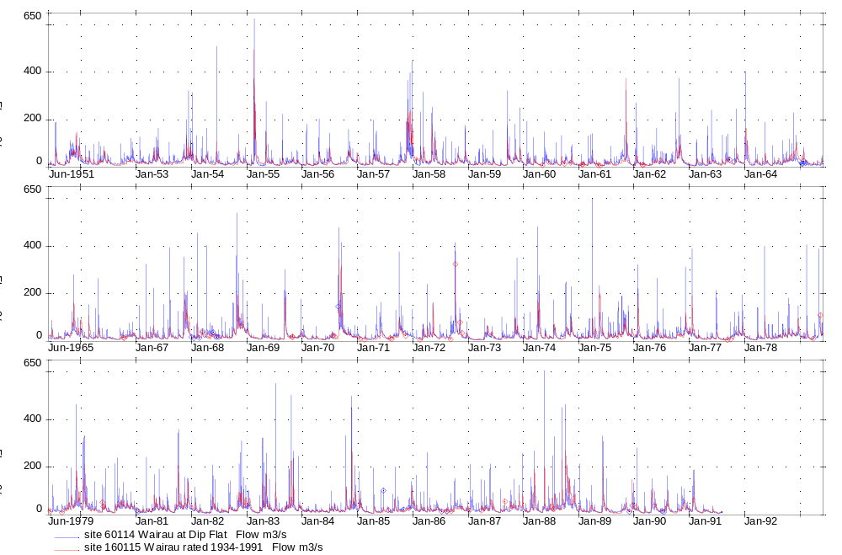
Figure 4.2 Comparison between the actual Wairau at Dip Flat record and the rated record used to extend the Spectra series

Hurunui River, Canterbury

Introduction
There are two options for a proposed hydro-power scheme along the Hurunui River. The first is upstream of State Highway 1 Bridge near the mouth of the River. The second possible site is upstream of the Hurunui at Mandamus site. These sites are shown in Figure 5.1.
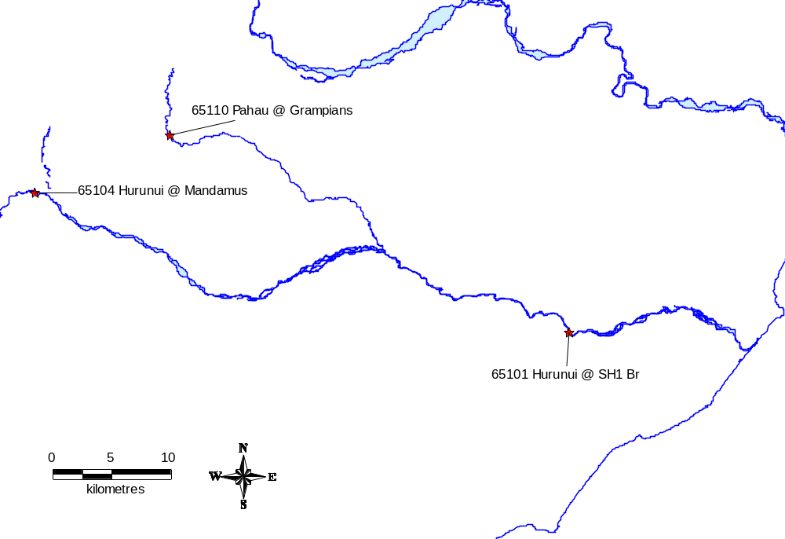
Figure 5.1 Hurunui River Location diagram

Hurunui at Mandamus
The longest flow record in the vicinity of the Hurunui River is the Hurunui at Mandamus recorder. This record extends back to 1956. The Hurunui at Mandamus record was correlated with the longer Gowan at Lake Rotoroa flow record to extend the Spectra series back to 1934.
The best correlation was obtained through a distribution rating of the Gowan record comparing flow data over the period 1934-1991. The distribution of flow in the resulting dataset is similar to the actual distribution of flow. However, the Gowan record is based on lake inflows so flood peaks are often smoothed. The Hurunui at Mandamus record is used from 1956 to present.
As with the Waiau extension, the first four years of record were selected from average flows from the Works Consultancy Services Ltd report titled Trends in Flow Data for Manapouri Local Inflows, Mangahao, Cobb, Coleridge Inflows and Waikato Tributary Flows (1993). The mean annual inflow ratios at Coleridge were 0.77 in 1932, 0.65 in 1933, and 1.05 in 1934.
The ratios are applied to the total mean flow of the correlated Gowan at Lake Rotoroa record (1934-2005, including actual Hurunui at Mandamus data from 1956). Mean annual flows were determined for the three years and compared to annual flows from the entire record. Flows from years that had similar mean annual flows were replicated in the earlier record. Flows from 1989 are replicated in 1932, flows from 1960 are replicated in 1933 and flows from 2003 are replicated in the initial three months of 1934.
The six months from 1 July 1931 to 31 December 1931 were replicated from the year with the nearest mean annual flow to the total mean flow of 51.7 m³/s. 1936 has a mean flow of 51.1 m³/s. The six months of record from 1 July 1936 to 31 December 1936 are replicated in 1931.
Care was taken to maintain the water balance in the River. Table 5.1 details the mean flows during the record correlation phases. Mean monthly flow values and the distribution of flow are displayed in Appendix A. A comparison plot showing the Hurunui at Mandamus flow and the Spectra rated record (prior to superimposing the actual record over the Spectra series) is displayed in Figure 5.2.
Table 5.1 Mean flow, Hurunui at Mandamus
Record | Record Length | Mean Flow (m³/s)
Hurunui at Mandamus | 1956-1991 | 51.2
Rated Hurunui at Mandamus* | 1956-1991 | 52.1
Rated Hurunui at Mandamus | 1931-2005 | 51.5
*Prior to superimposing the actual Hurunui at Mandamus record over the Spectra series

The monthly and annual flows in Appendix A show less amplitude in the synthetic record for flood flows although low flows are comparable.

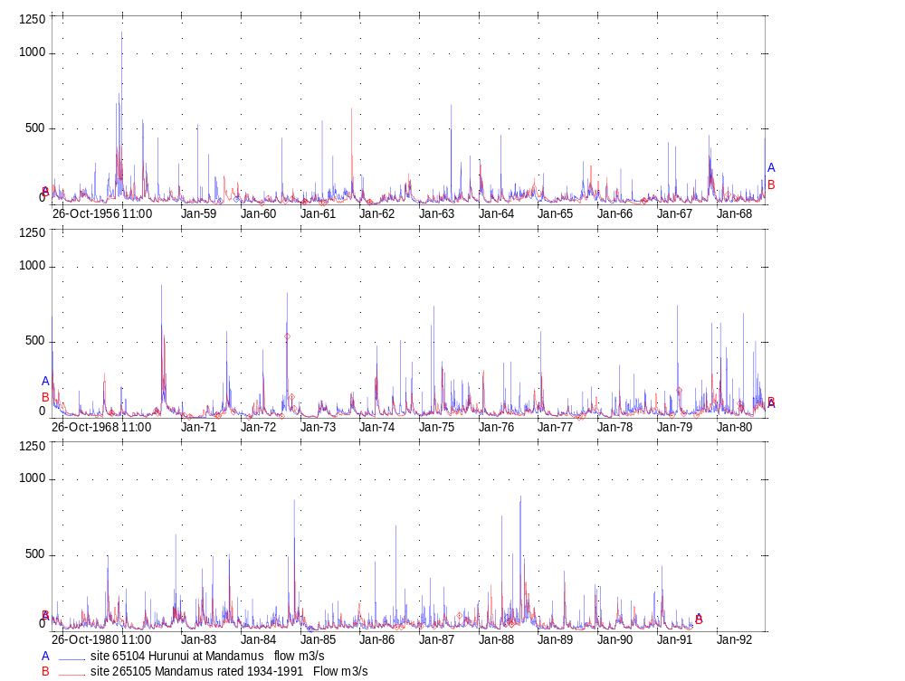
`Figure 5.2 Comparison between the actual Hurunui at Mandamus record and the rated record used to extend the Spectra series

Hurunui at SH1 Bridge
The most downstream site in the Hurunui catchment is the Hurunui at SH1 Bridge site. Flow data at this site exists from 1974 to 1999. Since June 1999 this site is used for flood warning only. The lower Hurunui River is potentially the most useful for hydro-power development because of the greater catchment area and Pahau tributary.
The Hurunui at SH1 Bridge was extended back to 1931 through a distribution correlation with the extended Hurunui at Mandamus record. The distribution rating compared flow data over the period 1974 to 1999. Actual data from the Hurunui at SH1 Bridge record is applied to the rated data.
Care was taken to maintain the water balance in the River. Table 5.2 details the mean flows during the record correlation phases. Mean monthly flow values and the distribution of flow are displayed in Appendix A. A comparison plot showing the Hurunui at SH1 Bridge flow and the Spectra rated record (prior to superimposing the actual record over the Spectra series) is displayed in Figure 5.3.
Table 5.2 Mean flow, Hurunui at SH1 Bridge
Record | Record Length | Mean Flow (m³/s)
Hurunui at SH1 Bridge | 1974-1999 | 72.8
Rated Hurunui at SH1 Bridge* | 1974-1999 | 72.9
Rated Hurunui at SH1 Bridge | 1931-2005 | 67.0
*Prior to superimposing the actual Hurunui at SH1 Bridge record over the Spectra series

A study of the monthly low flows in Appendix A show the synthetic record contains lower monthly flows than the actual record and this is reflected in the lower mean flow for the whole record period. The Hurunui at Mandamus extended record is preferred as the main Hurunui flow dataset.
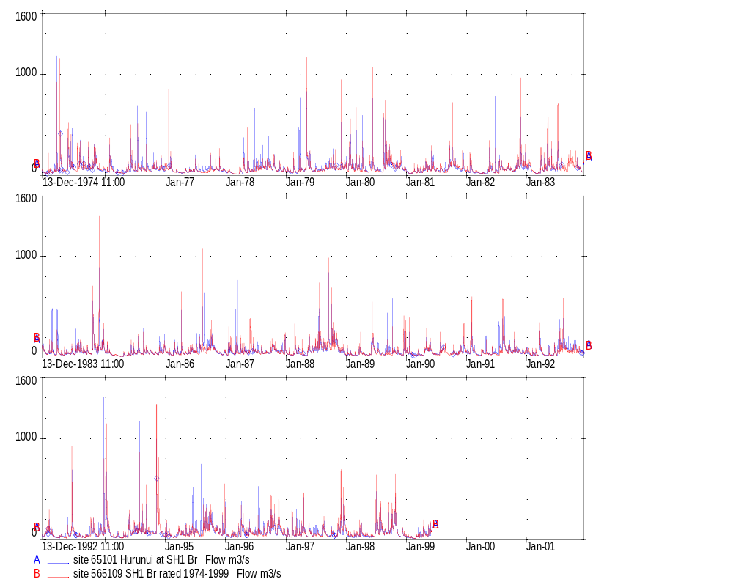
Figure 5.3 Comparison between the actual Hurunui at SH1 Bridge record and the rated record used to extend the Spectra series

Mohaka River, Hawke’s Bay

Introduction
The Mohaka River originates in the Kaweka Ranges in Hawke’s Bay. The catchment area is large at 2430 km² and drains the steep and rugged landscape. The proposed hydro-power scheme is in the lower reaches of the 172 km long river, near Raupunga.
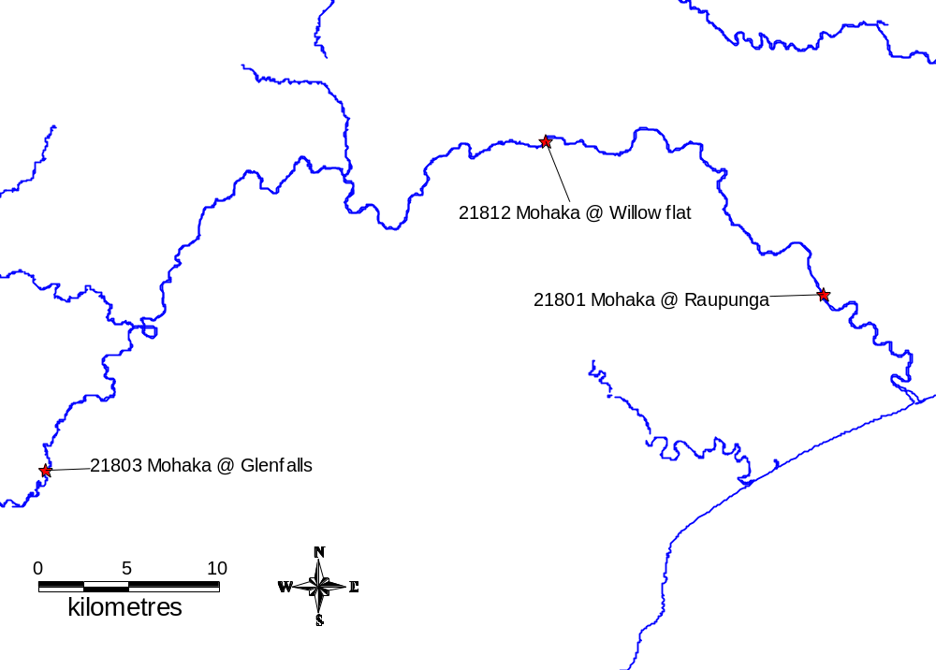
Figure 6.1 Mohaka River Location diagram.

Mohaka at Raupunga
The longest flow record in the vicinity of the Mohaka River is the Mohaka at Raupunga recorder. This record extends back to 1957. The Mohaka at Raupunga record was correlated with the Lake Waikaremoana inflow record to extend the spectra series back to 1931.
On 6 January 1985 a large landslide occurred upstream of the Raupunga gauge. This suppressed flow at the gauge significantly for approximately 10 hours and impacted on flows for approximately 3 days. The low stage value resulting from the landslide was removed from the data for the distribution analysis to provide a normal distribution of data.
The best correlation was obtained through a distribution rating of the Lake Waikaremoana inflow record comparing flow data over the period 1957-2001. The distribution of flow in the resulting dataset is similar to actual flow at the high end of the spectrum. Flows at the low end of the spectrum are slightly lower than the actual record.
Inflow to Lake Waikaremoana is calculated from lake level and outflow data. The resulting Mohaka at Raupunga rated record between 1931 and 1957 has some lake level characteristics, including a greater number of oscillations. Rated low flows are slightly lower and more common than in the actual record as the Lake inflow regularly drops to zero.
The Mohaka at Raupunga record (including the suppressed flow values in 1985) is used from 1957 to present. Gaps in the record were filled from correlation with the Ngaruroro at Whana Whana record.
Care was taken to maintain the water balance in the River. Table 6.1 details the mean flows during the record correlation phases. Mean monthly flow values and the distribution of flow are displayed in Appendix A. A comparison plot showing the Mohaka at Raupunga and the Spectra rated record (prior to superimposing the actual record over the Spectra series) is displayed in Figure 6.2.
Table 6.1 Mean flow, Mohaka at Raupunga
Record | Record Length | Mean Flow (m³/s)
Mohaka at Raupunga* | 1957-2001 | 79.5
Rated Mohaka at Raupunga** | 1957-2001 | 78.7
Rated Mohaka at Raupunga | 1931-2005 | 79.2
*Without low flows triggered the landslide
**Prior to superimposing the actual Mohaka at Raupunga record over the Spectra series
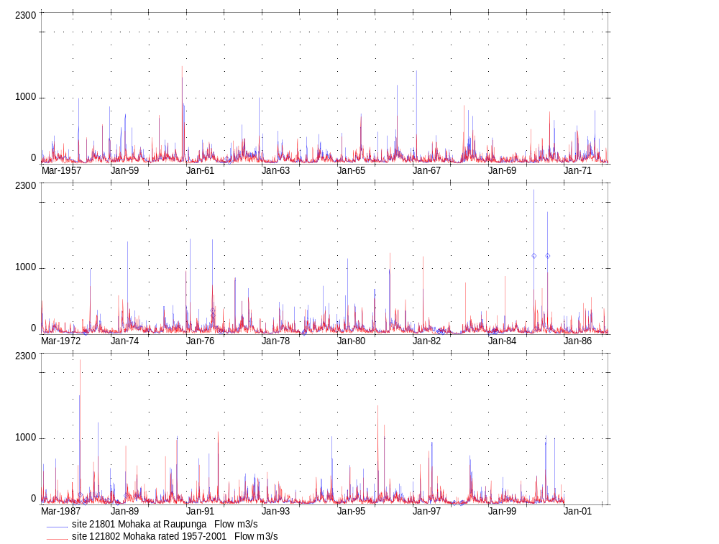
Figure 6.2 Comparison between the actual Mohaka at Raupunga record and the rated record used to extend the Spectra series

Monowai

Introduction
The Monowai hydro-electric power station is situated on the banks of the Waiau River 51 km’s from Tuatapere. The scheme was investigated in 1919; construction started in 1922 and opened in 1925. Initially there were two machines and a third was added in 1927.
The annual energy output is 30 GWH pa and the turbines are the horizontal Francis type.
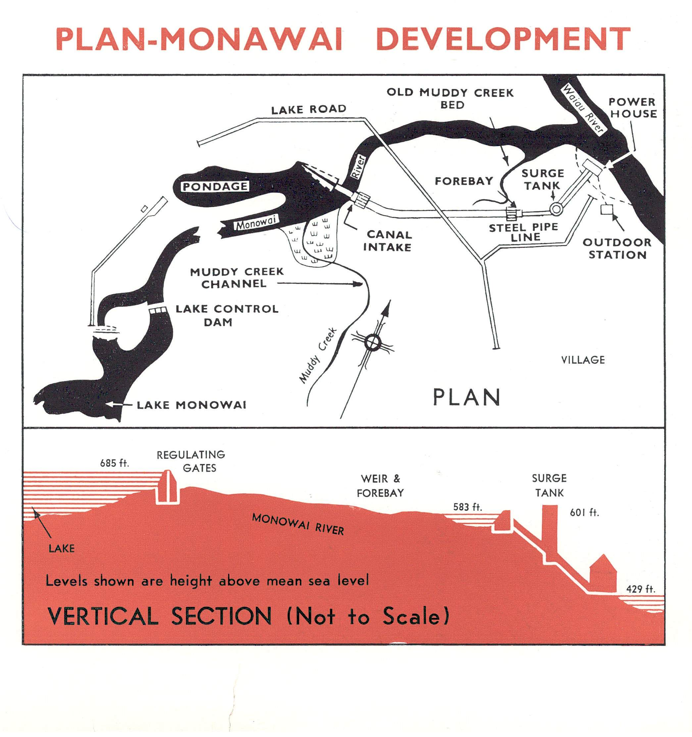
Monowai Lake area is 31 km² and about 8.5 km’s from the power house and controlled by gates at the Monowai River outlet. Waters flows down the river for about 6 km’s into a lake formed by a weir across the river. The water is then diverted into a canal that is 856 m long and arrives at a fore bay area where a 1036 m pipeline leads to a surge tank. From the surge tank three penstocks take the water to the turbines in the power house. Figure 7.1 shows a plan of the Monowai Power Development.
Plan of Monowai Development

Figure 7.1 Monowai Power Development Plan (original development).

Monowai Inflow
Inflows exist from 1960 to 1999. It was therefore necessary to extend the lake inflows back to 1931 and forward to 2006.
A linear regression with Te Anau and Manapouri did not provide a suitable correlation; therefore a flow distribution rating was applied to extend the Monowai record. A rating was derived from the Monowai Riddell - Opus and Lake Te Anau inflow data and then applied to the Te Anau inflow data.
This resulted in some differences for peak flow events in regard to timing but overall the two systems tracked each other well and flows were similar.
Table 7.1 details the mean flows for the records and included in appendix A are mean monthly flows values and a flow distribution.
Table 7.1 Monowai Mean Flow
Record | Record Length | Mean Flow (m³/s)
Riddell Inflow 1986 Report | 1960 - 1985 | 12.322
Riddell –Opus Inflow | 1960 - 1999 | 12.880
Monowai Rated Inflow | 1960 - 1999 | 13.076
Monowai Rated Inflow &  Riddell – Opus Inflows | 1927-2006 | 13.022

Figure 7.2 shows the Riddell-Opus record and the synthetic record from the PDist rating. Included in appendix A is a graph of the entire Monowai rated record. Our Power Archive data has been copied over the rated data for the 1960 – 1999 period and is the record for that period.
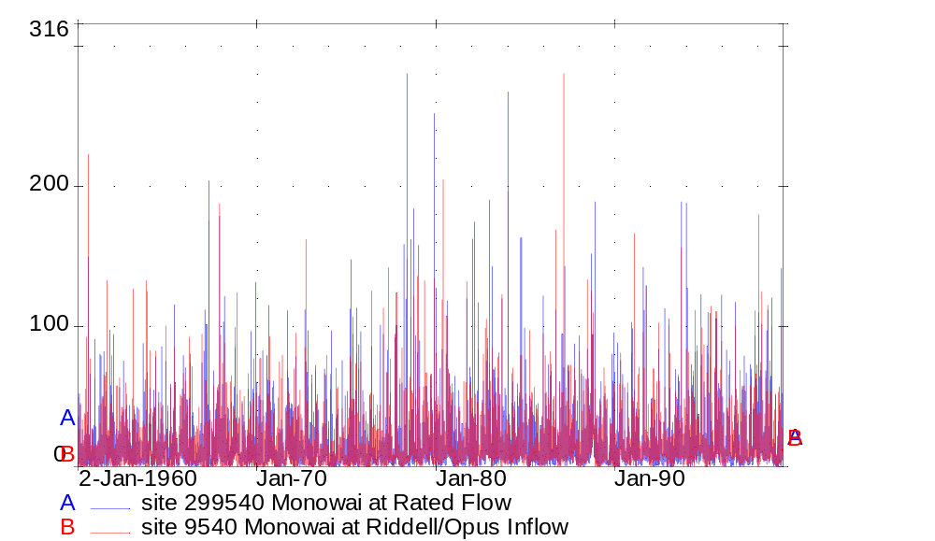
Figure 7.2: Riddell – Opus Monowai Inflow from the 1999 Report and synthetic inflow comparison

Summary

There are only a limited number of flow records that exist before or around 1931 and these records are the basis for record extension.

The flow records that extend before or around 1931 are:

- Lake Taupo inflow (1905-present)
- Lake Waikaremoana inflow (1928-present)
- Lake Ohau inflow (1926-present)
- Lake Tekapo inflow (1925-present)
- Lake Pukaki inflow (1925-present)
- Lake Wanaka inflow (1929-present)
- Lake Hawea inflow (1930-present)
- Lake Wakatipu inflow (1926-present)
- Lake Manapouri inflow (1932-present)
- Lake Te Anau inflow (1926-present)
- Kaituna at Lake Rotoiti Outlet (1906-present)
- Manawatu at Fitzherbert (1925-present)

Other sites that do not go back to 1931 but may be used to extend records close to 1931 are:

- Opuha at Skipton (1936-present)
- Gowan at Lake Rotoroa Outflow (1934-present)

An extra dataset is included in the Waiau River scenario, the dataset being Clarence at Jollies. Both the Waiau scenarios will benefit from having this record extended back to 1931 therefore a record was constructed.

There are two scenarios for this proposed scheme. One is detailed in the “Water of National Importance – Identification of Potential Hydrometric Resources” produced by the Ministry of Economic Development. The other scheme is via a report by A Lush, this is detailed in the Opus report “Additional Spectra Investigations of September 2005.

All the datasets produced from this report have very comparable mean/median flows and can be used with confidence however some flood activity will be repressed as a result of the correlations. Short duration low flows may show similar characteristics.

The construction of datasets from this report adds another 2,820 GWh pa of available power to be included in future Spectra datasets and for flow modelling purposes. Incorporating the existing Trustpower hydro power stations into the Spectra dataset in future could add another 872 GWh pa.

The Trustpower stations are as follows:

Wahopia (26 GWh pa)
Patea (80 GWh pa)
Arnold (23 GWh pa)
Highbank (75 GWh pa)
Paerau/Patearoa (61 GWh pa)
Waipori (220 GWh pa)
Hinemiaiaia (37 GWh pa)
Kaimai Hydro (174 GWh pa)
Wheao/Flaxy (129 GWh pa)
Mangorei and Motukawa (47 GWh pa)

In order to create or extend new or existing Trustpower station records a relationship with a long term flow station will have to be established and from this relationship datasets constructed. The datasets from 1931 will be constructed either by linear correlations, trend analysis, or a flow to flow relationship.

Recommendations

We recommend that another five datasets be created for the following sites:

- Highbank: Because a dataset exists from 1930 to 1998 on the Opus archive. Therefore only 8 years of data is required to complete the dataset. Although to complete this dataset actual power station records need to be accessed. This dataset can not be correlated with another flow station.

- Waipori: This station has a capacity of 220 GWh pa and the flow station at Berwick extends back to 1968.

- Kaimai Hydro: A dataset exists that goes back to 1925 from studies at the McClarens falls site. Therefore new record only has to be added for recent years. However Opus does not hold this record so the quality and availability may be an issue for this site.

- Whaeo/Flaxy: This is another scheme that has relatively high GWh pa and therefore a dataset should be constructed. Another factor that reinforces this fact is that the flow site Rangitaiki at Murapara has record from 1948 onwards and so backward extension is not a high proportion of the total record.

- Patea: Another scheme with relatively high GWh pa capability plus record could be extended using Patea at Mangimingi and Patea at McColls.

If any of these recommended sites prove to be poor in regard to a flow relationship or hard to construct for various reasons, other datasets can be constructed from the Arnold, Teviot or Paerau/Patearoa schemes.

Reference List

Payne, D.A., and Freestone, H.J. 2005. Additional Spectra Investigations. Opus International Consultants, Wellington.
Maslin, D.C., Duffy, J.R., and Freestone, H.J. 1993. Trends in Flow Data for Manapouri Local Inflows, Mangahao, Cobb, Coleridge Inflows and Waikato Tributary Flows. Works Consultancy Services, Wellington.

Appendix A - Statistical Summaries - PCAL and PDIST Listings

Contents Site Number

- Clarence at Jollies 162107 (Item 1)
- Waiau at Glenhope 164604 (Item 1)
- Waiau at Marble Point 164602 (Item 1)
- Ngaruroro at Whana Whana 123103 (Item 1)
- Ngaruroro at Kuripapango 123104 (Item 1)
- Ngaruroro at Chesterhope 123150 (Item 1)
- Wairau at Dip Flat 160114 (Item 1)
- Hurunui at Mandamus 165104 (Item 1)
- Hurunui at SH1 Bridge 165101 (Item 1)
- Mohaka at Raupunga 121801 (Item 1)
- Monowai Inflow 199540 (item 1)

Clarence at Jollies – 162107 (Item 1)

Flow (m³/s)
Year | Jan | Feb | Mar | Apr | May | Jun | Jul | Aug | Sep | Oct | Nov | Dec | Mean
1931 |  |  |  |  |  |  | 10 | 12 | 16 | 35 | 34 | 18 | 21
1932 | 5 | 8 | 5 | 14 | 10 | 10 | 19 | 6 | 7 | 8 | 29 | 16 | 11
1933 | 8 | 4 | 3 | 7 | 11 | 9 | 10 | 11 | 21 | 7 | 6 | 8 | 9
1934 | 10 | 12 | 10 | 14 | 17 | 14 | 15 | 18 | 16 | 28 | 14 | 9 | 15
1935 | 17 | 13 | 12 | 13 | 17 | 20 | 10 | 8 | 6 | 11 | 8 | 12 | 12
1936 | 10 | 9 | 6 | 8 | 15 | 4 | 10 | 12 | 16 | 35 | 34 | 18 | 15
1937 | 28 | 18 | 20 | 15 | 29 | 15 | 5 | 4 | 7 | 7 | 12 | 13 | 14
1938 | 18 | 13 | 22 | 23 | 11 | 12 | 8 | 10 | 19 | 17 | 19 | 38 | 18
1939 | 23 | 12 | 7 | 4 | 9 | 15 | 10 | 7 | 13 | 15 | 23 | 43 | 15
1940 | 18 | 44 | 27 | 9 | 9 | 9 | 5 | 3 | 3 | 19 | 16 | 10 | 14
1941 | 11 | 27 | 10 | 11 | 6 | 8 | 12 | 10 | 6 | 5 | 12 | 25 | 12
1942 | 18 | 11 | 17 | 92 | 27 | 8 | 21 | 8 | 12 | 31 | 21 | 20 | 24
1943 | 11 | 25 | 12 | 9 | 9 | 7 | 6 | 4 | 17 | 16 | 16 | 14 | 12
1944 | 6 | 11 | 11 | 15 | 12 | 8 | 9 | 6 | 12 | 20 | 26 | 27 | 13
1945 | 28 | 20 | 16 | 14 | 11 | 6 | 6 | 16 | 19 | 11 | 32 | 29 | 17
1946 | 17 | 17 | 7 | 8 | 4 | 4 | 7 | 17 | 14 | 17 | 14 | 35 | 13
1947 | 19 | 11 | 5 | 4 | 2 | 8 | 6 | 8 | 10 | 27 | 19 | 15 | 11
1948 | 16 | 6 | 6 | 11 | 13 | 14 | 9 | 4 | 5 | 21 | 34 | 19 | 13
1949 | 15 | 21 | 14 | 12 | 11 | 16 | 17 | 13 | 5 | 25 | 14 | 18 | 15
1950 | 19 | 7 | 4 | 14 | 13 | 19 | 8 | 11 | 8 | 6 | 6 | 16 | 11
1951 | 10 | 4 | 3 | 8 | 7 | 7 | 15 | 9 | 6 | 19 | 38 | 46 | 14
1952 | 21 | 18 | 13 | 10 | 16 | 24 | 10 | 4 | 4 | 7 | 15 | 15 | 13
1953 | 10 | 12 | 9 | 18 | 27 | 14 | 7 | 8 | 11 | 9 | 24 | 36 | 15
1954 | 20 | 15 | 14 | 16 | 7 | 17 | 9 | 5 | 6 | 6 | 21 | 12 | 12
1955 | 6 | 66 | 31 | 9 | 25 | 12 | 4 | 10 | 7 | 12 | 15 | 10 | 17
1956 | 5 | 8 | 5 | 14 | 10 | 10 | 19 | 6 | 7 | 8 | 29 | 16 | 11
1957 | 18 | 6 | 10 | 16 | 23 | 10 | 7 | 5 | 3 | 14 | 31 | 89 | 19
1958 | 32 | 22 | 24 | 14 | 40 | 23 | 8 | 9 | 8 | 14 | 15 | 22 | 19
1959 | 10 | 5 | 8 | 7 | 7 | 9 | 4 | 5 | 18 | 16 | 22 | 23 | 11
1960 | 5 | 5 | 6 | 5 | 6 | 12 | 17 | 15 | 16 | 12 | 15 | 15 | 11
1961 | 9 | 8 | 9 | 7 | 9 | 12 | 21 | 19 | 14 | 31 | 17 | 5 | 14
1962 | 11 | 4 | 5 | 9 | 9 | 16 | 21 | 19 | 19 | 22 | 14 | 7 | 13
1963 | 5 | 5 | 7 | 7 | 13 | 17 | 24 | 19 | 26 | 13 | 23 | 7 | 14
1964 | 22 | 5 | 6 | 5 | 14 | 13 | 17 | 18 | 21 | 22 | 15 | 11 | 14
1965 | 10 | 7 | 21 | 25 | 11 | 16 | 12 | 19 | 21 | 18 | 29 | 11 | 17
1966 | 8 | 8 | 7 | 12 | 24 | 9 | 13 | 13 | 22 | 15 | 15 | 13 | 13
1967 | 15 | 8 | 7 | 8 | 9 | 8 | 9 | 18 | 12 | 11 | 36 | 13 | 13
1968 | 6 | 10 | 5 | 19 | 13 | 12 | 15 | 15 | 15 | 44 | 28 | 21 | 17
1969 | 8 | 4 | 3 | 7 | 11 | 9 | 10 | 11 | 21 | 7 | 6 | 8 | 9
Year | Jan | Feb | Mar | Apr | May | Jun | Jul | Aug | Sep | Oct | Nov | Dec | Mean
1970 | 6 | 3 | 11 | 5 | 7 | 14 | 16 | 20 | 35 | 13 | 10 | 6 | 12
1971 | 9 | 3 | 2 | 2 | 6 | 13 | 8 | 18 | 21 | 35 | 15 | 7 | 12
1972 | 4 | 3 | 4 | 13 | 16 | 9 | 17 | 9 | 23 | 31 | 11 | 10 | 13
1973 | 5 | 2 | 2 | 5 | 13 | 12 | 6 | 28 | 20 | 9 | 20 | 7 | 11
1974 | 5 | 6 | 12 | 50 | 23 | 26 | 33 | 14 | 42 | 33 | 20 | 7 | 23
1975 | 11 | 8 | 12 | 16 | 23 | 16 | 29 | 28 | 25 | 30 | 22 | 9 | 19
1976 | 11 | 23 | 5 | 7 | 13 | 19 | 22 | 17 | 19 | 26 | 19 | 27 | 17
1977 | 22 | 9 | 5 | 4 | 15 | 18 | 21 | 11 | 24 | 28 | 17 | 11 | 16
1978 | 6 | 4 | 3 | 20 | 26 | 17 | 25 | 20 | 29 | 21 | 13 | 13 | 16
1979 | 5 | 7 | 12 | 19 | 33 | 12 | 19 | 32 | 28 | 24 | 18 | 27 | 20
1980 | 32 | 10 | 22 | 22 | 16 | 22 | 17 | 33 | 27 | 22 | 19 | 15 | 22
1981 | 5 | 3 | 5 | 9 | 16 | 22 | 16 | 13 | 25 | 29 | 11 | 11 | 14
1982 | 6 | 4 | 3 | 6 | 23 | 23 | 9 | 16 | 18 | 16 | 24 | 16 | 14
1983 | 10 | 4 | 4 | 16 | 41 | 23 | 26 | 16 | 21 | 37 | 15 | 15 | 19
1984 | 8 | 24 | 10 | 6 | 8 | 6 | 20 | 12 | 9 | 23 | 22 | 16 | 14
1985 | 10 | 4 | 5 | 6 | 9 | 16 | 20 | 29 | 22 | 14 | 18 | 20 | 15
1986 | 8 | 9 | 12 | 24 | 9 | 13 | 16 | 26 | 35 | 44 | 16 | 8 | 18
1987 | 9 | 8 | 38 | 12 | 13 | 14 | 8 | 14 | 8 | 18 | 13 | 18 | 14
1988 | 6 | 9 | 12 | 6 | 19 | 16 | 31 | 20 | 27 | 36 | 15 | 8 | 17
1989 | 5 | 6 | 6 | 6 | 5 | 32 | 10 | 11 | 11 | 19 | 11 | 13 | 11
1990 | 8 | 4 | 4 | 7 | 22 | 13 | 14 | 25 | 14 | 14 | 19 | 10 | 13
1991 | 8 | 16 | 5 | 17 | 11 | 13 | 14 | 37 | 13 | 15 | 22 | 12 | 15
1992 | 11 | 6 | 15 | 7 | 10 | 6 | 17 | 20 | 24 | 39 | 24 | 16 | 16
1993 | 12 | 7 | 5 | 10 | 13 | 24 | 8 | 5 | 23 | 23 | 13 | 31 | 15
1994 | 24 | 6 | 9 | 6 | 23 | 20 | 19 | 19 | 17 | 19 | 54 | 10 | 19
1995 | 7 | 7 | 9 | 9 | 13 | 25 | 14 | 18 | 30 | 37 | 19 | 12 | 17
1996 | 7 | 7 | 9 | 15 | 14 | 14 | 14 | 22 | 27 | 28 | 23 | 12 | 16
1997 | 9 | 9 | 17 | 14 | 8 | 14 | 14 | 21 | 13 | 16 | 11 | 23 | 14
1998 | 6 | 5 | 7 | 9 | 7 | 11 | 35 | 17 | 18 | 36 | 12 | 4 | 14
1999 | 3 | 2 | 5 | 9 | 10 | 21 | 14 | 19 | 13 | 20 | 26 | 10 | 13
2000 | 10 | 8 | 9 | 10 | 10 | 26 | 12 | 28 | 17 | 33 | 9 | 10 | 15
2001 | 8 | 3 | 2 | 3 | 5 | 12 | 11 | 21 | 11 | 17 | 20 | 19 | 11
2002 | 24 | 10 | 6 | 7 | 6 | 21 | 12 | 12 | 15 | 12 | 28 | 17 | 14
2003 | 9 | 6 | 4 | 16 | 10 | 17 | 16 | 12 | 39 | 32 | 14 | 8 | 15
2004 | 9 | 24 | 11 | 7 | 12 | 20 | 11 | 20 | 23 | 24 | 11 | 13 | 15
2005 | 9 | 4 | 7 | 8 | 9 | 10 |  |  |  |  |  |  | 8
Min. | 3 | 2 | 2 | 2 | 2 | 4 | 4 | 3 | 3 | 5 | 6 | 4 | 9
Mean | 12 | 11 | 10 | 12 | 14 | 14 | 14 | 15 | 17 | 21 | 19 | 17 | 15
Max. | 32 | 66 | 38 | 92 | 41 | 32 | 35 | 37 | 42 | 44 | 54 | 89 | 24

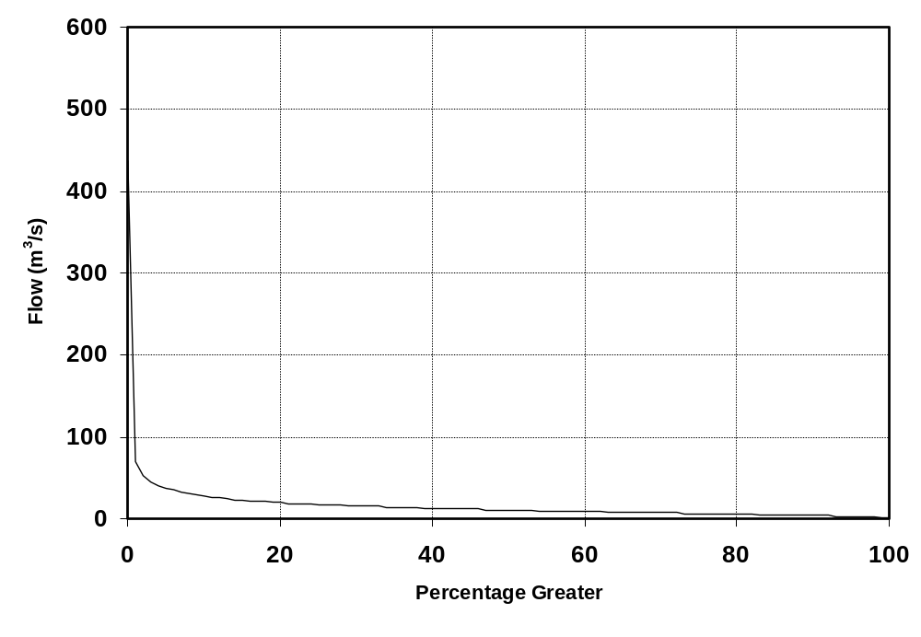
Figure depicting Percentage Exceedance graph.

Table Depicting Percentage Exceedence: Flow (m³/s).
 | 0 | 1 | 2 | 3 | 4 | 5 | 6 | 7 | 8 | 9
0 | 436.9 | 70.6 | 53.4 | 45.5 | 41.0 | 37.7 | 35.1 | 32.9 | 31.1 | 29.5
10 | 28.2 | 27.0 | 25.9 | 24.9 | 24.0 | 23.2 | 22.4 | 21.6 | 21.0 | 20.4
20 | 19.8 | 19.3 | 18.8 | 18.3 | 17.9 | 17.5 | 17.1 | 16.7 | 16.4 | 16.1
30 | 15.7 | 15.4 | 15.1 | 14.8 | 14.5 | 14.3 | 14.0 | 13.7 | 13.5 | 13.2
40 | 13.0 | 12.8 | 12.5 | 12.3 | 12.1 | 11.9 | 11.7 | 11.4 | 11.2 | 11.0
50 | 10.8 | 10.6 | 10.4 | 10.2 | 10.0 | 9.9 | 9.7 | 9.5 | 9.3 | 9.1
60 | 9.0 | 8.8 | 8.6 | 8.5 | 8.3 | 8.1 | 8.0 | 7.8 | 7.7 | 7.5
70 | 7.4 | 7.2 | 7.0 | 6.9 | 6.7 | 6.6 | 6.4 | 6.3 | 6.1 | 6.0
80 | 5.8 | 5.7 | 5.5 | 5.3 | 5.2 | 5.1 | 4.9 | 4.8 | 4.6 | 4.5
90 | 4.3 | 4.1 | 4.0 | 3.8 | 3.6 | 3.5 | 3.2 | 3.0 | 2.6 | 2.3
100 | 1.7
Note: 0% is the maximum flow and 100% is the minimum flow.

Summary Table: Flow (m³/s)
Record Length | Minimum | Mean | Median | Maximum
Jul 1931 to Jun 2005 | 1.7 | 14.7 | 10.8 | 436.9

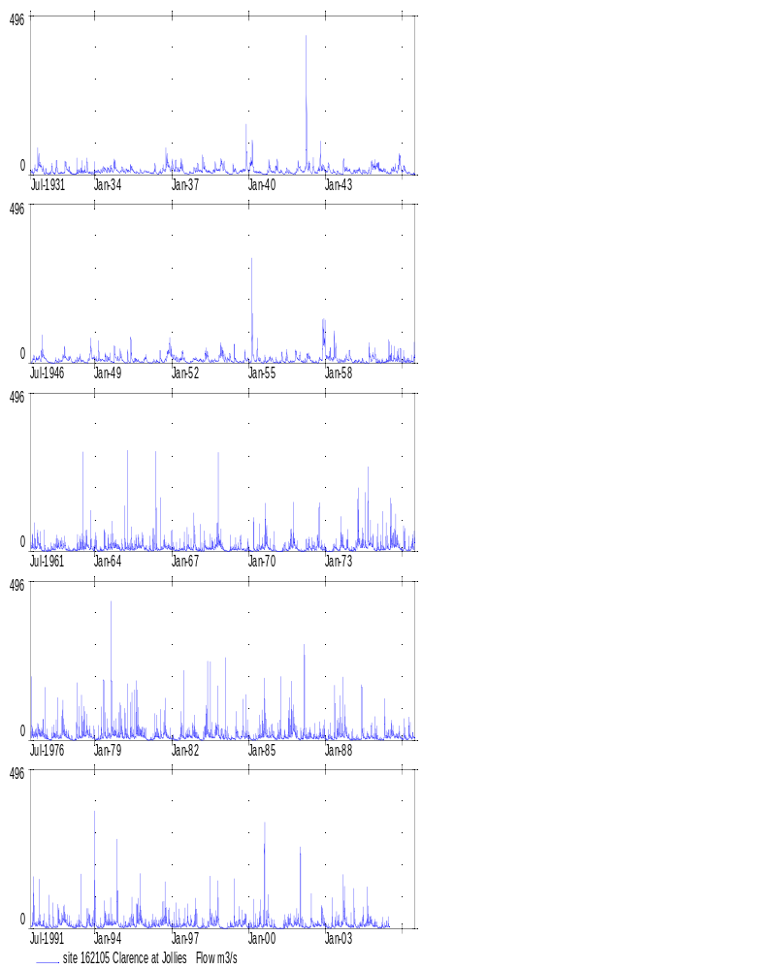
Clarence at Jollies, 1931-2005

Waiau at Glenhope – 164604 (Item 1)

Flow (m³/s)
Year | Jan | Feb | Mar | Apr | May | Jun | Jul | Aug | Sep | Oct | Nov | Dec | Mean
1931 |  |  |  |  |  |  | 25 | 29 | 35 | 68 | 68 | 40 | 44
1932 | 16 | 21 | 15 | 32 | 25 | 26 | 41 | 19 | 20 | 22 | 58 | 36 | 28
1933 | 22 | 15 | 11 | 19 | 26 | 24 | 26 | 27 | 45 | 20 | 18 | 23 | 23
1934 | 25 | 28 | 26 | 33 | 38 | 32 | 34 | 39 | 35 | 56 | 33 | 23 | 34
1935 | 37 | 31 | 29 | 31 | 37 | 43 | 25 | 22 | 18 | 28 | 21 | 29 | 29
1936 | 25 | 23 | 19 | 22 | 34 | 15 | 25 | 29 | 35 | 68 | 68 | 40 | 34
1937 | 56 | 39 | 42 | 35 | 59 | 34 | 17 | 15 | 20 | 19 | 29 | 31 | 33
1938 | 39 | 31 | 47 | 49 | 28 | 29 | 22 | 25 | 42 | 37 | 42 | 73 | 39
1939 | 49 | 28 | 20 | 14 | 23 | 35 | 25 | 20 | 31 | 34 | 48 | 80 | 34
1940 | 39 | 83 | 54 | 24 | 23 | 23 | 16 | 11 | 13 | 40 | 35 | 25 | 32
1941 | 27 | 54 | 25 | 28 | 17 | 22 | 29 | 25 | 17 | 16 | 28 | 52 | 28
1942 | 40 | 27 | 38 | 141 | 56 | 22 | 45 | 22 | 29 | 60 | 45 | 44 | 47
1943 | 26 | 52 | 28 | 23 | 23 | 19 | 18 | 14 | 36 | 37 | 36 | 32 | 29
1944 | 17 | 26 | 26 | 34 | 29 | 21 | 23 | 19 | 28 | 43 | 53 | 55 | 31
1945 | 57 | 42 | 36 | 32 | 27 | 19 | 18 | 35 | 42 | 28 | 63 | 59 | 38
1946 | 37 | 38 | 20 | 21 | 14 | 15 | 20 | 38 | 32 | 37 | 32 | 69 | 31
1947 | 41 | 27 | 17 | 14 | 10 | 21 | 19 | 22 | 25 | 55 | 41 | 34 | 27
1948 | 37 | 18 | 18 | 27 | 31 | 32 | 23 | 15 | 17 | 44 | 67 | 42 | 31
1949 | 34 | 45 | 33 | 30 | 28 | 35 | 38 | 31 | 17 | 51 | 33 | 39 | 34
1950 | 42 | 21 | 13 | 31 | 30 | 41 | 22 | 28 | 23 | 18 | 19 | 37 | 27
1951 | 26 | 14 | 12 | 21 | 21 | 21 | 34 | 24 | 18 | 41 | 73 | 86 | 33
1952 | 45 | 40 | 31 | 25 | 37 | 50 | 26 | 14 | 14 | 20 | 35 | 34 | 31
1953 | 26 | 28 | 24 | 39 | 55 | 33 | 21 | 21 | 27 | 24 | 49 | 70 | 35
1954 | 43 | 34 | 32 | 36 | 19 | 38 | 24 | 16 | 18 | 18 | 45 | 29 | 29
1955 | 17 | 108 | 61 | 23 | 51 | 29 | 13 | 25 | 21 | 28 | 34 | 26 | 36
1956 | 16 | 21 | 15 | 32 | 25 | 26 | 41 | 19 | 20 | 22 | 58 | 36 | 28
1957 | 39 | 19 | 25 | 36 | 47 | 25 | 20 | 17 | 13 | 33 | 60 | 152 | 41
1958 | 64 | 47 | 49 | 33 | 76 | 48 | 22 | 24 | 22 | 33 | 34 | 46 | 41
1959 | 25 | 17 | 22 | 20 | 20 | 23 | 13 | 15 | 39 | 36 | 47 | 49 | 27
1960 | 16 | 16 | 18 | 17 | 18 | 29 | 38 | 35 | 36 | 29 | 34 | 34 | 27
1961 | 23 | 21 | 24 | 21 | 24 | 30 | 44 | 40 | 24 | 61 | 38 | 17 | 31
1962 | 26 | 14 | 16 | 24 | 24 | 36 | 45 | 41 | 42 | 47 | 32 | 20 | 31
1963 | 16 | 16 | 20 | 20 | 30 | 38 | 47 | 41 | 54 | 31 | 47 | 20 | 32
1964 | 46 | 16 | 18 | 16 | 32 | 31 | 38 | 40 | 45 | 46 | 34 | 28 | 33
1965 | 26 | 21 | 43 | 48 | 27 | 35 | 29 | 40 | 44 | 39 | 59 | 27 | 37
1966 | 22 | 21 | 19 | 29 | 47 | 23 | 29 | 30 | 46 | 34 | 34 | 30 | 31
1967 | 34 | 21 | 20 | 21 | 23 | 22 | 24 | 39 | 30 | 26 | 68 | 31 | 30
1968 | 17 | 26 | 16 | 41 | 31 | 29 | 33 | 34 | 34 | 81 | 58 | 45 | 37
1969 | 22 | 15 | 11 | 19 | 26 | 24 | 26 | 27 | 45 | 20 | 18 | 23 | 23
Year | Jan | Feb | Mar | Apr | May | Jun | Jul | Aug | Sep | Oct | Nov | Dec | Mean
1970 | 18 | 12 | 26 | 16 | 19 | 32 | 35 | 43 | 68 | 31 | 25 | 18 | 29
1971 | 24 | 12 | 9 | 10 | 18 | 30 | 21 | 39 | 45 | 67 | 34 | 20 | 28
1972 | 14 | 11 | 14 | 30 | 36 | 24 | 38 | 24 | 48 | 61 | 27 | 25 | 29
1973 | 16 | 9 | 8 | 15 | 31 | 28 | 19 | 56 | 43 | 24 | 43 | 20 | 26
1974 | 17 | 22 | 20 | 91 | 50 | 41 | 57 | 30 | 44 | 53 | 53 | 26 | 42
1975 | 21 | 17 | 26 | 42 | 57 | 42 | 43 | 41 | 44 | 59 | 60 | 36 | 41
1976 | 42 | 43 | 20 | 19 | 27 | 46 | 38 | 29 | 25 | 38 | 37 | 56 | 35
1977 | 59 | 27 | 19 | 14 | 23 | 27 | 29 | 17 | 29 | 42 | 46 | 37 | 31
1978 | 23 | 14 | 14 | 27 | 44 | 25 | 32 | 41 | 48 | 44 | 40 | 42 | 33
1979 | 22 | 27 | 24 | 36 | 81 | 29 | 35 | 57 | 63 | 70 | 41 | 66 | 46
1980 | 64 | 48 | 45 | 42 | 36 | 41 | 25 | 44 | 56 | 49 | 53 | 40 | 45
1981 | 21 | 19 | 29 | 34 | 36 | 41 | 32 | 22 | 34 | 62 | 35 | 42 | 34
1982 | 32 | 18 | 14 | 14 | 34 | 30 | 19 | 31 | 32 | 29 | 63 | 45 | 30
1983 | 33 | 15 | 19 | 36 | 72 | 38 | 48 | 31 | 45 | 82 | 34 | 35 | 41
1984 | 23 | 30 | 20 | 18 | 21 | 20 | 44 | 37 | 22 | 54 | 71 | 62 | 35
1985 | 51 | 21 | 14 | 20 | 17 | 29 | 31 | 35 | 38 | 29 | 32 | 46 | 30
1986 | 29 | 25 | 23 | 42 | 25 | 30 | 28 | 41 | 46 | 65 | 42 | 27 | 35
1987 | 35 | 28 | 43 | 36 | 33 | 41 | 20 | 29 | 24 | 48 | 33 | 45 | 35
1988 | 24 | 31 | 39 | 23 | 47 | 42 | 58 | 41 | 55 | 101 | 56 | 31 | 46
1989 | 20 | 17 | 26 | 20 | 14 | 63 | 27 | 17 | 19 | 41 | 27 | 31 | 27
1990 | 25 | 18 | 19 | 27 | 50 | 24 | 24 | 40 | 21 | 26 | 33 | 32 | 28
1991 | 32 | 36 | 16 | 31 | 21 | 28 | 22 | 67 | 35 | 39 | 41 | 35 | 33
1992 | 30 | 23 | 40 | 20 | 15 | 15 | 28 | 44 | 28 | 47 | 50 | 38 | 31
1993 | 41 | 23 | 16 | 16 | 20 | 52 | 18 | 12 | 24 | 53 | 28 | 70 | 31
1994 | 76 | 21 | 22 | 15 | 45 | 42 | 39 | 40 | 36 | 36 | 147 | 43 | 47
1995 | 32 | 26 | 33 | 31 | 36 | 44 | 32 | 31 | 64 | 70 | 50 | 48 | 41
1996 | 29 | 23 | 23 | 33 | 18 | 27 | 24 | 32 | 54 | 73 | 63 | 40 | 37
1997 | 27 | 29 | 26 | 30 | 24 | 27 | 23 | 35 | 22 | 34 | 50 | 79 | 34
1998 | 25 | 21 | 25 | 32 | 19 | 28 | 66 | 40 | 37 | 95 | 36 | 20 | 37
1999 | 14 | 12 | 19 | 30 | 27 | 40 | 32 | 41 | 31 | 43 | 54 | 25 | 31
2000 | 25 | 22 | 23 | 26 | 24 | 54 | 29 | 51 | 37 | 65 | 24 | 25 | 34
2001 | 21 | 11 | 9 | 10 | 16 | 29 | 26 | 45 | 26 | 38 | 44 | 41 | 27
2002 | 48 | 25 | 19 | 20 | 18 | 45 | 30 | 29 | 35 | 28 | 56 | 38 | 33
2003 | 24 | 18 | 13 | 36 | 26 | 38 | 36 | 29 | 76 | 69 | 51 | 37 | 38
2004 | 36 | 50 | 30 | 18 | 30 | 53 | 30 | 38 | 36 | 50 | 36 | 36 | 37
2005 | 28 | 19 | 22 | 16 | 16 | 20 |  |  |  |  |  |  | 20
Min. | 14 | 9 | 8 | 10 | 10 | 15 | 13 | 11 | 13 | 16 | 18 | 17 | 23
Mean | 31 | 27 | 24 | 29 | 31 | 32 | 30 | 31 | 34 | 44 | 45 | 41 | 33
Max. | 76 | 108 | 61 | 141 | 81 | 63 | 66 | 67 | 76 | 101 | 147 | 152 | 47

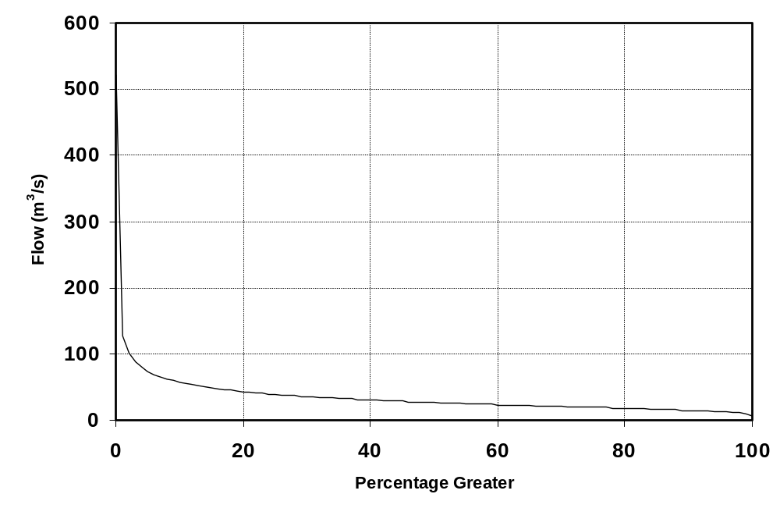
Figure depicting Percentage Exceedance graph.

Table Depicting Percentage Exceedence: Flow (m³/s).
 | 0 | 1 | 2 | 3 | 4 | 5 | 6 | 7 | 8 | 9
0 | 522 | 127 | 101 | 88 | 79 | 73 | 69 | 65 | 62 | 60
10 | 58 | 56 | 54 | 52 | 50 | 49 | 48 | 46 | 45 | 44
20 | 43 | 42 | 41 | 40 | 40 | 39 | 38 | 38 | 37 | 36
30 | 36 | 35 | 35 | 34 | 34 | 33 | 33 | 32 | 32 | 31
40 | 31 | 31 | 30 | 30 | 29 | 29 | 29 | 28 | 28 | 27
50 | 27 | 27 | 26 | 26 | 26 | 25 | 25 | 25 | 24 | 24
60 | 24 | 23 | 23 | 23 | 22 | 22 | 22 | 22 | 21 | 21
70 | 21 | 20 | 20 | 20 | 20 | 19 | 19 | 19 | 19 | 18
80 | 18 | 18 | 18 | 17 | 17 | 17 | 16 | 16 | 16 | 16
90 | 15 | 15 | 14 | 14 | 14 | 13 | 13 | 12 | 11 | 10
100 | 7
Note: 0% is the maximum flow and 100% is the minimum flow.

Summary Table: Flow (m³/s)
Record Length | Minimum | Mean | Median | Maximum
Jul 1931 to Jun 2005 | 7 | 33 | 27 | 522

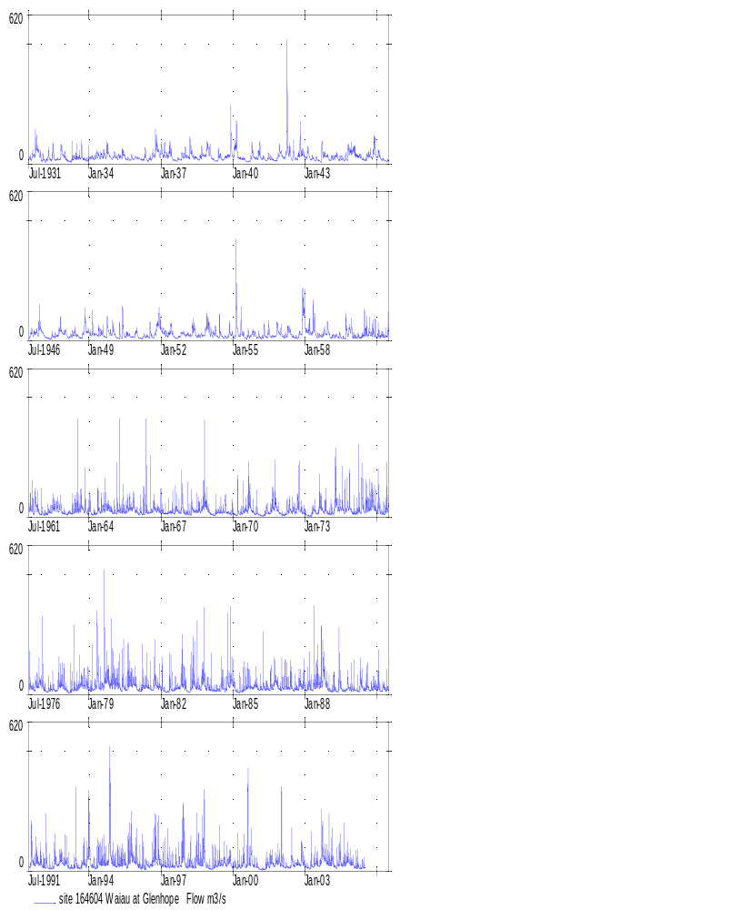
Waiau at Glenhope, 1931-2005

Waiau at Marble Point– 164602 (Item 1)

Flow (m³/s)
Year | Jan | Feb | Mar | Apr | May | Jun | Jul | Aug | Sep | Oct | Nov | Dec | Mean
1931 |  |  |  |  |  |  | 68 | 80 | 99 | 213 | 206 | 112 | 44
1932 | 43 | 58 | 40 | 90 | 68 | 71 | 119 | 51 | 55 | 60 | 173 | 100 | 77
1933 | 59 | 40 | 30 | 52 | 72 | 66 | 71 | 75 | 131 | 55 | 46 | 62 | 63
1934 | 69 | 78 | 70 | 92 | 105 | 90 | 96 | 110 | 100 | 165 | 92 | 62 | 94
1935 | 105 | 87 | 81 | 86 | 105 | 121 | 69 | 58 | 49 | 77 | 57 | 79 | 81
1936 | 67 | 62 | 49 | 61 | 96 | 38 | 68 | 80 | 99 | 213 | 206 | 113 | 96
1937 | 166 | 111 | 121 | 97 | 176 | 95 | 45 | 40 | 53 | 52 | 81 | 84 | 93
1938 | 110 | 84 | 139 | 141 | 77 | 78 | 58 | 68 | 120 | 104 | 120 | 224 | 110
1939 | 141 | 78 | 54 | 36 | 65 | 96 | 67 | 54 | 85 | 94 | 142 | 263 | 98
1940 | 113 | 265 | 168 | 66 | 62 | 63 | 42 | 28 | 34 | 117 | 99 | 68 | 93
1941 | 75 | 160 | 67 | 75 | 46 | 58 | 82 | 68 | 46 | 41 | 78 | 152 | 78
1942 | 113 | 72 | 106 | 469 | 164 | 59 | 131 | 59 | 81 | 190 | 130 | 125 | 142
1943 | 72 | 150 | 78 | 63 | 63 | 51 | 49 | 36 | 109 | 102 | 100 | 88 | 80
1944 | 46 | 72 | 72 | 95 | 81 | 58 | 62 | 50 | 79 | 127 | 156 | 163 | 88
1945 | 166 | 122 | 99 | 89 | 73 | 51 | 48 | 99 | 118 | 76 | 192 | 180 | 109
1946 | 104 | 107 | 53 | 57 | 37 | 39 | 54 | 106 | 88 | 104 | 91 | 214 | 88
1947 | 117 | 75 | 45 | 35 | 27 | 58 | 51 | 60 | 67 | 164 | 115 | 94 | 76
1948 | 103 | 48 | 48 | 74 | 87 | 89 | 63 | 40 | 45 | 127 | 210 | 119 | 88
1949 | 95 | 136 | 93 | 81 | 76 | 100 | 106 | 85 | 44 | 152 | 92 | 113 | 98
1950 | 120 | 55 | 35 | 90 | 92 | 119 | 59 | 76 | 62 | 47 | 50 | 104 | 76
1951 | 71 | 36 | 31 | 58 | 56 | 55 | 96 | 64 | 49 | 117 | 223 | 280 | 95
1952 | 129 | 114 | 86 | 67 | 103 | 146 | 70 | 35 | 38 | 55 | 96 | 94 | 86
1953 | 69 | 78 | 66 | 113 | 161 | 91 | 55 | 57 | 73 | 65 | 146 | 214 | 99
1954 | 123 | 95 | 88 | 102 | 52 | 111 | 67 | 41 | 48 | 47 | 129 | 79 | 81
1955 | 46 | 370 | 189 | 63 | 153 | 79 | 35 | 69 | 56 | 78 | 95 | 70 | 107
1956 | 41 | 58 | 40 | 90 | 68 | 71 | 119 | 51 | 55 | 60 | 173 | 100 | 77
1957 | 110 | 50 | 67 | 101 | 136 | 67 | 53 | 45 | 34 | 91 | 191 | 545 | 125
1958 | 199 | 136 | 146 | 90 | 246 | 143 | 59 | 66 | 58 | 92 | 95 | 134 | 122
1959 | 69 | 45 | 58 | 55 | 54 | 63 | 35 | 40 | 118 | 101 | 134 | 143 | 76
1960 | 43 | 42 | 48 | 44 | 49 | 83 | 108 | 98 | 103 | 79 | 94 | 96 | 74
1961 | 62 | 57 | 65 | 57 | 66 | 84 | 130 | 118 | 66 | 186 | 109 | 44 | 87
1962 | 74 | 36 | 43 | 67 | 65 | 103 | 128 | 116 | 120 | 135 | 89 | 54 | 86
1963 | 42 | 43 | 54 | 53 | 83 | 108 | 143 | 119 | 159 | 86 | 143 | 54 | 91
1964 | 135 | 41 | 47 | 41 | 91 | 88 | 108 | 115 | 133 | 131 | 95 | 76 | 92
1965 | 72 | 56 | 131 | 146 | 73 | 101 | 82 | 115 | 128 | 111 | 175 | 73 | 105
1966 | 60 | 59 | 51 | 83 | 144 | 62 | 86 | 84 | 134 | 95 | 95 | 86 | 87
1967 | 97 | 56 | 54 | 57 | 63 | 61 | 67 | 113 | 82 | 74 | 265 | 126 | 93
1968 | 64 | 93 | 68 | 88 | 83 | 69 | 82 | 74 | 87 | 254 | 194 | 150 | 109
1969 | 88 | 44 | 41 | 59 | 63 | 50 | 52 | 57 | 134 | 63 | 48 | 68 | 64
Year | Jan | Feb | Mar | Apr | May | Jun | Jul | Aug | Sep | Oct | Nov | Dec | Mean
1970 | 59 | 30 | 46 | 43 | 42 | 53 | 81 | 129 | 251 | 129 | 88 | 65 | 85
1971 | 52 | 29 | 23 | 24 | 38 | 63 | 45 | 75 | 141 | 264 | 125 | 77 | 80
1972 | 57 | 41 | 65 | 102 | 116 | 68 | 102 | 62 | 148 | 218 | 117 | 80 | 98
1973 | 43 | 25 | 25 | 65 | 121 | 82 | 41 | 95 | 81 | 76 | 152 | 57 | 72
1974 | 53 | 69 | 51 | 195 | 83 | 98 | 162 | 91 | 175 | 153 | 131 | 57 | 110
1975 | 55 | 56 | 93 | 121 | 171 | 118 | 129 | 133 | 136 | 167 | 134 | 89 | 117
1976 | 116 | 110 | 54 | 49 | 83 | 125 | 117 | 82 | 95 | 123 | 115 | 143 | 101
1977 | 161 | 76 | 54 | 43 | 78 | 92 | 97 | 63 | 102 | 125 | 130 | 95 | 93
1978 | 68 | 35 | 48 | 90 | 124 | 86 | 109 | 126 | 147 | 114 | 97 | 85 | 94
1979 | 45 | 66 | 70 | 97 | 169 | 79 | 85 | 126 | 164 | 169 | 120 | 171 | 114
1980 | 179 | 132 | 140 | 121 | 108 | 118 | 82 | 152 | 194 | 152 | 146 | 105 | 136
1981 | 48 | 51 | 60 | 86 | 98 | 115 | 92 | 71 | 129 | 186 | 93 | 111 | 95
1982 | 101 | 49 | 33 | 35 | 114 | 107 | 68 | 83 | 101 | 82 | 196 | 139 | 92
1983 | 130 | 50 | 75 | 93 | 215 | 121 | 132 | 93 | 144 | 232 | 107 | 98 | 125
1984 | 65 | 85 | 65 | 57 | 62 | 60 | 116 | 101 | 63 | 147 | 183 | 131 | 95
1985 | 106 | 46 | 34 | 47 | 41 | 77 | 93 | 95 | 102 | 77 | 82 | 120 | 77
1986 | 66 | 60 | 49 | 89 | 68 | 88 | 87 | 141 | 125 | 188 | 103 | 76 | 95
1987 | 99 | 71 | 121 | 91 | 92 | 119 | 59 | 79 | 71 | 131 | 85 | 122 | 95
1988 | 63 | 99 | 93 | 60 | 141 | 133 | 205 | 136 | 201 | 289 | 142 | 75 | 137
1989 | 50 | 42 | 74 | 55 | 39 | 152 | 71 | 47 | 55 | 87 | 70 | 102 | 70
1990 | 90 | 45 | 50 | 87 | 163 | 74 | 81 | 121 | 69 | 78 | 94 | 94 | 88
1991 | 93 | 120 | 39 | 78 | 62 | 86 | 76 | 200 | 99 | 116 | 117 | 95 | 98
1992 | 74 | 67 | 114 | 51 | 45 | 49 | 100 | 139 | 86 | 139 | 127 | 99 | 91
1993 | 118 | 65 | 44 | 53 | 62 | 160 | 57 | 38 | 73 | 149 | 76 | 152 | 87
1994 | 191 | 46 | 48 | 44 | 142 | 110 | 123 | 119 | 108 | 94 | 373 | 109 | 126
1995 | 83 | 62 | 89 | 70 | 84 | 116 | 99 | 115 | 219 | 200 | 144 | 121 | 117
1996 | 61 | 63 | 62 | 113 | 88 | 75 | 82 | 90 | 147 | 202 | 182 | 112 | 106
1997 | 66 | 94 | 85 | 98 | 68 | 78 | 68 | 100 | 57 | 90 | 140 | 209 | 96
1998 | 59 | 53 | 69 | 85 | 49 | 69 | 191 | 114 | 118 | 259 | 83 | 62 | 101
1999 | 33 | 34 | 54 | 82 | 66 | 111 | 77 | 77 | 74 | 146 | 143 | 59 | 80
2000 | 64 | 43 | 40 | 96 | 82 | 137 | 93 | 146 | 155 | 237 | 72 | 102 | 106
2001 | 65 | 36 | 35 | 33 | 51 | 85 | 63 | 80 | 57 | 81 | 128 | 174 | 74
2002 | 135 | 52 | 72 | 55 | 49 | 192 | 81 | 77 | 126 | 115 | 176 | 143 | 106
2003 | 84 | 79 | 47 | 72 | 85 | 122 | 96 | 65 | 195 | 183 | 132 | 78 | 103
2004 | 97 | 151 | 82 | 48 | 97 | 164 | 73 | 119 | 119 | 142 | 84 | 90 | 105
2005 | 64 | 53 | 62 | 41 | 45 | 51 |  |  |  |  |  |  | 53
Min. | 33 | 25 | 23 | 24 | 27 | 38 | 35 | 28 | 34 | 41 | 46 | 44 | 63
Mean | 87 | 76 | 69 | 80 | 89 | 90 | 85 | 86 | 102 | 129 | 129 | 118 | 95
Max. | 199 | 370 | 189 | 469 | 246 | 192 | 205 | 200 | 251 | 289 | 373 | 545 | 142

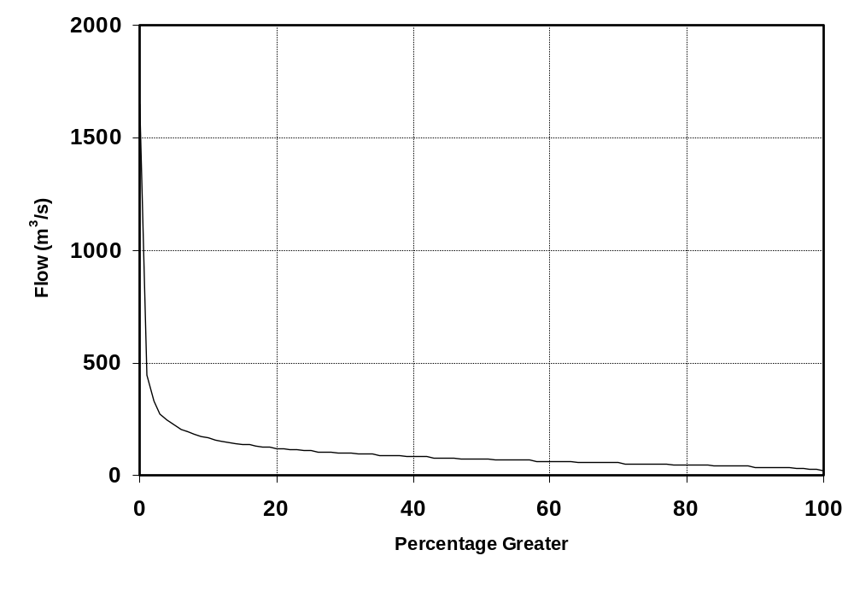
Figure depicting Percentage Exceedance graph.

Table Depicting Percentage Exceedence: Flow (m³/s).
 | 0 | 1 | 2 | 3 | 4 | 5 | 6 | 7 | 8 | 9
0 | 1650 | 445 | 330 | 275 | 244 | 223 | 207 | 194 | 184 | 175
10 | 167 | 160 | 154 | 148 | 144 | 139 | 135 | 131 | 128 | 124
20 | 121 | 119 | 116 | 114 | 111 | 109 | 107 | 105 | 103 | 102
30 | 100 | 98 | 97 | 95 | 93 | 92 | 90 | 89 | 87 | 86
40 | 85 | 83 | 82 | 81 | 79 | 78 | 77 | 76 | 75 | 74
50 | 73 | 72 | 71 | 70 | 69 | 68 | 67 | 66 | 65 | 64
60 | 63 | 63 | 62 | 61 | 60 | 60 | 59 | 58 | 57 | 57
70 | 56 | 55 | 54 | 53 | 53 | 52 | 51 | 50 | 49 | 49
80 | 48 | 47 | 46 | 45 | 44 | 43 | 43 | 42 | 41 | 40
90 | 39 | 38 | 37 | 36 | 35 | 34 | 33 | 32 | 29 | 25
100 | 19
Note: 0% is the maximum flow and 100% is the minimum flow.

Summary Table: Flow (m³/s)
Record Length | Minimum | Mean | Median | Maximum
Jul 1931 to Jun 2005 | 19 | 95 | 73 | 1650

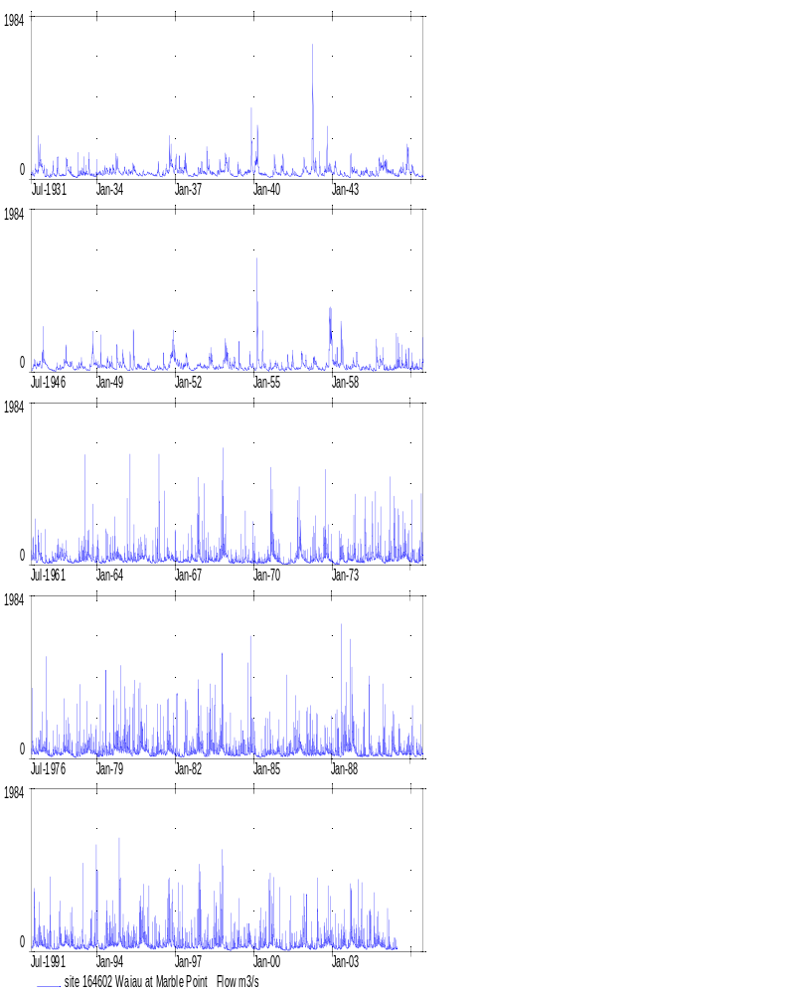
Waiau at Marble Point, 1931-2005

Ngaruroro at Whana Whana – 123103 (Item 1)

Flow (m³/s)
Year | Jan | Feb | Mar | Apr | May | Jun | Jul | Aug | Sep | Oct | Nov | Dec | Mean
1931 |  |  |  |  |  |  | 53 | 34 | 53 | 22 | 15 | 11 | 44
1932 | 9 | 85 | 59 | 30 | 52 | 26 | 30 | 42 | 34 | 33 | 14 | 13 | 35
1933 | 14 | 27 | 28 | 14 | 54 | 38 | 53 | 47 | 49 | 36 | 25 | 23 | 34
1934 | 12 | 38 | 15 | 22 | 34 | 35 | 38 | 46 | 31 | 28 | 24 | 16 | 28
1935 | 9 | 21 | 35 | 76 | 34 | 53 | 42 | 60 | 38 | 24 | 56 | 20 | 39
1936 | 43 | 50 | 37 | 21 | 27 | 34 | 43 | 25 | 28 | 23 | 23 | 23 | 31
1937 | 33 | 16 | 16 | 20 | 22 | 37 | 66 | 34 | 41 | 32 | 27 | 27 | 31
1938 | 15 | 46 | 17 | 87 | 46 | 38 | 85 | 51 | 22 | 18 | 20 | 35 | 40
1939 | 11 | 15 | 13 | 18 | 41 | 33 | 31 | 45 | 42 | 29 | 24 | 34 | 28
1940 | 30 | 28 | 31 | 29 | 42 | 31 | 53 | 47 | 38 | 41 | 46 | 20 | 36
1941 | 26 | 15 | 28 | 34 | 24 | 37 | 55 | 56 | 37 | 49 | 24 | 20 | 34
1942 | 43 | 51 | 25 | 27 | 30 | 57 | 73 | 65 | 46 | 23 | 26 | 33 | 41
1943 | 30 | 23 | 23 | 40 | 77 | 85 | 40 | 47 | 90 | 32 | 45 | 31 | 47
1944 | 51 | 53 | 108 | 20 | 40 | 46 | 53 | 55 | 34 | 29 | 20 | 24 | 45
1945 | 29 | 24 | 14 | 10 | 45 | 39 | 39 | 39 | 39 | 42 | 20 | 11 | 29
1946 | 8 | 2 | 4 | 30 | 45 | 47 | 59 | 45 | 45 | 37 | 22 | 14 | 30
1947 | 21 | 23 | 21 | 56 | 51 | 75 | 72 | 29 | 26 | 30 | 18 | 14 | 36
1948 | 12 | 2 | 2 | 35 | 120 | 59 | 40 | 34 | 28 | 48 | 51 | 20 | 38
1949 | 28 | 9 | 15 | 11 | 60 | 43 | 32 | 69 | 30 | 29 | 26 | 19 | 31
1950 | 18 | 26 | 6 | 37 | 38 | 29 | 66 | 43 | 50 | 67 | 71 | 19 | 39
1951 | 33 | 38 | 61 | 37 | 71 | 35 | 42 | 53 | 23 | 28 | 29 | 23 | 40
1952 | 17 | 30 | 14 | 7 | 17 | 45 | 34 | 62 | 81 | 34 | 59 | 57 | 38
1953 | 33 | 25 | 14 | 28 | 34 | 78 | 37 | 28 | 23 | 28 | 13 | 11 | 29
1954 | 2 | 2 | 20 | 111 | 47 | 35 | 41 | 109 | 42 | 21 | 28 | 42 | 42
1955 | 19 | 18 | 35 | 52 | 34 | 38 | 108 | 58 | 53 | 38 | 23 | 23 | 42
1956 | 17 | 21 | 21 | 32 | 99 | 73 | 68 | 59 | 34 | 40 | 30 | 15 | 43
1957 | 17 | 14 | 18 | 21 | 25 | 41 | 53 | 51 | 43 | 36 | 23 | 22 | 30
1958 | 12 | 21 | 13 | 5 | 27 | 19 | 50 | 50 | 30 | 53 | 28 | 44 | 29
1959 | 22 | 28 | 37 | 38 | 63 | 35 | 37 | 49 | 27 | 59 | 26 | 16 | 36
1960 | 19 | 56 | 38 | 72 | 50 | 54 | 54 | 40 | 92 | 41 | 79 | 91 | 57
1961 | 55 | 29 | 17 | 18 | 31 | 56 | 80 | 72 | 72 | 26 | 15 | 19 | 41
1962 | 17 | 21 | 31 | 26 | 32 | 53 | 72 | 42 | 34 | 44 | 29 | 76 | 40
1963 | 26 | 13 | 9 | 10 | 10 | 55 | 74 | 40 | 49 | 36 | 21 | 19 | 30
1964 | 18 | 14 | 27 | 9 | 11 | 26 | 55 | 24 | 35 | 17 | 10 | 8 | 21
1965 | 13 | 14 | 61 | 12 | 8 | 16 | 28 | 97 | 14 | 9 | 32 | 37 | 29
1966 | 46 | 31 | 27 | 32 | 72 | 45 | 69 | 75 | 51 | 9 | 15 | 15 | 41
1967 | 24 | 47 | 33 | 14 | 17 | 42 | 44 | 103 | 41 | 22 | 55 | 63 | 42
1968 | 34 | 14 | 8 | 62 | 83 | 128 | 106 | 80 | 49 | 49 | 29 | 36 | 57
1969 | 29 | 35 | 16 | 20 | 24 | 26 | 26 | 33 | 43 | 27 | 22 | 31 | 28
Year | Jan | Feb | Mar | Apr | May | Jun | Jul | Aug | Sep | Oct | Nov | Dec | Mean
1970 | 15 | 17 | 29 | 24 | 38 | 52 | 37 | 54 | 48 | 39 | 28 | 13 | 33
1971 | 27 | 18 | 23 | 57 | 56 | 30 | 51 | 67 | 72 | 72 | 41 | 29 | 45
1972 | 14 | 12 | 41 | 20 | 37 | 33 | 44 | 34 | 26 | 21 | 13 | 25 | 27
1973 | 19 | 15 | 14 | 37 | 19 | 42 | 35 | 52 | 44 | 24 | 17 | 17 | 28
1974 | 16 | 8 | 17 | 45 | 43 | 30 | 42 | 54 | 55 | 48 | 27 | 26 | 34
1975 | 32 | 14 | 44 | 22 | 33 | 69 | 44 | 52 | 39 | 38 | 23 | 24 | 36
1976 | 68 | 52 | 16 | 28 | 34 | 31 | 54 | 65 | 106 | 39 | 39 | 31 | 47
1977 | 20 | 12 | 12 | 35 | 41 | 66 | 56 | 87 | 87 | 48 | 18 | 25 | 42
1978 | 10 | 15 | 6 | 20 | 21 | 55 | 80 | 38 | 29 | 31 | 22 | 17 | 29
1979 | 9 | 12 | 44 | 31 | 29 | 30 | 36 | 66 | 58 | 44 | 26 | 21 | 34
1980 | 34 | 22 | 64 | 54 | 19 | 36 | 47 | 43 | 39 | 23 | 24 | 75 | 40
1981 | 41 | 20 | 29 | 60 | 53 | 68 | 68 | 67 | 49 | 43 | 38 | 25 | 47
1982 | 14 | 20 | 20 | 36 | 28 | 38 | 38 | 31 | 18 | 20 | 15 | 21 | 25
1983 | 11 | 7 | 6 | 13 | 29 | 43 | 46 | 30 | 27 | 52 | 33 | 27 | 27
1984 | 12 | 15 | 21 | 14 | 18 | 17 | 28 | 38 | 55 | 32 | 15 | 23 | 24
1985 | 17 | 13 | 50 | 24 | 26 | 77 | 89 | 61 | 47 | 21 | 19 | 35 | 40
1986 | 43 | 30 | 24 | 10 | 20 | 20 | 37 | 47 | 72 | 32 | 15 | 15 | 30
1987 | 21 | 13 | 62 | 42 | 20 | 18 | 75 | 40 | 24 | 27 | 33 | 29 | 34
1988 | 14 | 30 | 113 | 23 | 26 | 29 | 73 | 54 | 86 | 27 | 19 | 23 | 43
1989 | 34 | 27 | 9 | 8 | 27 | 69 | 42 | 54 | 150 | 68 | 40 | 25 | 46
1990 | 19 | 12 | 18 | 12 | 18 | 30 | 46 | 89 | 23 | 52 | 31 | 13 | 31
1991 | 9 | 17 | 15 | 49 | 64 | 23 | 26 | 62 | 27 | 25 | 54 | 15 | 32
1992 | 17 | 16 | 14 | 17 | 22 | 41 | 70 | 62 | 41 | 100 | 56 | 41 | 42
1993 | 18 | 41 | 26 | 18 | 35 | 34 | 21 | 20 | 27 | 19 | 18 | 12 | 24
1994 | 10 | 10 | 9 | 11 | 19 | 33 | 54 | 50 | 33 | 42 | 62 | 14 | 29
1995 | 9 | 13 | 16 | 35 | 41 | 35 | 50 | 35 | 43 | 29 | 22 | 26 | 30
1996 | 36 | 32 | 23 | 52 | 29 | 36 | 70 | 42 | 42 | 22 | 16 | 22 | 35
1997 | 24 | 13 | 19 | 16 | 12 | 36 | 70 | 40 | 35 | 34 | 19 | 13 | 28
1998 | 9 | 10 | 8 | 9 | 10 | 14 | 108 | 40 | 27 | 44 | 22 | 33 | 28
1999 | 27 | 14 | 11 | 23 | 41 | 39 | 32 | 35 | 27 | 14 | 46 | 39 | 29
2000 | 26 | 14 | 10 | 31 | 28 | 37 | 92 | 33 | 31 | 44 | 23 | 24 | 33
2001 | 17 | 10 | 9 | 10 | 46 | 33 | 48 | 67 | 42 | 39 | 40 | 70 | 36
2002 | 21 | 24 | 14 | 12 | 16 | 42 | 142 | 96 | 38 | 27 | 14 | 40 | 41
2003 | 21 | 15 | 21 | 11 | 28 | 31 | 24 | 96 | 105 | 66 | 26 | 21 | 39
2004 | 17 | 51 | 26 | 10 | 21 | 45 | 58 | 53 | 31 | 38 | 20 | 21 | 32
2005 | 18 | 10 | 15 | 12 | 34 | 46 |  |  |  |  |  |  | 23
Min. | 2 | 2 | 2 | 5 | 8 | 14 | 21 | 20 | 14 | 9 | 10 | 8 | 21
Mean | 23 | 23 | 26 | 29 | 37 | 43 | 55 | 53 | 45 | 36 | 29 | 27 | 35
Max. | 68 | 85 | 113 | 111 | 120 | 128 | 142 | 109 | 150 | 100 | 79 | 91 | 57

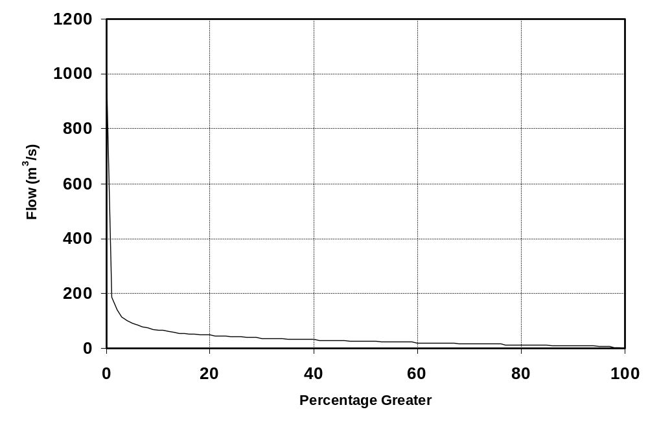
Figure depicting Percentage Exceedance graph.

Table Depicting Percentage Exceedence: Flow (m³/s).
 | 0 | 1 | 2 | 3 | 4 | 5 | 6 | 7 | 8 | 9
0 | 1026 | 187 | 139 | 115 | 101 | 91 | 84 | 79 | 74 | 70
10 | 67 | 64 | 61 | 59 | 57 | 55 | 53 | 52 | 50 | 49
20 | 48 | 46 | 45 | 44 | 43 | 42 | 41 | 40 | 39 | 39
30 | 38 | 37 | 36 | 35 | 35 | 34 | 34 | 33 | 32 | 32
40 | 32 | 31 | 30 | 30 | 29 | 29 | 28 | 28 | 27 | 27
50 | 26 | 26 | 25 | 25 | 24 | 24 | 23 | 23 | 22 | 22
60 | 21 | 21 | 20 | 20 | 20 | 19 | 19 | 18 | 18 | 18
70 | 17 | 17 | 16 | 16 | 16 | 15 | 15 | 15 | 14 | 14
80 | 14 | 13 | 13 | 13 | 12 | 12 | 11 | 11 | 11 | 10
90 | 10 | 10 | 9 | 9 | 9 | 8 | 7 | 6 | 4 | 2
100 | 1
Note: 0% is the maximum flow and 100% is the minimum flow.

Summary Table: Flow (m³/s)
Record Length | Minimum | Mean | Median | Maximum
Jul 1931 to Jun 2005 | 1 | 35 | 26 | 1026

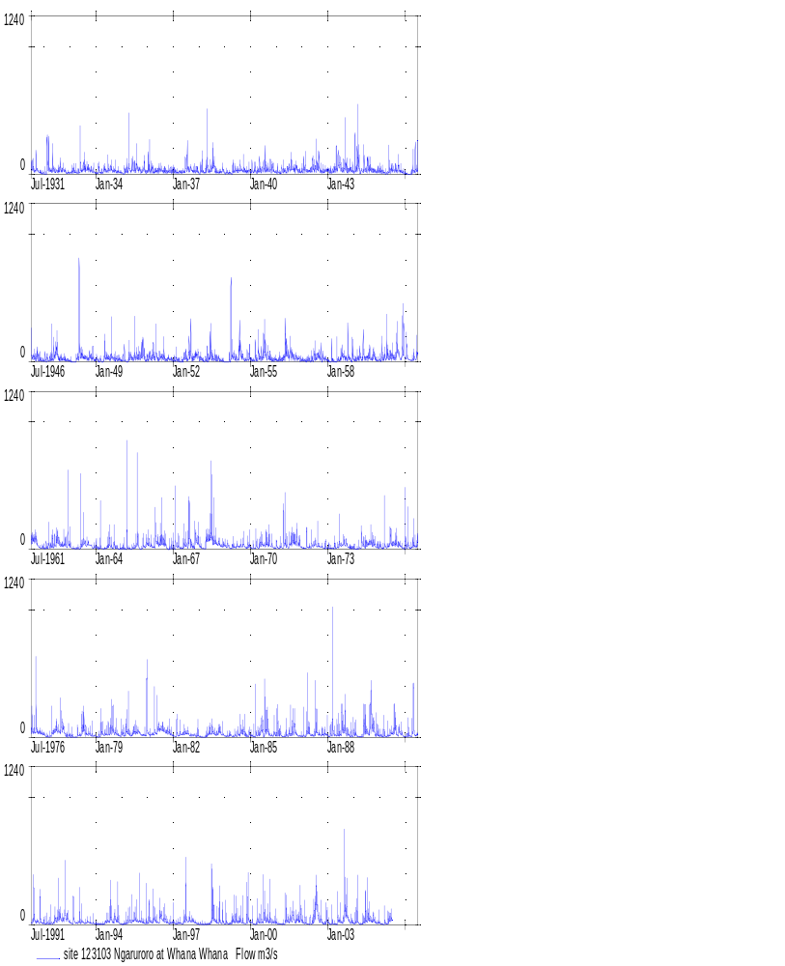
Ngaruroro at Whana Whana, 1931-2005

Ngaruroro at Kuripapango – 123104 (Item 1)

Flow (m³/s)
Year | Jan | Feb | Mar | Apr | May | Jun | Jul | Aug | Sep | Oct | Nov | Dec | Mean
1931 |  |  |  |  |  |  | 26 | 16 | 26 | 11 | 7 | 5 | 44
1932 | 4 | 43 | 29 | 14 | 26 | 12 | 15 | 21 | 16 | 16 | 7 | 7 | 17
1933 | 7 | 13 | 14 | 7 | 27 | 19 | 26 | 23 | 24 | 17 | 12 | 12 | 17
1934 | 6 | 19 | 8 | 11 | 17 | 17 | 19 | 22 | 15 | 14 | 12 | 8 | 14
1935 | 5 | 10 | 17 | 38 | 17 | 26 | 21 | 30 | 18 | 12 | 28 | 10 | 19
1936 | 21 | 25 | 18 | 10 | 13 | 17 | 21 | 12 | 14 | 11 | 11 | 11 | 15
1937 | 16 | 8 | 8 | 10 | 11 | 19 | 33 | 17 | 20 | 16 | 13 | 13 | 15
1938 | 8 | 23 | 8 | 44 | 23 | 19 | 43 | 26 | 11 | 9 | 10 | 17 | 20
1939 | 6 | 8 | 6 | 9 | 21 | 16 | 15 | 22 | 21 | 14 | 12 | 17 | 14
1940 | 15 | 14 | 15 | 14 | 21 | 15 | 27 | 23 | 19 | 20 | 23 | 10 | 18
1941 | 13 | 7 | 14 | 17 | 12 | 18 | 27 | 28 | 18 | 24 | 12 | 10 | 17
1942 | 22 | 25 | 12 | 13 | 15 | 29 | 37 | 32 | 23 | 11 | 13 | 16 | 21
1943 | 15 | 11 | 11 | 20 | 39 | 43 | 20 | 24 | 45 | 16 | 22 | 15 | 23
1944 | 26 | 26 | 55 | 10 | 20 | 23 | 27 | 28 | 16 | 14 | 10 | 12 | 22
1945 | 14 | 12 | 7 | 5 | 23 | 19 | 19 | 19 | 19 | 21 | 10 | 5 | 14
1946 | 4 | 1 | 2 | 15 | 22 | 23 | 29 | 22 | 22 | 18 | 11 | 7 | 15
1947 | 11 | 11 | 10 | 28 | 26 | 38 | 36 | 14 | 13 | 15 | 9 | 7 | 18
1948 | 6 | 1 | 1 | 17 | 60 | 29 | 19 | 16 | 14 | 24 | 26 | 10 | 19
1949 | 14 | 5 | 8 | 5 | 30 | 21 | 16 | 34 | 14 | 14 | 13 | 10 | 15
1950 | 9 | 13 | 3 | 18 | 19 | 14 | 32 | 21 | 25 | 34 | 36 | 9 | 20
1951 | 16 | 19 | 31 | 18 | 35 | 17 | 21 | 26 | 11 | 14 | 14 | 11 | 20
1952 | 9 | 15 | 7 | 3 | 8 | 22 | 17 | 31 | 40 | 16 | 29 | 28 | 19
1953 | 16 | 12 | 7 | 14 | 17 | 39 | 18 | 14 | 11 | 13 | 7 | 5 | 14
1954 | 1 | 1 | 10 | 56 | 23 | 17 | 20 | 55 | 20 | 10 | 14 | 21 | 21
1955 | 9 | 9 | 18 | 26 | 17 | 19 | 55 | 29 | 26 | 19 | 11 | 11 | 21
1956 | 8 | 10 | 10 | 16 | 51 | 37 | 34 | 29 | 16 | 20 | 14 | 8 | 21
1957 | 9 | 7 | 9 | 10 | 12 | 21 | 27 | 25 | 21 | 18 | 11 | 11 | 15
1958 | 6 | 11 | 6 | 3 | 13 | 9 | 25 | 25 | 14 | 27 | 13 | 22 | 15
1959 | 11 | 14 | 18 | 19 | 32 | 17 | 18 | 24 | 13 | 30 | 12 | 8 | 18
1960 | 9 | 28 | 19 | 36 | 25 | 27 | 27 | 20 | 47 | 20 | 40 | 46 | 28
1961 | 28 | 14 | 9 | 9 | 15 | 28 | 41 | 36 | 36 | 13 | 8 | 10 | 20
1962 | 8 | 10 | 16 | 13 | 16 | 26 | 37 | 20 | 16 | 21 | 14 | 38 | 20
1963 | 13 | 6 | 5 | 5 | 5 | 27 | 37 | 19 | 27 | 9 | 8 | 9 | 14
1964 | 13 | 7 | 23 | 4 | 6 | 13 | 44 | 22 | 36 | 19 | 14 | 15 | 18
1965 | 14 | 19 | 25 | 11 | 8 | 19 | 21 | 61 | 19 | 11 | 25 | 18 | 21
1966 | 18 | 9 | 11 | 16 | 28 | 21 | 34 | 38 | 33 | 10 | 16 | 15 | 21
1967 | 20 | 21 | 15 | 7 | 9 | 16 | 18 | 46 | 18 | 8 | 21 | 16 | 18
1968 | 9 | 5 | 4 | 11 | 26 | 44 | 47 | 36 | 19 | 23 | 13 | 16 | 21
1969 | 15 | 18 | 7 | 6 | 13 | 11 | 10 | 14 | 27 | 12 | 7 | 16 | 13
Year | Jan | Feb | Mar | Apr | May | Jun | Jul | Aug | Sep | Oct | Nov | Dec | Mean
1970 | 6 | 9 | 9 | 13 | 23 | 34 | 18 | 34 | 41 | 19 | 17 | 6 | 19
1971 | 14 | 11 | 10 | 16 | 28 | 27 | 19 | 30 | 35 | 38 | 18 | 15 | 22
1972 | 7 | 5 | 21 | 9 | 20 | 10 | 27 | 16 | 15 | 10 | 6 | 6 | 13
1973 | 6 | 3 | 4 | 5 | 10 | 24 | 11 | 24 | 23 | 9 | 10 | 7 | 11
1974 | 6 | 4 | 8 | 26 | 22 | 32 | 45 | 22 | 20 | 25 | 12 | 12 | 20
1975 | 12 | 6 | 13 | 8 | 15 | 31 | 19 | 30 | 19 | 21 | 11 | 10 | 16
1976 | 34 | 27 | 7 | 14 | 19 | 17 | 27 | 27 | 57 | 19 | 14 | 14 | 23
1977 | 9 | 6 | 7 | 18 | 18 | 32 | 27 | 40 | 40 | 22 | 9 | 11 | 20
1978 | 5 | 6 | 3 | 10 | 9 | 21 | 40 | 15 | 17 | 13 | 15 | 8 | 13
1979 | 4 | 9 | 21 | 15 | 14 | 13 | 14 | 33 | 25 | 29 | 16 | 13 | 17
1980 | 23 | 9 | 24 | 32 | 12 | 22 | 29 | 22 | 20 | 10 | 11 | 38 | 21
1981 | 14 | 7 | 9 | 20 | 25 | 34 | 28 | 26 | 16 | 19 | 21 | 15 | 20
1982 | 7 | 12 | 12 | 20 | 16 | 24 | 15 | 13 | 13 | 12 | 9 | 16 | 14
1983 | 8 | 4 | 3 | 10 | 16 | 21 | 24 | 16 | 16 | 32 | 18 | 17 | 15
1984 | 7 | 10 | 15 | 9 | 11 | 11 | 22 | 18 | 23 | 16 | 8 | 14 | 14
1985 | 9 | 6 | 30 | 15 | 14 | 42 | 33 | 31 | 26 | 10 | 9 | 16 | 20
1986 | 27 | 14 | 12 | 5 | 13 | 12 | 24 | 26 | 38 | 18 | 7 | 8 | 17
1987 | 14 | 7 | 29 | 23 | 11 | 12 | 30 | 19 | 13 | 16 | 16 | 18 | 17
1988 | 7 | 12 | 54 | 10 | 15 | 17 | 33 | 27 | 39 | 18 | 13 | 16 | 22
1989 | 22 | 18 | 6 | 4 | 13 | 40 | 20 | 19 | 49 | 34 | 17 | 13 | 21
1990 | 11 | 6 | 16 | 9 | 13 | 15 | 23 | 51 | 13 | 23 | 18 | 7 | 17
1991 | 6 | 13 | 8 | 22 | 27 | 11 | 15 | 37 | 16 | 13 | 22 | 6 | 16
1992 | 9 | 9 | 8 | 8 | 8 | 17 | 23 | 30 | 17 | 43 | 22 | 20 | 18
1993 | 7 | 14 | 10 | 8 | 23 | 23 | 11 | 8 | 14 | 9 | 10 | 7 | 12
1994 | 6 | 5 | 5 | 6 | 10 | 22 | 27 | 29 | 20 | 22 | 45 | 8 | 17
1995 | 6 | 9 | 12 | 23 | 23 | 17 | 29 | 21 | 27 | 17 | 13 | 19 | 18
1996 | 25 | 17 | 14 | 27 | 18 | 13 | 32 | 20 | 29 | 13 | 10 | 16 | 19
1997 | 12 | 6 | 9 | 9 | 6 | 24 | 34 | 22 | 20 | 20 | 10 | 7 | 15
1998 | 5 | 6 | 5 | 5 | 7 | 11 | 60 | 22 | 17 | 33 | 12 | 15 | 17
1999 | 9 | 6 | 6 | 10 | 22 | 19 | 16 | 20 | 15 | 7 | 24 | 13 | 14
2000 | 10 | 7 | 5 | 13 | 13 | 18 | 34 | 16 | 17 | 23 | 10 | 12 | 15
2001 | 8 | 5 | 4 | 6 | 22 | 14 | 17 | 26 | 14 | 17 | 19 | 32 | 15
2002 | 8 | 12 | 8 | 7 | 9 | 21 | 41 | 27 | 16 | 12 | 7 | 19 | 16
2003 | 8 | 5 | 7 | 7 | 19 | 16 | 13 | 39 | 50 | 37 | 15 | 13 | 19
2004 | 8 | 37 | 15 | 3 | 14 | 31 | 32 | 30 | 15 | 22 | 11 | 11 | 19
2005 | 11 | 4 | 6 | 5 | 15 | 23 |  |  |  |  |  |  | 11
Min. | 1 | 1 | 1 | 3 | 5 | 9 | 10 | 8 | 11 | 7 | 6 | 5 | 11
Mean | 11 | 12 | 13 | 14 | 19 | 22 | 27 | 26 | 23 | 18 | 15 | 14 | 18
Max. | 34 | 43 | 55 | 56 | 60 | 44 | 60 | 61 | 57 | 43 | 45 | 46 | 28

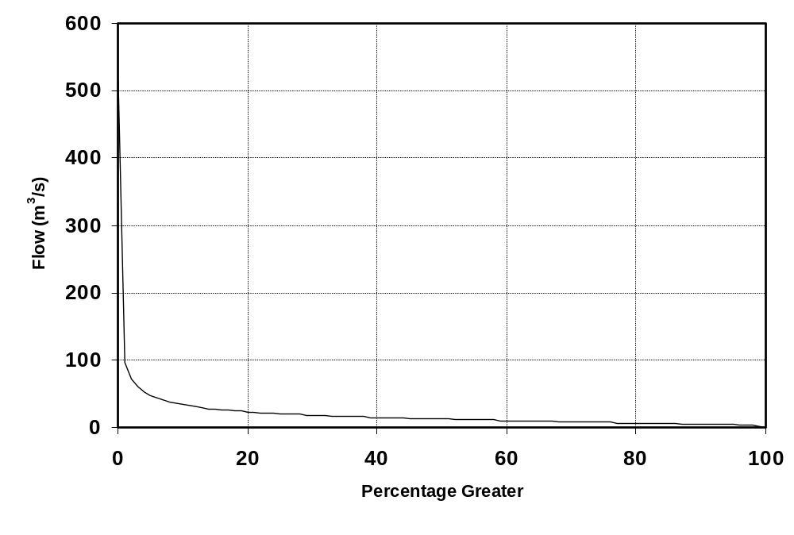
Figure depicting Percentage Exceedance graph.

Table Depicting Percentage Exceedence: Flow (m³/s).
 | 0 | 1 | 2 | 3 | 4 | 5 | 6 | 7 | 8 | 9
0 | 516 | 97 | 73 | 60 | 53 | 47 | 43 | 40 | 38 | 36
10 | 34 | 32 | 31 | 30 | 28 | 27 | 26 | 26 | 25 | 24
20 | 23 | 23 | 22 | 21 | 21 | 20 | 20 | 19 | 19 | 19
30 | 18 | 18 | 17 | 17 | 17 | 16 | 16 | 16 | 16 | 15
40 | 15 | 15 | 15 | 14 | 14 | 14 | 14 | 13 | 13 | 13
50 | 13 | 12 | 12 | 12 | 12 | 11 | 11 | 11 | 11 | 11
60 | 10 | 10 | 10 | 10 | 10 | 9 | 9 | 9 | 9 | 9
70 | 9 | 8 | 8 | 8 | 8 | 8 | 8 | 7 | 7 | 7
80 | 7 | 7 | 7 | 6 | 6 | 6 | 6 | 6 | 6 | 5
90 | 5 | 5 | 5 | 5 | 5 | 4 | 4 | 4 | 3 | 1
100 | 1
Note: 0% is the maximum flow and 100% is the minimum flow.

Summary Table: Flow (m³/s)
Record Length | Minimum | Mean | Median | Maximum
Jul 1931 to Jun 2005 | 1 | 18 | 13 | 516

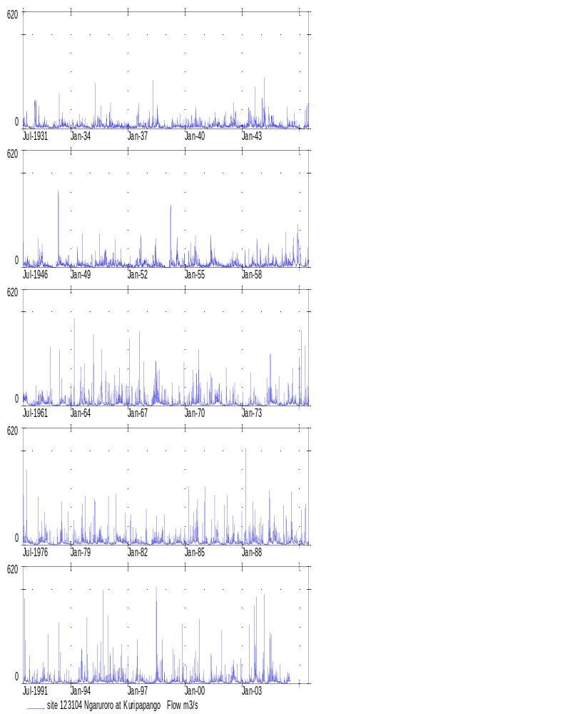
Ngaruroro at Kuripapango, 1931-2005

Ngaruroro at Chesterhope Bridge – 123150 (Item 1)

Flow (m³/s)
Year | Jan | Feb | Mar | Apr | May | Jun | Jul | Aug | Sep | Oct | Nov | Dec | Mean
1931 |  |  |  |  |  |  | 66 | 39 | 68 | 24 | 15 | 9 | 44
1932 | 9 | 128 | 82 | 34 | 68 | 28 | 34 | 51 | 39 | 38 | 14 | 12 | 44
1933 | 13 | 31 | 32 | 13 | 78 | 45 | 67 | 59 | 61 | 42 | 28 | 26 | 42
1934 | 10 | 46 | 15 | 24 | 39 | 43 | 45 | 56 | 35 | 33 | 26 | 15 | 32
1935 | 7 | 23 | 41 | 115 | 41 | 66 | 52 | 80 | 45 | 26 | 71 | 21 | 49
1936 | 54 | 66 | 44 | 22 | 30 | 40 | 53 | 27 | 31 | 25 | 25 | 25 | 37
1937 | 38 | 16 | 16 | 20 | 23 | 45 | 90 | 40 | 50 | 37 | 30 | 31 | 36
1938 | 17 | 59 | 17 | 136 | 57 | 46 | 118 | 65 | 23 | 18 | 20 | 41 | 51
1939 | 11 | 15 | 11 | 21 | 51 | 39 | 35 | 55 | 52 | 32 | 26 | 40 | 32
1940 | 35 | 32 | 36 | 33 | 51 | 35 | 69 | 59 | 45 | 50 | 57 | 21 | 44
1941 | 30 | 14 | 33 | 40 | 26 | 44 | 71 | 72 | 44 | 62 | 26 | 21 | 40
1942 | 54 | 65 | 27 | 30 | 34 | 74 | 101 | 85 | 58 | 24 | 29 | 38 | 52
1943 | 34 | 25 | 25 | 49 | 107 | 115 | 48 | 59 | 132 | 37 | 55 | 36 | 60
1944 | 71 | 69 | 166 | 21 | 51 | 58 | 68 | 71 | 39 | 32 | 21 | 26 | 58
1945 | 33 | 26 | 13 | 10 | 59 | 47 | 47 | 46 | 48 | 53 | 20 | 10 | 34
1946 | 7 | 1 | 4 | 38 | 59 | 62 | 80 | 56 | 56 | 44 | 23 | 13 | 37
1947 | 23 | 26 | 22 | 78 | 66 | 100 | 99 | 32 | 29 | 34 | 18 | 13 | 45
1948 | 12 | 1 | 1 | 42 | 199 | 75 | 48 | 39 | 32 | 60 | 65 | 21 | 50
1949 | 32 | 8 | 16 | 11 | 81 | 52 | 37 | 99 | 34 | 33 | 29 | 20 | 38
1950 | 18 | 30 | 5 | 47 | 45 | 33 | 92 | 52 | 63 | 89 | 95 | 20 | 49
1951 | 39 | 45 | 80 | 44 | 99 | 41 | 51 | 69 | 25 | 32 | 33 | 25 | 49
1952 | 18 | 35 | 13 | 6 | 17 | 56 | 41 | 83 | 117 | 39 | 76 | 72 | 48
1953 | 38 | 27 | 13 | 31 | 41 | 111 | 44 | 32 | 25 | 31 | 12 | 10 | 35
1954 | 1 | 1 | 23 | 178 | 59 | 40 | 51 | 162 | 51 | 22 | 31 | 53 | 56
1955 | 19 | 18 | 43 | 71 | 40 | 45 | 158 | 75 | 67 | 46 | 24 | 25 | 53
1956 | 17 | 22 | 22 | 37 | 143 | 97 | 92 | 75 | 39 | 49 | 33 | 15 | 54
1957 | 17 | 13 | 19 | 23 | 28 | 51 | 69 | 63 | 52 | 46 | 25 | 23 | 36
1958 | 11 | 27 | 12 | 4 | 34 | 19 | 64 | 62 | 34 | 74 | 31 | 59 | 36
1959 | 23 | 32 | 44 | 45 | 86 | 41 | 43 | 62 | 30 | 76 | 28 | 16 | 44
1960 | 19 | 73 | 46 | 103 | 62 | 69 | 68 | 49 | 127 | 50 | 117 | 130 | 76
1961 | 71 | 32 | 17 | 17 | 36 | 72 | 107 | 95 | 95 | 29 | 15 | 20 | 51
1962 | 17 | 23 | 37 | 29 | 38 | 67 | 96 | 50 | 39 | 53 | 33 | 112 | 50
1963 | 30 | 11 | 7 | 9 | 8 | 77 | 102 | 47 | 61 | 41 | 22 | 20 | 36
1964 | 19 | 14 | 33 | 7 | 9 | 29 | 72 | 26 | 43 | 17 | 8 | 7 | 24
1965 | 11 | 14 | 93 | 11 | 6 | 16 | 33 | 149 | 13 | 7 | 37 | 45 | 37
1966 | 57 | 35 | 31 | 39 | 96 | 55 | 93 | 102 | 65 | 7 | 15 | 15 | 51
1967 | 26 | 62 | 38 | 13 | 17 | 52 | 55 | 149 | 50 | 23 | 71 | 81 | 53
1968 | 40 | 14 | 6 | 81 | 112 | 190 | 158 | 109 | 60 | 61 | 33 | 43 | 76
1969 | 32 | 40 | 16 | 21 | 25 | 29 | 29 | 38 | 53 | 30 | 23 | 35 | 31
Year | Jan | Feb | Mar | Apr | May | Jun | Jul | Aug | Sep | Oct | Nov | Dec | Mean
1970 | 14 | 17 | 34 | 26 | 45 | 65 | 43 | 68 | 60 | 47 | 32 | 12 | 39
1971 | 30 | 18 | 24 | 79 | 76 | 34 | 63 | 88 | 94 | 97 | 49 | 34 | 58
1972 | 13 | 11 | 51 | 20 | 45 | 37 | 54 | 40 | 28 | 22 | 11 | 28 | 30
1973 | 20 | 14 | 13 | 46 | 19 | 53 | 41 | 65 | 53 | 25 | 17 | 17 | 32
1974 | 16 | 6 | 17 | 58 | 52 | 34 | 50 | 67 | 70 | 60 | 30 | 29 | 41
1975 | 37 | 14 | 56 | 23 | 39 | 92 | 53 | 65 | 46 | 45 | 24 | 31 | 44
1976 | 101 | 67 | 15 | 32 | 40 | 35 | 68 | 85 | 161 | 46 | 44 | 31 | 60
1977 | 16 | 10 | 13 | 42 | 42 | 90 | 81 | 150 | 125 | 62 | 24 | 27 | 57
1978 | 7 | 17 | 5 | 24 | 20 | 85 | 117 | 47 | 35 | 29 | 25 | 15 | 35
1979 | 7 | 12 | 89 | 38 | 34 | 45 | 62 | 109 | 116 | 74 | 30 | 23 | 54
1980 | 39 | 30 | 105 | 106 | 30 | 54 | 77 | 52 | 42 | 24 | 19 | 155 | 61
1981 | 55 | 19 | 21 | 88 | 58 | 99 | 78 | 109 | 67 | 50 | 45 | 31 | 60
1982 | 11 | 24 | 21 | 43 | 30 | 48 | 45 | 37 | 20 | 19 | 15 | 15 | 27
1983 | 7 | 4 | 3 | 12 | 24 | 54 | 50 | 27 | 25 | 62 | 31 | 22 | 27
1984 | 10 | 15 | 21 | 13 | 19 | 17 | 32 | 60 | 82 | 38 | 16 | 23 | 29
1985 | 14 | 10 | 85 | 24 | 27 | 111 | 179 | 83 | 51 | 18 | 16 | 36 | 55
1986 | 40 | 33 | 21 | 9 | 15 | 16 | 37 | 54 | 95 | 41 | 15 | 13 | 32
1987 | 16 | 10 | 78 | 47 | 22 | 21 | 108 | 48 | 29 | 26 | 46 | 28 | 40
1988 | 11 | 38 | 176 | 21 | 16 | 14 | 103 | 70 | 129 | 31 | 15 | 19 | 54
1989 | 33 | 24 | 7 | 5 | 31 | 67 | 38 | 63 | 289 | 73 | 39 | 31 | 58
1990 | 16 | 12 | 20 | 10 | 16 | 24 | 46 | 127 | 41 | 39 | 28 | 10 | 33
1991 | 6 | 11 | 13 | 31 | 92 | 26 | 29 | 64 | 25 | 23 | 71 | 14 | 34
1992 | 15 | 14 | 12 | 15 | 21 | 49 | 91 | 67 | 52 | 151 | 72 | 65 | 52
1993 | 23 | 82 | 41 | 23 | 49 | 45 | 24 | 23 | 33 | 17 | 16 | 11 | 32
1994 | 8 | 7 | 5 | 7 | 17 | 39 | 77 | 64 | 33 | 46 | 70 | 10 | 32
1995 | 5 | 12 | 14 | 62 | 65 | 45 | 73 | 51 | 47 | 31 | 26 | 25 | 38
1996 | 46 | 40 | 21 | 59 | 36 | 46 | 106 | 46 | 58 | 20 | 14 | 24 | 43
1997 | 36 | 13 | 21 | 16 | 12 | 63 | 130 | 55 | 59 | 56 | 21 | 11 | 41
1998 | 6 | 7 | 5 | 6 | 10 | 16 | 122 | 44 | 28 | 30 | 21 | 40 | 28
1999 | 39 | 15 | 12 | 27 | 52 | 58 | 38 | 37 | 32 | 15 | 54 | 39 | 35
2000 | 20 | 13 | 7 | 34 | 27 | 38 | 138 | 44 | 45 | 51 | 27 | 28 | 40
2001 | 18 | 9 | 8 | 10 | 46 | 27 | 44 | 62 | 40 | 33 | 32 | 71 | 34
2002 | 24 | 24 | 13 | 10 | 15 | 46 | 146 | 107 | 46 | 37 | 16 | 45 | 44
2003 | 25 | 12 | 43 | 16 | 35 | 34 | 29 | 173 | 181 | 81 | 21 | 30 | 57
2004 | 19 | 69 | 36 | 11 | 32 | 64 | 90 | 75 | 35 | 49 | 21 | 18 | 43
2005 | 18 | 8 | 17 | 14 | 56 | 75 |  |  |  |  |  |  | 32
Min. | 1 | 1 | 1 | 4 | 6 | 14 | 24 | 23 | 13 | 7 | 8 | 7 | 24
Mean | 25 | 27 | 32 | 36 | 46 | 54 | 72 | 68 | 59 | 42 | 33 | 31 | 44
Max. | 101 | 128 | 176 | 178 | 199 | 190 | 179 | 173 | 289 | 151 | 117 | 155 | 76

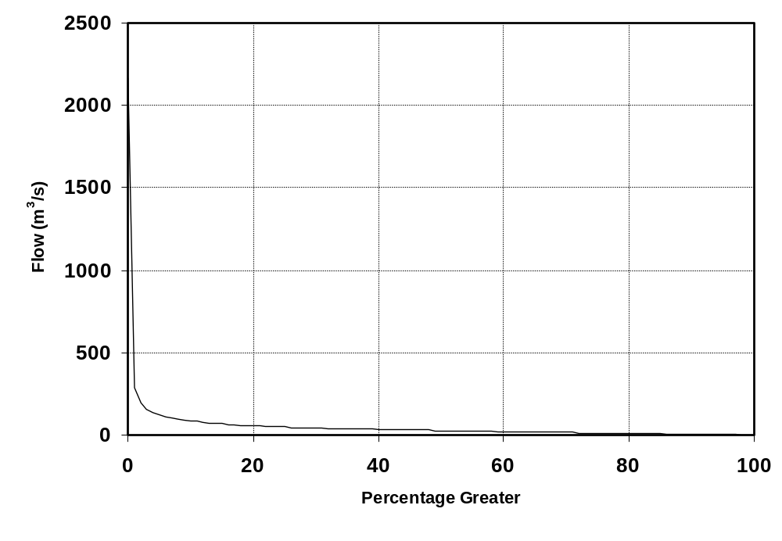
Figure depicting Percentage Exceedance graph.

Table Depicting Percentage Exceedence: Flow (m³/s).
 | 0 | 1 | 2 | 3 | 4 | 5 | 6 | 7 | 8 | 9
0 | 2163 | 289 | 199 | 160 | 139 | 124 | 113 | 104 | 98 | 92
10 | 87 | 82 | 78 | 75 | 72 | 69 | 67 | 64 | 62 | 60
20 | 58 | 57 | 55 | 53 | 52 | 50 | 49 | 48 | 46 | 45
30 | 44 | 43 | 42 | 41 | 40 | 39 | 38 | 38 | 37 | 36
40 | 36 | 35 | 34 | 33 | 33 | 32 | 31 | 30 | 30 | 29
50 | 28 | 28 | 27 | 26 | 26 | 25 | 25 | 24 | 23 | 23
60 | 22 | 22 | 21 | 21 | 20 | 20 | 19 | 19 | 18 | 18
70 | 17 | 17 | 16 | 16 | 15 | 15 | 14 | 14 | 13 | 13
80 | 12 | 12 | 11 | 11 | 11 | 10 | 10 | 9 | 9 | 9
90 | 8 | 8 | 7 | 7 | 6 | 6 | 5 | 4 | 2 | 1
100 | 1
Note: 0% is the maximum flow and 100% is the minimum flow.

Summary Table: Flow (m³/s)
Record Length | Minimum | Mean | Median | Maximum
Jul 1931 to Jun 2005 | 1 | 44 | 28 | 2163

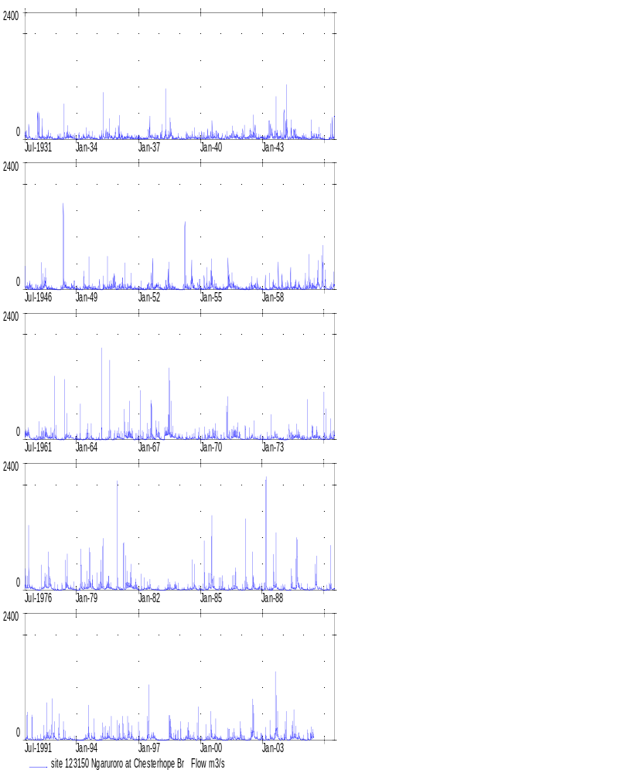
Ngaruroro at Chesterhope Bridge, 1931-2005

Wairau at Dip Flat – 160114 (Item 1)

Flow (m³/s)
Year | Jan | Feb | Mar | Apr | May | Jun | Jul | Aug | Sep | Oct | Nov | Dec | Mean
1931 |  |  |  |  |  |  | 23 | 19 | 19 | 34 | 33 | 52 | 44
1932 | 21 | 44 | 18 | 20 | 13 | 16 | 22 | 19 | 12 | 11 | 21 | 42 | 21
1933 | 21 | 44 | 18 | 20 | 13 | 16 | 22 | 19 | 12 | 11 | 21 | 42 | 21
1934 | 38 | 24 | 30 | 25 | 29 | 24 | 26 | 30 | 27 | 46 | 25 | 17 | 28
1935 | 29 | 24 | 22 | 23 | 29 | 33 | 19 | 16 | 13 | 21 | 15 | 21 | 22
1936 | 18 | 17 | 13 | 17 | 26 | 11 | 18 | 22 | 27 | 60 | 57 | 31 | 26
1937 | 46 | 30 | 33 | 26 | 49 | 26 | 12 | 11 | 15 | 14 | 22 | 23 | 26
1938 | 30 | 23 | 38 | 39 | 21 | 21 | 16 | 19 | 33 | 28 | 33 | 63 | 30
1939 | 39 | 21 | 15 | 10 | 18 | 26 | 18 | 15 | 23 | 25 | 39 | 75 | 27
1940 | 31 | 74 | 47 | 18 | 17 | 17 | 12 | 8 | 9 | 32 | 27 | 19 | 26
1941 | 20 | 44 | 18 | 20 | 13 | 16 | 22 | 19 | 12 | 11 | 21 | 42 | 21
1942 | 31 | 20 | 29 | 149 | 45 | 16 | 36 | 16 | 22 | 53 | 35 | 34 | 40
1943 | 20 | 41 | 21 | 17 | 17 | 14 | 13 | 10 | 31 | 28 | 27 | 24 | 22
1944 | 13 | 20 | 20 | 26 | 22 | 16 | 17 | 14 | 21 | 35 | 43 | 45 | 24
1945 | 46 | 33 | 27 | 24 | 20 | 14 | 13 | 27 | 32 | 21 | 53 | 50 | 30
1946 | 28 | 29 | 14 | 15 | 10 | 11 | 15 | 29 | 24 | 28 | 25 | 60 | 24
1947 | 32 | 20 | 12 | 10 | 8 | 16 | 14 | 16 | 18 | 45 | 31 | 26 | 21
1948 | 28 | 13 | 13 | 20 | 24 | 24 | 17 | 11 | 12 | 35 | 59 | 32 | 24
1949 | 26 | 38 | 25 | 22 | 21 | 27 | 29 | 23 | 12 | 42 | 25 | 31 | 27
1950 | 33 | 15 | 10 | 25 | 26 | 33 | 16 | 21 | 17 | 13 | 14 | 28 | 21
1951 | 19 | 10 | 9 | 16 | 15 | 13 | 32 | 14 | 16 | 39 | 60 | 51 | 25
1952 | 24 | 22 | 20 | 15 | 35 | 36 | 21 | 14 | 18 | 26 | 39 | 37 | 26
1953 | 29 | 26 | 20 | 28 | 47 | 28 | 19 | 22 | 29 | 26 | 48 | 53 | 31
1954 | 38 | 24 | 29 | 34 | 23 | 37 | 18 | 14 | 16 | 21 | 36 | 27 | 26
1955 | 13 | 74 | 20 | 8 | 39 | 23 | 11 | 25 | 21 | 25 | 22 | 17 | 24
1956 | 16 | 14 | 12 | 33 | 21 | 30 | 29 | 13 | 19 | 28 | 50 | 28 | 24
1957 | 17 | 12 | 20 | 38 | 37 | 16 | 15 | 15 | 13 | 35 | 66 | 89 | 31
1958 | 27 | 23 | 32 | 18 | 55 | 27 | 19 | 21 | 18 | 33 | 29 | 34 | 28
1959 | 14 | 15 | 19 | 26 | 24 | 25 | 11 | 13 | 38 | 33 | 39 | 32 | 24
1960 | 17 | 19 | 23 | 13 | 26 | 28 | 19 | 20 | 22 | 28 | 23 | 11 | 21
1961 | 11 | 12 | 24 | 22 | 12 | 13 | 21 | 20 | 22 | 50 | 54 | 13 | 23
1962 | 31 | 14 | 14 | 11 | 36 | 30 | 26 | 24 | 27 | 78 | 42 | 15 | 29
1963 | 8 | 18 | 12 | 11 | 28 | 29 | 16 | 24 | 39 | 20 | 38 | 20 | 22
1964 | 54 | 11 | 20 | 13 | 24 | 12 | 18 | 17 | 24 | 38 | 43 | 36 | 26
1965 | 33 | 17 | 10 | 13 | 13 | 19 | 11 | 14 | 20 | 28 | 64 | 31 | 23
1966 | 29 | 22 | 16 | 28 | 21 | 15 | 14 | 11 | 17 | 21 | 31 | 26 | 21
1967 | 17 | 12 | 22 | 28 | 21 | 14 | 19 | 45 | 17 | 26 | 76 | 48 | 29
1968 | 18 | 31 | 22 | 41 | 32 | 21 | 22 | 22 | 23 | 81 | 78 | 63 | 38
1969 | 35 | 17 | 12 | 17 | 24 | 13 | 10 | 10 | 68 | 21 | 16 | 27 | 22
Year | Jan | Feb | Mar | Apr | May | Jun | Jul | Aug | Sep | Oct | Nov | Dec | Mean
1970 | 21 | 10 | 13 | 15 | 8 | 14 | 20 | 42 | 90 | 37 | 31 | 22 | 27
1971 | 20 | 14 | 12 | 14 | 34 | 48 | 15 | 18 | 29 | 66 | 37 | 25 | 28
1972 | 21 | 12 | 23 | 37 | 32 | 18 | 26 | 18 | 39 | 77 | 39 | 19 | 30
1973 | 12 | 7 | 6 | 15 | 27 | 20 | 10 | 21 | 20 | 18 | 56 | 18 | 19
1974 | 17 | 20 | 12 | 79 | 20 | 18 | 29 | 17 | 23 | 52 | 48 | 19 | 29
1975 | 16 | 15 | 24 | 36 | 41 | 25 | 23 | 25 | 30 | 47 | 47 | 23 | 29
1976 | 38 | 21 | 13 | 14 | 21 | 32 | 23 | 19 | 19 | 34 | 33 | 52 | 27
1977 | 44 | 18 | 14 | 9 | 15 | 24 | 22 | 9 | 11 | 27 | 38 | 37 | 23
1978 | 16 | 9 | 11 | 15 | 35 | 18 | 18 | 21 | 29 | 35 | 30 | 34 | 23
1979 | 18 | 29 | 10 | 21 | 60 | 18 | 23 | 18 | 26 | 45 | 44 | 55 | 31
1980 | 60 | 38 | 28 | 26 | 23 | 29 | 16 | 32 | 39 | 40 | 36 | 31 | 33
1981 | 14 | 11 | 21 | 22 | 31 | 37 | 24 | 16 | 22 | 52 | 36 | 44 | 28
1982 | 26 | 16 | 11 | 9 | 36 | 27 | 13 | 13 | 33 | 20 | 61 | 37 | 25
1983 | 33 | 14 | 12 | 41 | 52 | 24 | 46 | 19 | 24 | 64 | 34 | 32 | 33
1984 | 17 | 18 | 16 | 17 | 16 | 13 | 26 | 24 | 17 | 34 | 53 | 37 | 24
1985 | 39 | 17 | 12 | 21 | 14 | 23 | 17 | 19 | 36 | 22 | 20 | 43 | 23
1986 | 32 | 22 | 24 | 28 | 20 | 26 | 16 | 19 | 23 | 44 | 32 | 20 | 26
1987 | 32 | 21 | 20 | 29 | 30 | 29 | 12 | 20 | 20 | 37 | 28 | 43 | 27
1988 | 18 | 30 | 46 | 17 | 40 | 25 | 49 | 33 | 47 | 78 | 46 | 32 | 39
1989 | 24 | 17 | 22 | 17 | 11 | 54 | 23 | 13 | 12 | 23 | 26 | 36 | 23
1990 | 29 | 13 | 13 | 21 | 38 | 16 | 22 | 38 | 15 | 24 | 41 | 28 | 25
1991 | 32 | 35 | 11 | 18 | 14 | 12 | 9 | 42 | 36 | 31 | 27 | 29 | 25
1992 | 26 | 22 | 31 | 15 | 9 | 8 | 12 | 26 | 14 | 35 | 45 | 35 | 23
1993 | 31 | 15 | 16 | 14 | 17 | 46 | 14 | 10 | 13 | 40 | 25 | 28 | 22
1994 | 47 | 16 | 17 | 10 | 27 | 30 | 24 | 25 | 26 | 30 | 137 | 36 | 36
1995 | 28 | 28 | 24 | 34 | 34 | 23 | 17 | 23 | 59 | 66 | 47 | 54 | 36
1996 | 31 | 23 | 23 | 46 | 19 | 17 | 13 | 19 | 47 | 67 | 53 | 32 | 32
1997 | 18 | 20 | 26 | 24 | 18 | 20 | 12 | 18 | 14 | 28 | 35 | 58 | 24
1998 | 21 | 17 | 21 | 28 | 18 | 25 | 75 | 40 | 37 | 89 | 32 | 15 | 35
1999 | 11 | 9 | 14 | 25 | 20 | 32 | 17 | 15 | 20 | 40 | 57 | 16 | 23
2000 | 21 | 18 | 9 | 35 | 25 | 37 | 30 | 27 | 39 | 64 | 21 | 24 | 29
2001 | 20 | 10 | 8 | 9 | 15 | 27 | 11 | 18 | 18 | 34 | 47 | 69 | 24
2002 | 25 | 12 | 19 | 14 | 13 | 47 | 19 | 18 | 37 | 27 | 39 | 43 | 26
2003 | 20 | 14 | 11 | 17 | 23 | 35 | 28 | 11 | 36 | 51 | 44 | 31 | 27
2004 | 29 | 44 | 24 | 11 | 20 | 49 | 22 | 26 | 28 | 51 | 37 | 29 | 31
2005 | 27 | 18 | 24 | 16 | 11 | 19 |  |  |  |  |  |  | 19
Min. | 8 | 7 | 6 | 8 | 8 | 8 | 9 | 8 | 9 | 11 | 14 | 11 | 19
Mean | 26 | 22 | 19 | 24 | 25 | 24 | 20 | 20 | 25 | 38 | 40 | 35 | 27
Max. | 60 | 74 | 47 | 149 | 60 | 54 | 75 | 45 | 90 | 89 | 137 | 89 | 40

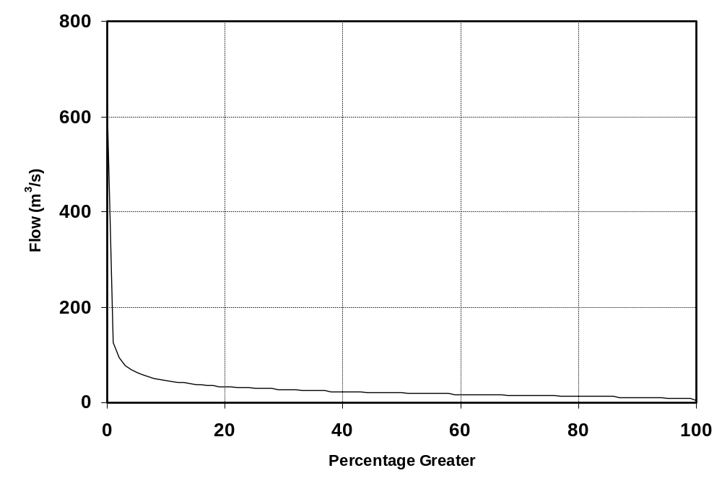
Figure depicting Percentage Exceedance graph.

Table Depicting Percentage Exceedence: Flow (m³/s).
 | 0 | 1 | 2 | 3 | 4 | 5 | 6 | 7 | 8 | 9
0 | 626 | 127 | 93 | 78 | 70 | 63 | 58 | 54 | 51 | 48
10 | 46 | 44 | 43 | 41 | 40 | 39 | 38 | 37 | 36 | 35
20 | 34 | 33 | 32 | 32 | 31 | 30 | 30 | 29 | 29 | 28
30 | 27 | 27 | 27 | 26 | 26 | 25 | 25 | 24 | 24 | 24
40 | 23 | 23 | 23 | 22 | 22 | 22 | 21 | 21 | 21 | 20
50 | 20 | 20 | 19 | 19 | 19 | 19 | 18 | 18 | 18 | 18
60 | 17 | 17 | 17 | 17 | 16 | 16 | 16 | 16 | 16 | 15
70 | 15 | 15 | 15 | 14 | 14 | 14 | 14 | 14 | 13 | 13
80 | 13 | 13 | 12 | 12 | 12 | 12 | 12 | 11 | 11 | 11
90 | 11 | 11 | 10 | 10 | 10 | 9 | 9 | 9 | 8 | 7
100 | 4
Note: 0% is the maximum flow and 100% is the minimum flow.

Summary Table: Flow (m³/s)
Record Length | Minimum | Mean | Median | Maximum
Jul 1931 to Jun 2005 | 4 | 27 | 20 | 626

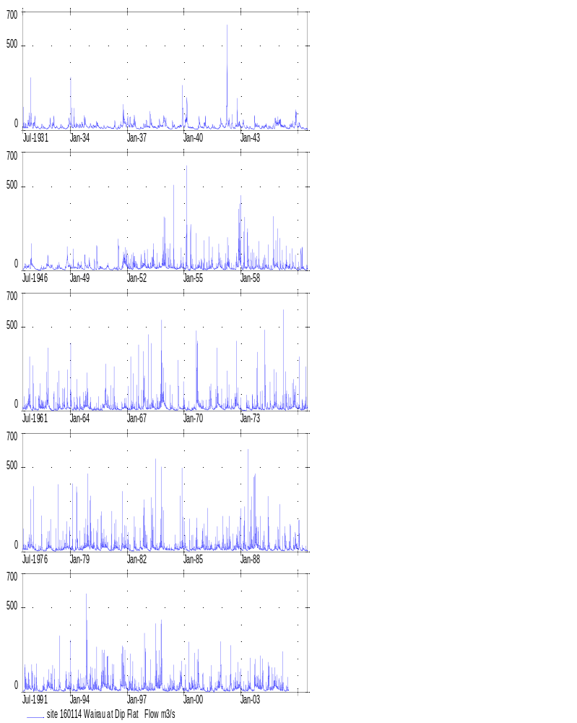
Wairau at Dip Flat, 1931-2005

Hurunui at Mandamus – 165104 (Item 1)

Flow (m³/s)
Year | Jan | Feb | Mar | Apr | May | Jun | Jul | Aug | Sep | Oct | Nov | Dec | Mean
1931 |  |  |  |  |  |  | 74 | 64 | 57 | 70 | 78 | 34 | 44
1932 | 29 | 23 | 42 | 32 | 24 | 81 | 39 | 28 | 38 | 44 | 39 | 60 | 40
1933 | 27 | 34 | 32 | 21 | 26 | 33 | 31 | 35 | 71 | 37 | 33 | 27 | 34
1934 | 47 | 47 | 28 | 50 | 57 | 49 | 52 | 59 | 53 | 88 | 50 | 33 | 51
1935 | 57 | 47 | 44 | 46 | 56 | 65 | 37 | 32 | 27 | 42 | 31 | 43 | 44
1936 | 36 | 34 | 27 | 33 | 52 | 21 | 37 | 43 | 53 | 108 | 107 | 61 | 51
1937 | 88 | 59 | 65 | 52 | 92 | 51 | 25 | 22 | 29 | 29 | 44 | 45 | 50
1938 | 59 | 46 | 72 | 75 | 42 | 42 | 32 | 37 | 64 | 56 | 64 | 116 | 59
1939 | 75 | 42 | 29 | 19 | 35 | 52 | 36 | 29 | 46 | 51 | 74 | 131 | 52
1940 | 60 | 134 | 86 | 36 | 34 | 34 | 23 | 13 | 18 | 62 | 53 | 37 | 49
1941 | 41 | 85 | 36 | 41 | 25 | 32 | 44 | 37 | 25 | 23 | 42 | 81 | 42
1942 | 61 | 39 | 57 | 260 | 87 | 32 | 69 | 32 | 44 | 96 | 70 | 67 | 76
1943 | 39 | 80 | 42 | 34 | 34 | 28 | 27 | 19 | 56 | 55 | 54 | 47 | 43
1944 | 25 | 39 | 39 | 51 | 44 | 31 | 34 | 27 | 43 | 67 | 83 | 86 | 48
1945 | 88 | 65 | 54 | 48 | 40 | 28 | 27 | 53 | 64 | 41 | 99 | 92 | 58
1946 | 56 | 58 | 29 | 31 | 20 | 20 | 29 | 57 | 48 | 56 | 49 | 109 | 47
1947 | 63 | 41 | 25 | 19 | 13 | 31 | 28 | 33 | 36 | 86 | 62 | 51 | 41
1948 | 56 | 26 | 26 | 40 | 47 | 48 | 34 | 22 | 24 | 68 | 106 | 64 | 47
1949 | 51 | 70 | 50 | 44 | 41 | 54 | 57 | 46 | 25 | 80 | 50 | 60 | 52
1950 | 64 | 30 | 18 | 47 | 46 | 63 | 32 | 41 | 33 | 26 | 28 | 56 | 41
1951 | 39 | 20 | 15 | 31 | 31 | 30 | 52 | 35 | 27 | 63 | 116 | 139 | 50
1952 | 69 | 61 | 46 | 37 | 56 | 77 | 38 | 19 | 19 | 30 | 52 | 50 | 46
1953 | 37 | 42 | 36 | 60 | 85 | 49 | 30 | 31 | 40 | 35 | 76 | 111 | 53
1954 | 66 | 51 | 47 | 55 | 28 | 58 | 36 | 23 | 26 | 26 | 69 | 43 | 44
1955 | 25 | 190 | 96 | 34 | 79 | 43 | 18 | 37 | 30 | 42 | 51 | 38 | 56
1956 | 23 | 32 | 21 | 48 | 37 | 38 | 63 | 28 | 30 | 34 | 77 | 54 | 40
1957 | 44 | 29 | 41 | 55 | 72 | 45 | 61 | 31 | 25 | 90 | 121 | 164 | 65
1958 | 80 | 57 | 54 | 39 | 136 | 71 | 39 | 59 | 39 | 50 | 37 | 53 | 60
1959 | 25 | 19 | 24 | 36 | 38 | 50 | 33 | 47 | 60 | 54 | 72 | 45 | 42
1960 | 26 | 34 | 32 | 21 | 26 | 33 | 31 | 35 | 71 | 37 | 33 | 27 | 34
1961 | 21 | 31 | 40 | 45 | 60 | 45 | 74 | 64 | 57 | 70 | 78 | 34 | 52
1962 | 55 | 22 | 11 | 13 | 35 | 38 | 50 | 40 | 58 | 78 | 65 | 22 | 41
1963 | 19 | 24 | 31 | 26 | 42 | 53 | 67 | 41 | 70 | 36 | 81 | 34 | 44
1964 | 98 | 28 | 44 | 33 | 92 | 35 | 57 | 68 | 63 | 73 | 60 | 58 | 59
1965 | 41 | 40 | 22 | 28 | 40 | 55 | 43 | 45 | 53 | 83 | 91 | 53 | 50
1966 | 47 | 41 | 26 | 35 | 42 | 28 | 39 | 34 | 31 | 29 | 41 | 43 | 36
1967 | 35 | 35 | 52 | 62 | 50 | 28 | 37 | 58 | 37 | 36 | 153 | 82 | 55
1968 | 34 | 47 | 39 | 45 | 43 | 37 | 48 | 40 | 46 | 137 | 102 | 64 | 57
1969 | 32 | 22 | 25 | 43 | 31 | 27 | 30 | 35 | 77 | 35 | 26 | 38 | 35
Year | Jan | Feb | Mar | Apr | May | Jun | Jul | Aug | Sep | Oct | Nov | Dec | Mean
1970 | 38 | 21 | 21 | 26 | 22 | 27 | 40 | 76 | 167 | 64 | 44 | 34 | 48
1971 | 25 | 12 | 10 | 10 | 11 | 37 | 33 | 36 | 71 | 139 | 58 | 35 | 40
1972 | 29 | 18 | 29 | 48 | 74 | 34 | 46 | 26 | 71 | 135 | 60 | 42 | 51
1973 | 25 | 14 | 13 | 29 | 66 | 51 | 22 | 47 | 45 | 41 | 80 | 38 | 39
1974 | 28 | 42 | 30 | 112 | 34 | 40 | 70 | 39 | 65 | 73 | 71 | 31 | 53
1975 | 27 | 28 | 58 | 84 | 101 | 72 | 77 | 77 | 78 | 82 | 79 | 47 | 68
1976 | 54 | 45 | 25 | 20 | 41 | 73 | 59 | 46 | 54 | 56 | 53 | 56 | 49
1977 | 83 | 43 | 28 | 22 | 34 | 40 | 43 | 27 | 33 | 48 | 56 | 41 | 41
1978 | 32 | 17 | 22 | 50 | 57 | 38 | 54 | 75 | 74 | 73 | 47 | 39 | 48
1979 | 31 | 37 | 41 | 43 | 125 | 39 | 37 | 51 | 64 | 85 | 57 | 93 | 59
1980 | 97 | 57 | 74 | 54 | 49 | 72 | 35 | 82 | 128 | 79 | 78 | 56 | 72
1981 | 22 | 31 | 33 | 42 | 50 | 59 | 41 | 36 | 66 | 136 | 59 | 69 | 54
1982 | 63 | 33 | 24 | 17 | 55 | 44 | 37 | 52 | 56 | 40 | 122 | 93 | 53
1983 | 74 | 28 | 37 | 59 | 109 | 68 | 81 | 55 | 86 | 114 | 59 | 65 | 70
1984 | 40 | 42 | 42 | 29 | 36 | 40 | 66 | 71 | 40 | 95 | 136 | 90 | 61
1985 | 58 | 25 | 19 | 19 | 21 | 42 | 53 | 46 | 48 | 38 | 38 | 58 | 39
1986 | 39 | 35 | 35 | 54 | 38 | 56 | 48 | 85 | 61 | 98 | 43 | 37 | 52
1987 | 55 | 44 | 53 | 57 | 54 | 89 | 39 | 43 | 39 | 79 | 45 | 61 | 55
1988 | 34 | 44 | 47 | 30 | 77 | 70 | 127 | 87 | 139 | 134 | 93 | 50 | 78
1989 | 29 | 23 | 42 | 32 | 24 | 81 | 39 | 28 | 38 | 44 | 39 | 60 | 40
1990 | 54 | 24 | 25 | 37 | 85 | 37 | 41 | 61 | 30 | 41 | 41 | 73 | 46
1991 | 60 | 88 | 20 | 40 | 33 | 37 | 32 | 129 | 57 | 58 | 47 | 42 | 54
1992 | 42 | 35 | 61 | 28 | 22 | 33 | 54 | 99 | 50 | 59 | 50 | 37 | 48
1993 | 73 | 42 | 20 | 26 | 29 | 97 | 33 | 23 | 31 | 86 | 38 | 74 | 48
1994 | 148 | 27 | 28 | 21 | 68 | 67 | 95 | 78 | 75 | 50 | 231 | 48 | 78
1995 | 42 | 26 | 46 | 42 | 44 | 56 | 54 | 64 | 132 | 119 | 69 | 69 | 64
1996 | 37 | 36 | 38 | 100 | 52 | 46 | 53 | 44 | 86 | 137 | 105 | 61 | 66
1997 | 35 | 52 | 47 | 65 | 44 | 39 | 38 | 66 | 29 | 43 | 75 | 154 | 57
1998 | 43 | 32 | 41 | 58 | 31 | 35 | 118 | 79 | 61 | 158 | 54 | 42 | 63
1999 | 22 | 19 | 27 | 48 | 44 | 68 | 43 | 39 | 35 | 89 | 104 | 29 | 47
2000 | 37 | 29 | 19 | 61 | 40 | 84 | 54 | 90 | 119 | 152 | 37 | 42 | 64
2001 | 40 | 20 | 15 | 21 | 23 | 44 | 29 | 37 | 25 | 32 | 81 | 106 | 40
2002 | 97 | 21 | 45 | 31 | 22 | 135 | 54 | 44 | 86 | 70 | 94 | 69 | 64
2003 | 47 | 47 | 26 | 30 | 50 | 66 | 56 | 25 | 100 | 109 | 65 | 36 | 55
2004 | 50 | 76 | 46 | 30 | 59 | 96 | 36 | 74 | 68 | 78 | 46 | 42 | 58
2005 | 33 | 30 | 39 | 25 | 26 | 27 |  |  |  |  |  |  | 30
Min. | 19 | 12 | 10 | 10 | 11 | 20 | 18 | 13 | 18 | 23 | 26 | 22 | 34
Mean | 48 | 41 | 37 | 44 | 48 | 50 | 47 | 48 | 56 | 70 | 69 | 60 | 52
Max. | 148 | 190 | 96 | 260 | 136 | 135 | 127 | 129 | 167 | 158 | 231 | 164 | 78

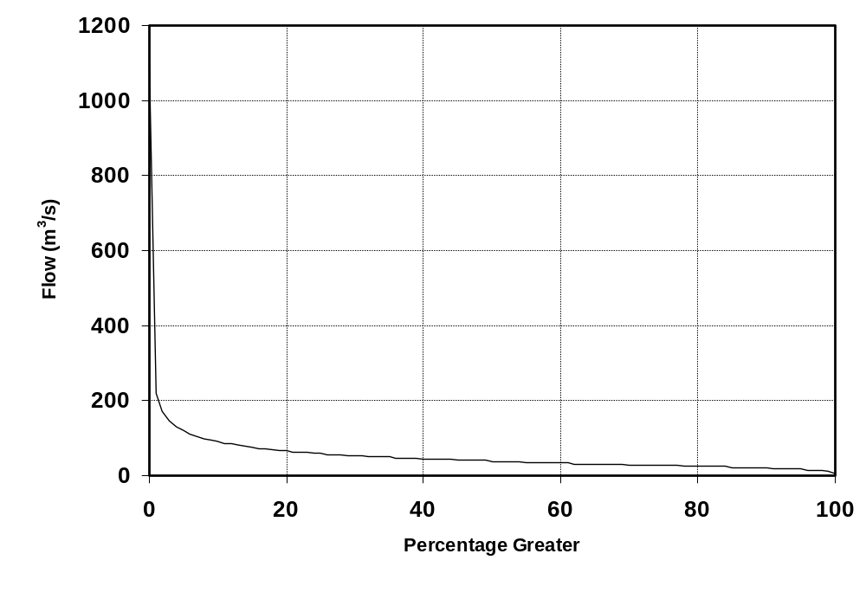
Figure depicting Percentage Exceedance graph.

Table Depicting Percentage Exceedence: Flow (m³/s).
 | 0 | 1 | 2 | 3 | 4 | 5 | 6 | 7 | 8 | 9
0 | 1145 | 220 | 172 | 147 | 132 | 122 | 113 | 106 | 100 | 96
10 | 92 | 88 | 85 | 82 | 79 | 77 | 74 | 72 | 70 | 69
20 | 67 | 65 | 64 | 62 | 61 | 60 | 59 | 58 | 56 | 55
30 | 54 | 53 | 52 | 52 | 51 | 50 | 49 | 48 | 48 | 47
40 | 46 | 45 | 45 | 44 | 43 | 42 | 42 | 41 | 41 | 40
50 | 39 | 39 | 38 | 38 | 37 | 37 | 36 | 36 | 35 | 35
60 | 34 | 34 | 33 | 33 | 33 | 32 | 32 | 31 | 31 | 31
70 | 30 | 30 | 29 | 29 | 29 | 28 | 28 | 27 | 27 | 26
80 | 26 | 26 | 25 | 25 | 24 | 24 | 23 | 23 | 22 | 22
90 | 21 | 21 | 20 | 20 | 19 | 18 | 17 | 16 | 14 | 12
100 | 8
Note: 0% is the maximum flow and 100% is the minimum flow.

Summary Table: Flow (m³/s)
Record Length | Minimum | Mean | Median | Maximum
Jul 1931 to Jun 2005 | 8 | 51 | 39 | 1145

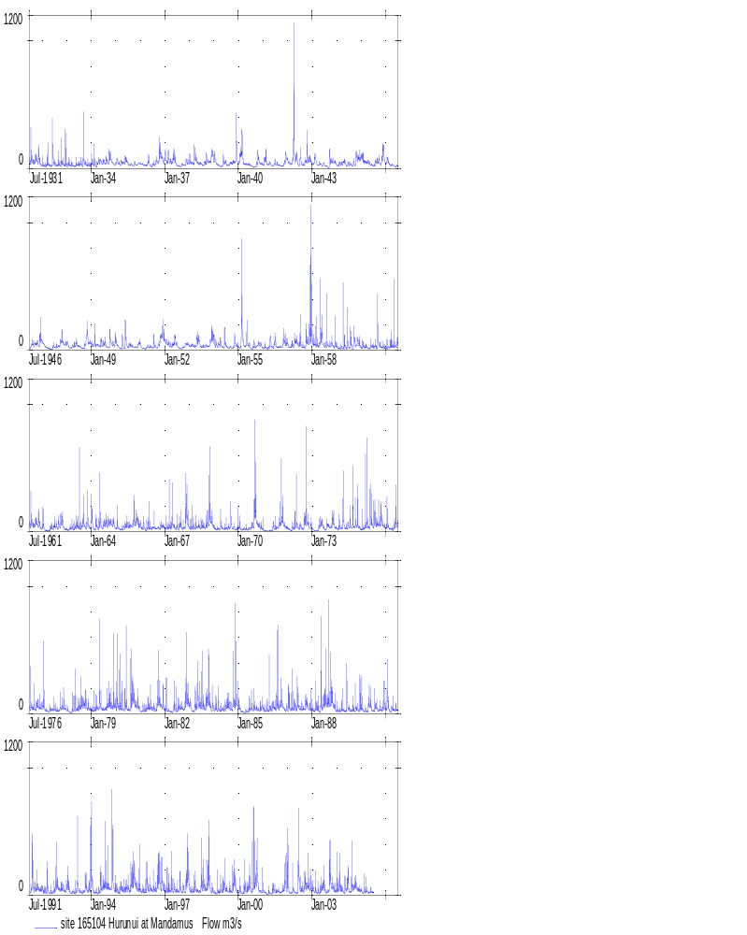
Hurunui at Mandamus, 1931-2005

Hurunui at SH 1 Bridge – 165101 (Item 1)

Flow (m³/s)
Year | Jan | Feb | Mar | Apr | May | Jun | Jul | Aug | Sep | Oct | Nov | Dec | Mean
1931 |  |  |  |  |  |  | 94 | 82 | 74 | 90 | 99 | 45 | 44
1932 | 37 | 30 | 54 | 42 | 31 | 104 | 50 | 36 | 49 | 57 | 51 | 76 | 52
1933 | 35 | 45 | 42 | 27 | 34 | 44 | 40 | 46 | 92 | 49 | 42 | 35 | 44
1934 | 62 | 60 | 36 | 65 | 74 | 64 | 68 | 77 | 69 | 112 | 65 | 44 | 66
1935 | 74 | 62 | 58 | 61 | 73 | 85 | 49 | 42 | 35 | 54 | 40 | 57 | 57
1936 | 48 | 45 | 35 | 43 | 67 | 26 | 49 | 56 | 70 | 138 | 135 | 79 | 66
1937 | 112 | 76 | 84 | 69 | 117 | 66 | 32 | 28 | 38 | 37 | 57 | 60 | 65
1938 | 77 | 60 | 93 | 97 | 55 | 56 | 41 | 48 | 82 | 73 | 83 | 146 | 76
1939 | 96 | 56 | 38 | 25 | 45 | 68 | 48 | 38 | 61 | 66 | 95 | 170 | 67
1940 | 78 | 169 | 111 | 48 | 44 | 45 | 30 | 17 | 23 | 80 | 70 | 49 | 63
1941 | 53 | 108 | 48 | 54 | 33 | 41 | 58 | 49 | 32 | 29 | 55 | 103 | 55
1942 | 79 | 52 | 74 | 382 | 111 | 42 | 89 | 42 | 57 | 123 | 90 | 87 | 102
1943 | 52 | 103 | 55 | 45 | 45 | 36 | 35 | 24 | 70 | 72 | 71 | 62 | 55
1944 | 32 | 51 | 52 | 67 | 57 | 41 | 44 | 36 | 56 | 85 | 106 | 110 | 61
1945 | 113 | 84 | 70 | 64 | 52 | 36 | 34 | 69 | 82 | 55 | 125 | 117 | 75
1946 | 73 | 75 | 38 | 41 | 26 | 26 | 37 | 75 | 62 | 73 | 63 | 139 | 61
1947 | 82 | 53 | 32 | 24 | 15 | 40 | 36 | 43 | 48 | 110 | 81 | 67 | 53
1948 | 73 | 34 | 34 | 52 | 62 | 63 | 45 | 28 | 31 | 87 | 134 | 83 | 61
1949 | 67 | 90 | 65 | 58 | 54 | 70 | 74 | 60 | 31 | 102 | 66 | 77 | 68
1950 | 83 | 39 | 24 | 60 | 59 | 81 | 42 | 54 | 44 | 33 | 36 | 73 | 52
1951 | 51 | 25 | 19 | 41 | 40 | 40 | 66 | 46 | 34 | 81 | 146 | 175 | 64
1952 | 90 | 79 | 61 | 48 | 73 | 99 | 50 | 24 | 25 | 39 | 68 | 66 | 60
1953 | 50 | 56 | 48 | 78 | 108 | 64 | 40 | 41 | 52 | 47 | 98 | 140 | 68
1954 | 84 | 67 | 62 | 71 | 37 | 75 | 47 | 29 | 34 | 33 | 88 | 56 | 57
1955 | 32 | 266 | 124 | 45 | 101 | 56 | 23 | 48 | 40 | 56 | 67 | 50 | 74
1956 | 29 | 41 | 27 | 62 | 48 | 50 | 81 | 36 | 39 | 44 | 99 | 71 | 52
1957 | 57 | 38 | 53 | 71 | 93 | 59 | 79 | 41 | 33 | 114 | 159 | 216 | 85
1958 | 102 | 75 | 71 | 51 | 176 | 92 | 50 | 76 | 51 | 66 | 48 | 69 | 77
1959 | 33 | 24 | 31 | 47 | 49 | 64 | 43 | 62 | 75 | 71 | 93 | 59 | 54
1960 | 34 | 45 | 42 | 27 | 34 | 44 | 40 | 46 | 92 | 49 | 42 | 35 | 44
1961 | 27 | 40 | 53 | 58 | 80 | 59 | 94 | 82 | 74 | 90 | 99 | 45 | 67
1962 | 71 | 28 | 14 | 16 | 45 | 49 | 65 | 52 | 75 | 100 | 84 | 28 | 53
1963 | 24 | 30 | 41 | 34 | 56 | 70 | 90 | 54 | 90 | 47 | 103 | 44 | 57
1964 | 124 | 36 | 56 | 43 | 119 | 46 | 74 | 88 | 82 | 95 | 79 | 75 | 77
1965 | 54 | 52 | 28 | 36 | 53 | 72 | 57 | 60 | 70 | 106 | 116 | 70 | 64
1966 | 61 | 54 | 34 | 45 | 55 | 37 | 52 | 44 | 41 | 38 | 54 | 57 | 48
1967 | 45 | 46 | 68 | 80 | 66 | 36 | 47 | 75 | 49 | 48 | 197 | 105 | 72
1968 | 44 | 61 | 50 | 59 | 57 | 48 | 63 | 52 | 60 | 180 | 130 | 83 | 74
1969 | 42 | 28 | 33 | 56 | 40 | 36 | 38 | 47 | 98 | 46 | 33 | 49 | 46
Year | Jan | Feb | Mar | Apr | May | Jun | Jul | Aug | Sep | Oct | Nov | Dec | Mean
1970 | 49 | 27 | 27 | 33 | 28 | 35 | 53 | 104 | 211 | 84 | 59 | 44 | 63
1971 | 32 | 14 | 12 | 12 | 13 | 49 | 42 | 48 | 91 | 179 | 75 | 46 | 51
1972 | 38 | 23 | 37 | 62 | 95 | 44 | 61 | 34 | 91 | 183 | 77 | 55 | 67
1973 | 33 | 18 | 15 | 37 | 85 | 67 | 29 | 62 | 60 | 55 | 102 | 50 | 51
1974 | 37 | 55 | 40 | 143 | 45 | 52 | 89 | 52 | 86 | 94 | 92 | 39 | 68
1975 | 34 | 38 | 104 | 106 | 103 | 107 | 99 | 106 | 101 | 103 | 101 | 48 | 88
1976 | 58 | 66 | 30 | 27 | 49 | 88 | 96 | 70 | 109 | 83 | 64 | 74 | 68
1977 | 107 | 53 | 33 | 28 | 44 | 56 | 90 | 64 | 71 | 75 | 69 | 48 | 62
1978 | 35 | 20 | 23 | 93 | 81 | 79 | 134 | 120 | 137 | 93 | 59 | 51 | 77
1979 | 36 | 40 | 85 | 65 | 144 | 49 | 58 | 112 | 86 | 99 | 74 | 107 | 80
1980 | 134 | 84 | 142 | 94 | 61 | 108 | 56 | 105 | 143 | 98 | 92 | 70 | 99
1981 | 29 | 35 | 39 | 48 | 68 | 88 | 54 | 61 | 88 | 144 | 62 | 69 | 66
1982 | 64 | 36 | 26 | 22 | 59 | 73 | 57 | 68 | 66 | 53 | 126 | 87 | 62
1983 | 73 | 33 | 40 | 71 | 122 | 72 | 91 | 71 | 108 | 146 | 73 | 81 | 82
1984 | 48 | 70 | 87 | 33 | 45 | 47 | 92 | 79 | 50 | 110 | 142 | 103 | 76
1985 | 61 | 28 | 19 | 21 | 26 | 47 | 70 | 63 | 59 | 49 | 57 | 89 | 49
1986 | 48 | 45 | 53 | 72 | 45 | 68 | 80 | 191 | 109 | 125 | 53 | 42 | 78
1987 | 55 | 47 | 99 | 66 | 70 | 107 | 63 | 58 | 49 | 93 | 62 | 81 | 71
1988 | 41 | 48 | 57 | 40 | 86 | 86 | 147 | 92 | 173 | 194 | 95 | 54 | 93
1989 | 36 | 30 | 53 | 44 | 32 | 104 | 61 | 48 | 91 | 75 | 44 | 66 | 57
1990 | 60 | 30 | 32 | 44 | 97 | 47 | 50 | 79 | 40 | 46 | 58 | 80 | 56
1991 | 62 | 88 | 31 | 51 | 51 | 56 | 71 | 148 | 78 | 69 | 70 | 51 | 69
1992 | 47 | 35 | 69 | 35 | 33 | 47 | 104 | 138 | 98 | 99 | 64 | 49 | 68
1993 | 81 | 51 | 24 | 36 | 49 | 112 | 40 | 29 | 53 | 90 | 53 | 119 | 62
1994 | 157 | 33 | 34 | 30 | 81 | 78 | 142 | 97 | 89 | 72 | 288 | 55 | 97
1995 | 48 | 34 | 52 | 59 | 61 | 129 | 93 | 125 | 195 | 144 | 91 | 83 | 93
1996 | 45 | 44 | 45 | 108 | 72 | 65 | 116 | 74 | 102 | 138 | 110 | 68 | 82
1997 | 48 | 75 | 82 | 86 | 57 | 64 | 67 | 86 | 43 | 58 | 76 | 148 | 74
1998 | 42 | 35 | 48 | 62 | 34 | 38 | 137 | 91 | 75 | 179 | 66 | 48 | 72
1999 | 26 | 24 | 39 | 65 | 61 | 96 | 57 | 50 | 46 | 113 | 132 | 38 | 62
2000 | 47 | 37 | 25 | 79 | 52 | 107 | 70 | 119 | 152 | 194 | 49 | 54 | 82
2001 | 52 | 26 | 19 | 27 | 29 | 57 | 37 | 48 | 32 | 42 | 104 | 135 | 51
2002 | 125 | 27 | 58 | 40 | 28 | 175 | 70 | 58 | 109 | 90 | 120 | 88 | 83
2003 | 62 | 60 | 34 | 39 | 64 | 86 | 71 | 33 | 129 | 139 | 84 | 48 | 71
2004 | 65 | 97 | 60 | 39 | 75 | 121 | 46 | 95 | 88 | 100 | 60 | 55 | 75
2005 | 43 | 39 | 50 | 32 | 33 | 35 |  |  |  |  |  |  | 39
Min. | 24 | 14 | 12 | 12 | 13 | 26 | 23 | 17 | 23 | 29 | 33 | 28 | 44
Mean | 60 | 53 | 50 | 57 | 62 | 66 | 65 | 65 | 75 | 89 | 86 | 76 | 67
Max. | 157 | 266 | 142 | 382 | 176 | 175 | 147 | 191 | 211 | 194 | 288 | 216 | 102

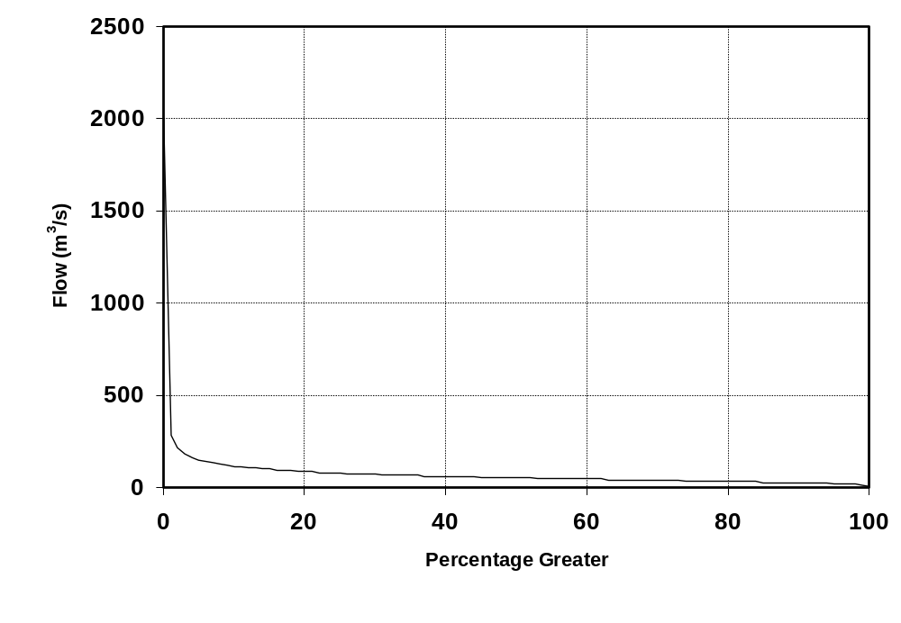
Figure depicting Percentage Exceedance graph.

Table Depicting Percentage Exceedence: Flow (m³/s).
 | 0 | 1 | 2 | 3 | 4 | 5 | 6 | 7 | 8 | 9
0 | 2001 | 283 | 215 | 183 | 165 | 152 | 142 | 135 | 128 | 122
10 | 117 | 113 | 109 | 105 | 102 | 99 | 97 | 94 | 92 | 89
20 | 87 | 85 | 83 | 81 | 80 | 78 | 76 | 75 | 74 | 72
30 | 71 | 70 | 69 | 68 | 67 | 66 | 65 | 64 | 63 | 62
40 | 61 | 60 | 59 | 58 | 58 | 57 | 56 | 55 | 54 | 53
50 | 53 | 52 | 51 | 50 | 50 | 49 | 48 | 48 | 47 | 46
60 | 46 | 45 | 44 | 44 | 43 | 42 | 42 | 41 | 41 | 40
70 | 39 | 39 | 38 | 38 | 37 | 37 | 36 | 35 | 35 | 34
80 | 33 | 33 | 32 | 31 | 31 | 30 | 30 | 29 | 28 | 28
90 | 27 | 26 | 26 | 25 | 24 | 24 | 22 | 20 | 18 | 15
100 | 10
Note: 0% is the maximum flow and 100% is the minimum flow.

Summary Table: Flow (m³/s)
Record Length | Minimum | Mean | Median | Maximum
Jul 1931 to Jun 2005 | 10 | 67 | 53 | 2001

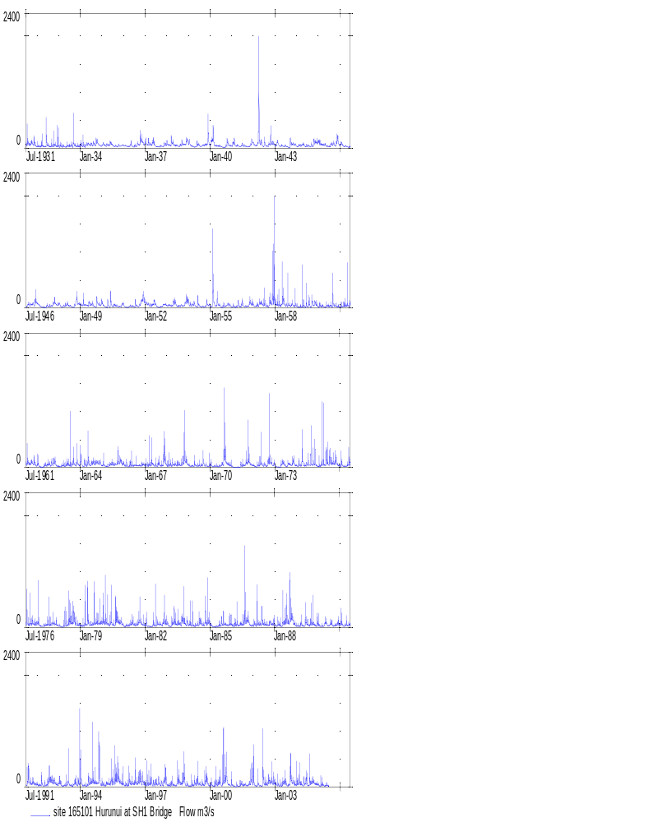
Hurunui at SH1 Bridge, 1931-2005

Mohaka at Raupunga – 121801 (Item 1)

Flow (m³/s)
Year | Jan | Feb | Mar | Apr | May | Jun | Jul | Aug | Sep | Oct | Nov | Dec | Mean
1931 |  |  |  |  |  |  | 115 | 77 | 115 | 53 | 37 | 29 | 44
1932 | 28 | 178 | 126 | 69 | 113 | 59 | 68 | 93 | 76 | 75 | 36 | 33 | 79
1933 | 35 | 62 | 64 | 35 | 114 | 85 | 116 | 104 | 109 | 82 | 59 | 55 | 77
1934 | 31 | 84 | 38 | 52 | 77 | 79 | 86 | 101 | 70 | 65 | 56 | 38 | 65
1935 | 26 | 51 | 78 | 160 | 78 | 115 | 94 | 129 | 85 | 56 | 122 | 48 | 87
1936 | 96 | 108 | 83 | 49 | 62 | 76 | 97 | 57 | 64 | 53 | 55 | 55 | 71
1937 | 74 | 39 | 39 | 47 | 52 | 82 | 140 | 77 | 93 | 73 | 62 | 63 | 70
1938 | 40 | 102 | 41 | 182 | 102 | 85 | 179 | 112 | 51 | 43 | 46 | 78 | 88
1939 | 31 | 38 | 32 | 46 | 91 | 76 | 70 | 100 | 94 | 66 | 55 | 76 | 65
1940 | 68 | 64 | 70 | 66 | 93 | 70 | 116 | 105 | 85 | 91 | 102 | 48 | 82
1941 | 60 | 37 | 65 | 76 | 56 | 85 | 119 | 123 | 84 | 109 | 57 | 48 | 77
1942 | 95 | 111 | 57 | 63 | 68 | 123 | 155 | 139 | 102 | 53 | 60 | 75 | 92
1943 | 69 | 54 | 55 | 90 | 163 | 181 | 90 | 105 | 188 | 74 | 99 | 71 | 103
1944 | 108 | 114 | 224 | 49 | 89 | 102 | 116 | 120 | 77 | 66 | 48 | 56 | 98
1945 | 66 | 55 | 35 | 29 | 97 | 87 | 87 | 87 | 87 | 94 | 47 | 30 | 67
1946 | 25 | 16 | 20 | 69 | 98 | 102 | 127 | 101 | 99 | 82 | 52 | 35 | 69
1947 | 50 | 55 | 50 | 121 | 111 | 160 | 154 | 66 | 60 | 69 | 43 | 35 | 81
1948 | 33 | 16 | 15 | 80 | 249 | 128 | 90 | 76 | 65 | 107 | 111 | 48 | 85
1949 | 65 | 26 | 40 | 32 | 129 | 95 | 73 | 146 | 68 | 66 | 60 | 46 | 71
1950 | 43 | 59 | 21 | 82 | 86 | 68 | 139 | 96 | 110 | 145 | 153 | 45 | 87
1951 | 74 | 85 | 131 | 84 | 149 | 79 | 95 | 116 | 54 | 65 | 67 | 55 | 88
1952 | 42 | 69 | 35 | 24 | 41 | 100 | 78 | 134 | 169 | 76 | 129 | 125 | 85
1953 | 74 | 59 | 35 | 64 | 77 | 163 | 83 | 65 | 54 | 64 | 33 | 30 | 67
1954 | 15 | 15 | 49 | 231 | 105 | 79 | 91 | 224 | 93 | 50 | 63 | 93 | 93
1955 | 46 | 43 | 79 | 110 | 78 | 85 | 222 | 125 | 116 | 85 | 53 | 54 | 92
1956 | 41 | 49 | 50 | 73 | 207 | 156 | 145 | 128 | 77 | 90 | 68 | 39 | 94
1957 | 42 | 35 | 46 | 31 | 56 | 123 | 137 | 108 | 88 | 107 | 98 | 70 | 79
1958 | 45 | 130 | 55 | 29 | 68 | 62 | 117 | 124 | 86 | 98 | 80 | 178 | 89
1959 | 62 | 56 | 71 | 115 | 154 | 93 | 110 | 114 | 61 | 142 | 97 | 49 | 94
1960 | 40 | 68 | 75 | 103 | 72 | 123 | 120 | 93 | 113 | 70 | 207 | 164 | 104
1961 | 85 | 54 | 30 | 34 | 59 | 106 | 126 | 118 | 139 | 54 | 31 | 31 | 72
1962 | 34 | 50 | 89 | 73 | 117 | 144 | 201 | 138 | 125 | 130 | 108 | 150 | 114
1963 | 76 | 31 | 23 | 23 | 26 | 112 | 157 | 77 | 116 | 54 | 38 | 59 | 66
1964 | 52 | 30 | 64 | 27 | 34 | 53 | 175 | 101 | 108 | 97 | 68 | 45 | 71
1965 | 52 | 84 | 62 | 42 | 31 | 62 | 86 | 200 | 84 | 42 | 83 | 59 | 74
1966 | 77 | 45 | 50 | 47 | 95 | 80 | 169 | 193 | 112 | 60 | 64 | 69 | 89
1967 | 88 | 134 | 53 | 33 | 34 | 62 | 90 | 132 | 86 | 49 | 80 | 70 | 76
1968 | 43 | 27 | 23 | 45 | 88 | 199 | 177 | 185 | 83 | 92 | 58 | 76 | 92
1969 | 63 | 121 | 41 | 30 | 38 | 40 | 42 | 50 | 71 | 50 | 34 | 52 | 52
Year | Jan | Feb | Mar | Apr | May | Jun | Jul | Aug | Sep | Oct | Nov | Dec | Mean
1970 | 31 | 44 | 37 | 45 | 93 | 116 | 72 | 159 | 150 | 117 | 69 | 33 | 81
1971 | 55 | 53 | 70 | 78 | 145 | 93 | 96 | 133 | 190 | 198 | 90 | 104 | 109
1972 | 40 | 30 | 97 | 37 | 62 | 61 | 114 | 65 | 46 | 45 | 28 | 33 | 55
1973 | 35 | 26 | 24 | 35 | 43 | 114 | 57 | 112 | 113 | 66 | 41 | 31 | 58
1974 | 28 | 22 | 39 | 84 | 76 | 153 | 180 | 143 | 101 | 111 | 59 | 64 | 89
1975 | 70 | 35 | 46 | 33 | 66 | 163 | 114 | 109 | 117 | 125 | 78 | 56 | 85
1976 | 192 | 174 | 51 | 82 | 79 | 65 | 84 | 110 | 255 | 106 | 76 | 55 | 110
1977 | 43 | 37 | 35 | 88 | 68 | 167 | 138 | 183 | 184 | 91 | 44 | 51 | 94
1978 | 29 | 33 | 19 | 51 | 37 | 103 | 150 | 88 | 85 | 77 | 79 | 42 | 66
1979 | 25 | 51 | 131 | 82 | 99 | 80 | 73 | 164 | 142 | 129 | 73 | 60 | 93
1980 | 99 | 49 | 134 | 156 | 61 | 126 | 117 | 106 | 101 | 58 | 52 | 167 | 102
1981 | 78 | 41 | 41 | 85 | 104 | 145 | 147 | 151 | 77 | 88 | 71 | 77 | 93
1982 | 41 | 40 | 45 | 97 | 75 | 97 | 75 | 60 | 47 | 62 | 42 | 38 | 60
1983 | 26 | 18 | 17 | 33 | 51 | 80 | 86 | 66 | 70 | 148 | 101 | 54 | 63
1984 | 42 | 53 | 74 | 38 | 38 | 58 | 73 | 69 | 96 | 69 | 37 | 43 | 57
1985 | 37 | 28 | 183 | 75 | 73 | 189 | 200 | 80 | 85 | 33 | 26 | 60 | 90
1986 | 89 | 56 | 50 | 28 | 53 | 47 | 91 | 115 | 145 | 92 | 48 | 40 | 71
1987 | 52 | 33 | 78 | 97 | 48 | 54 | 137 | 78 | 50 | 45 | 56 | 65 | 66
1988 | 37 | 83 | 178 | 40 | 56 | 89 | 137 | 124 | 189 | 93 | 45 | 64 | 95
1989 | 125 | 71 | 30 | 22 | 68 | 126 | 93 | 110 | 173 | 142 | 66 | 51 | 90
1990 | 45 | 32 | 62 | 37 | 60 | 62 | 87 | 197 | 59 | 149 | 79 | 41 | 76
1991 | 31 | 47 | 39 | 44 | 114 | 55 | 62 | 145 | 69 | 71 | 143 | 38 | 72
1992 | 48 | 54 | 37 | 41 | 45 | 78 | 127 | 125 | 71 | 167 | 101 | 113 | 84
1993 | 42 | 76 | 43 | 42 | 68 | 93 | 63 | 48 | 52 | 36 | 48 | 36 | 54
1994 | 28 | 24 | 18 | 25 | 37 | 87 | 111 | 128 | 75 | 110 | 192 | 43 | 73
1995 | 26 | 42 | 41 | 90 | 111 | 77 | 153 | 87 | 96 | 91 | 55 | 47 | 77
1996 | 88 | 70 | 64 | 141 | 95 | 61 | 158 | 97 | 110 | 52 | 40 | 61 | 86
1997 | 59 | 31 | 83 | 48 | 29 | 105 | 171 | 101 | 85 | 85 | 51 | 32 | 74
1998 | 25 | 28 | 29 | 24 | 29 | 48 | 252 | 107 | 65 | 90 | 52 | 66 | 68
1999 | 50 | 23 | 20 | 29 | 67 | 96 | 65 | 75 | 66 | 37 | 67 | 54 | 54
2000 | 35 | 29 | 27 | 60 | 46 | 80 | 184 | 66 | 69 | 141 | 55 | 51 | 71
2001 | 53 | 48 | 41 | 55 | 55 | 49 | 67 | 90 | 61 | 59 | 71 | 148 | 67
2002 | 54 | 44 | 35 | 35 | 40 | 76 | 194 | 127 | 52 | 49 | 33 | 53 | 66
2003 | 33 | 27 | 33 | 29 | 46 | 55 | 53 | 144 | 167 | 117 | 63 | 79 | 71
2004 | 62 | 90 | 60 | 28 | 54 | 109 | 166 | 134 | 59 | 97 | 63 | 41 | 80
2005 | 54 | 29 | 27 | 19 | 52 | 91 |  |  |  |  |  |  | 45
Min. | 15 | 15 | 15 | 19 | 26 | 40 | 42 | 48 | 46 | 33 | 26 | 29 | 52
Mean | 54 | 56 | 57 | 63 | 78 | 96 | 119 | 113 | 97 | 84 | 69 | 62 | 80
Max. | 192 | 178 | 224 | 231 | 249 | 199 | 252 | 224 | 255 | 198 | 207 | 178 | 114

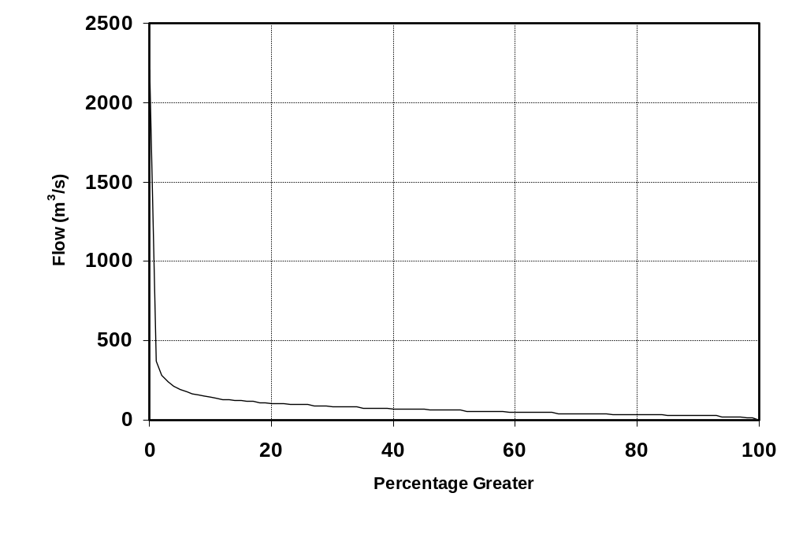
Figure depicting Percentage Exceedance graph.

Table Depicting Percentage Exceedence: Flow (m³/s).
 | 0 | 1 | 2 | 3 | 4 | 5 | 6 | 7 | 8 | 9
0 | 2204 | 371 | 283 | 239 | 212 | 192 | 178 | 167 | 158 | 150
10 | 144 | 138 | 133 | 129 | 125 | 121 | 118 | 114 | 111 | 109
20 | 106 | 104 | 102 | 100 | 97 | 95 | 93 | 91 | 89 | 87
30 | 85 | 84 | 82 | 81 | 79 | 78 | 76 | 75 | 74 | 73
40 | 72 | 71 | 69 | 68 | 67 | 66 | 64 | 63 | 62 | 61
50 | 60 | 59 | 58 | 57 | 56 | 55 | 54 | 53 | 52 | 51
60 | 50 | 49 | 48 | 47 | 47 | 46 | 45 | 44 | 43 | 43
70 | 42 | 41 | 40 | 40 | 39 | 38 | 37 | 36 | 36 | 35
80 | 34 | 33 | 33 | 32 | 31 | 30 | 30 | 29 | 28 | 27
90 | 27 | 26 | 25 | 25 | 24 | 23 | 21 | 20 | 17 | 16
100 | 1
Note: 0% is the maximum flow and 100% is the minimum flow.

Summary Table: Flow (m³/s)
Record Length | Minimum | Mean | Median | Maximum
Jul 1931 to Jun 2005 | 1 | 79 | 60 | 2204

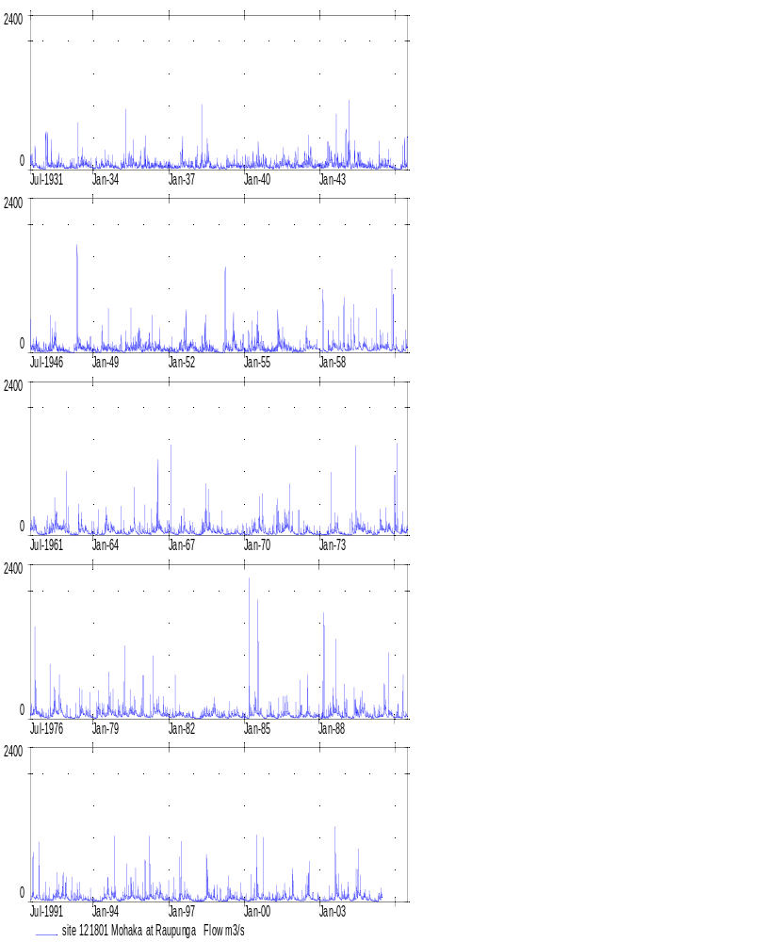
Mohaka at Raupunga, 1931-2005

Monowai Inflow – 199540 (Item 1)
Flow (m³/s)
Year | Jan | Feb | Mar | Apr | May | Jun | Jul | Aug | Sep | Oct | Nov | Dec | Mean
1931 | 30 |  |  |  |  |  | 12 | 8 | 8 | 22 | 18 | 14 | 14
1932 | 21 | 12 | 6 | 11 | 9 | 6 | 4 | 8 | 11 | 13 | 21 | 11 | 11
1933 | 11 | 23 | 18 | 28 | 27 | 4 | 8 | 13 | 15 | 22 | 12 | 14 | 16
1934 | 11 | 4 | 15 | 18 | 20 | 8 | 10 | 15 | 20 | 20 | 9 | 9 | 13
1935 | 29 | 6 | 15 | 11 | 12 | 9 | 5 | 11 | 4 | 18 | 8 | 10 | 12
1936 | 11 | 8 | 9 | 16 | 15 | 6 | 9 | 20 | 20 | 32 | 27 | 14 | 16
1937 | 19 | 11 | 11 | 20 | 13 | 5 | 9 | 7 | 8 | 7 | 11 | 8 | 11
1938 | 15 | 8 | 9 | 7 | 9 | 11 | 4 | 12 | 13 | 25 | 12 | 18 | 12
1939 | 15 | 17 | 4 | 15 | 11 | 16 | 8 | 6 | 14 | 10 | 18 | 21 | 13
1940 | 8 | 36 | 14 | 13 | 17 | 13 | 4 | 9 | 12 | 27 | 12 | 14 | 15
1941 | 14 | 11 | 10 | 13 | 16 | 10 | 9 | 4 | 12 | 9 | 27 | 9 | 12
1942 | 15 | 7 | 16 | 17 | 23 | 11 | 14 | 13 | 19 | 22 | 20 | 13 | 16
1943 | 12 | 17 | 17 | 17 | 12 | 10 | 7 | 5 | 10 | 11 | 14 | 10 | 12
1944 | 8 | 16 | 9 | 18 | 7 | 16 | 11 | 7 | 12 | 20 | 19 | 13 | 13
1945 | 16 | 16 | 28 | 18 | 9 | 5 | 6 | 14 | 15 | 12 | 33 | 13 | 15
1946 | 14 | 31 | 7 | 7 | 5 | 5 | 10 | 18 | 21 | 28 | 10 | 23 | 15
1947 | 9 | 8 | 4 | 4 | 10 | 15 | 8 | 10 | 19 | 16 | 13 | 10 | 10
1948 | 10 | 6 | 17 | 6 | 11 | 8 | 14 | 8 | 19 | 23 | 23 | 23 | 14
1949 | 9 | 25 | 20 | 21 | 7 | 4 | 17 | 13 | 9 | 21 | 9 | 16 | 14
1950 | 22 | 10 | 9 | 9 | 13 | 10 | 11 | 9 | 12 | 8 | 8 | 16 | 11
1951 | 5 | 5 | 5 | 8 | 7 | 4 | 21 | 6 | 16 | 15 | 19 | 10 | 10
1952 | 18 | 21 | 15 | 11 | 16 | 14 | 6 | 3 | 13 | 22 | 6 | 6 | 13
1953 | 2 | 3 | 10 | 21 | 11 | 6 | 10 | 13 | 18 | 7 | 19 | 18 | 12
1954 | 10 | 13 | 19 | 10 | 3 | 20 | 15 | 10 | 11 | 18 | 17 | 8 | 13
1955 | 14 | 15 | 13 | 9 | 18 | 14 | 5 | 11 | 17 | 8 | 15 | 11 | 13
1956 | 7 | 4 | 7 | 18 | 9 | 14 | 10 | 11 | 12 | 11 | 16 | 20 | 11
1957 | 18 | 10 | 9 | 16 | 19 | 11 | 14 | 9 | 7 | 19 | 35 | 29 | 16
1958 | 20 | 33 | 22 | 22 | 35 | 20 | 4 | 9 | 10 | 18 | 12 | 11 | 18
1959 | 5 | 11 | 8 | 9 | 8 | 18 | 9 | 5 | 21 | 11 | 22 | 11 | 11
1960 | 8 | 12 | 6 | 7 | 7 | 19 | 11 | 24 | 12 | 7 | 6 | 8 | 10
1961 | 3 | 5 | 8 | 13 | 11 | 14 | 16 | 16 | 10 | 15 | 19 | 6 | 11
1962 | 8 | 8 | 9 | 8 | 9 | 11 | 14 | 11 | 19 | 11 | 8 | 4 | 10
1963 | 12 | 8 | 7 | 7 | 12 | 12 | 9 | 13 | 11 | 14 | 17 | 8 | 11
1964 | 20 | 6 | 16 | 11 | 19 | 8 | 8 | 13 | 13 | 11 | 17 | 10 | 13
1965 | 5 | 5 | 7 | 6 | 18 | 19 | 10 | 6 | 20 | 18 | 19 | 11 | 12
1966 | 13 | 11 | 12 | 16 | 11 | 11 | 11 | 9 | 8 | 12 | 7 | 14 | 11
1967 | 7 | 10 | 8 | 23 | 15 | 6 | 5 | 11 | 8 | 12 | 24 | 20 | 12
1968 | 10 | 10 | 17 | 9 | 9 | 5 | 10 | 11 | 17 | 28 | 21 | 16 | 14
1969 | 9 | 6 | 11 | 14 | 8 | 10 | 12 | 13 | 15 | 18 | 5 | 12 | 11
1970 | 7 | 8 | 8 | 15 | 5 | 7 | 18 | 15 | 27 | 16 | 9 | 13 | 12
1971 | 3 | 3 | 9 | 10 | 10 | 16 | 4 | 9 | 25 | 21 | 17 | 11 | 12
1972 | 9 | 7 | 20 | 15 | 14 | 16 | 14 | 7 | 31 | 14 | 15 | 7 | 14
1973 | 5 | 7 | 4 | 16 | 19 | 10 | 4 | 6 | 10 | 17 | 15 | 8 | 10
1974 | 5 | 8 | 4 | 5 | 7 | 14 | 18 | 8 | 9 | 12 | 8 | 4 | 9
1975 | 5 | 6 | 10 | 24 | 19 | 12 | 16 | 17 | 14 | 13 | 7 | 12 | 13
1976 | 7 | 6 | 5 | 4 | 13 | 22 | 14 | 11 | 7 | 10 | 15 | 8 | 10
1977 | 12 | 13 | 4 | 18 | 23 | 15 | 8 | 6 | 15 | 22 | 14 | 7 | 13
1978 | 8 | 5 | 6 | 9 | 15 | 7 | 14 | 22 | 14 | 16 | 13 | 10 | 12
1979 | 21 | 13 | 5 | 15 | 23 | 12 | 13 | 10 | 22 | 13 | 5 | 14 | 14
1980 | 19 | 14 | 11 | 7 | 16 | 23 | 12 | 29 | 27 | 16 | 18 | 6 | 16
1981 | 7 | 6 | 5 | 13 | 9 | 8 | 11 | 10 | 20 | 24 | 7 | 13 | 11
1982 | 16 | 10 | 8 | 9 | 24 | 9 | 12 | 20 | 10 | 20 | 39 | 13 | 16
1983 | 31 | 8 | 15 | 13 | 14 | 17 | 14 | 15 | 21 | 10 | 8 | 15 | 15
1984 | 21 | 10 | 7 | 16 | 16 | 13 | 9 | 15 | 13 | 23 | 10 | 12 | 14
1985 | 17 | 6 | 4 | 14 | 13 | 12 | 12 | 11 | 12 | 8 | 7 | 8 | 10
1986 | 13 | 17 | 10 | 15 | 14 | 22 | 17 | 15 | 16 | 21 | 10 | 11 | 15
1987 | 11 | 24 | 24 | 14 | 12 | 20 | 19 | 13 | 20 | 27 | 6 | 7 | 16
1988 | 9 | 16 | 9 | 9 | 12 | 19 | 19 | 18 | 26 | 41 | 22 | 8 | 17
1989 | 7 | 8 | 14 | 9 | 8 | 18 | 10 | 5 | 4 | 9 | 12 | 14 | 10
1990 | 10 | 5 | 5 | 14 | 28 | 16 | 11 | 7 | 9 | 16 | 6 | 21 | 12
1991 | 13 | 24 | 6 | 14 | 13 | 12 | 7 | 24 | 14 | 23 | 16 | 8 | 14
1992 | 9 | 15 | 17 | 11 | 10 | 7 | 19 | 16 | 10 | 17 | 12 | 9 | 13
1993 | 20 | 11 | 6 | 7 | 10 | 20 | 13 | 11 | 13 | 24 | 12 | 14 | 13
1994 | 16 | 10 | 10 | 14 | 19 | 13 | 23 | 21 | 16 | 12 | 31 | 13 | 17
1995 | 10 | 4 | 18 | 5 | 20 | 14 | 11 | 17 | 26 | 22 | 13 | 19 | 15
1996 | 10 | 8 | 5 | 14 | 17 | 21 | 12 | 11 | 15 | 27 | 16 | 11 | 14
1997 | 9 | 12 | 11 | 17 | 11 | 8 | 12 | 23 | 9 | 17 | 33 | 21 | 15
1998 | 8 | 19 | 23 | 23 | 9 | 16 | 11 | 15 | 21 | 26 | 7 | 10 | 16
1999 | 6 | 3 | 11 | 12 | 14 | 10 | 12 | 8 | 8 | 15 | 32 | 6 | 11
2000 | 6 | 10 | 6 | 9 | 22 | 24 | 11 | 9 | 16 | 25 | 7 | 25 | 14
2001 | 8 | 5 | 9 | 9 | 7 | 18 | 4 | 10 | 9 | 11 | 15 | 17 | 10
2002 | 8 | 7 | 14 | 7 | 10 | 24 | 10 | 15 | 29 | 14 | 17 | 22 | 15
2003 | 8 | 11 | 5 | 3 | 16 | 22 | 12 | 11 | 22 | 15 | 23 | 16 | 14
2004 | 15 | 18 | 13 | 9 | 17 | 25 | 7 | 11 | 16 | 10 | 16 | 11 | 14
2005 | 12 | 13 | 21 | 8 | 15 | 9 | 12 |  |  |  |  |  | 13
Min. | 2 | 3 | 4 | 3 | 3 | 4 | 4 | 3 | 4 | 7 | 5 | 4 | 9
Mean | 12 | 11 | 11 | 13 | 13 | 13 | 11 | 12 | 15 | 17 | 15 | 13 | 13
Max. | 31 | 36 | 28 | 28 | 35 | 25 | 23 | 29 | 31 | 41 | 39 | 29 | 18

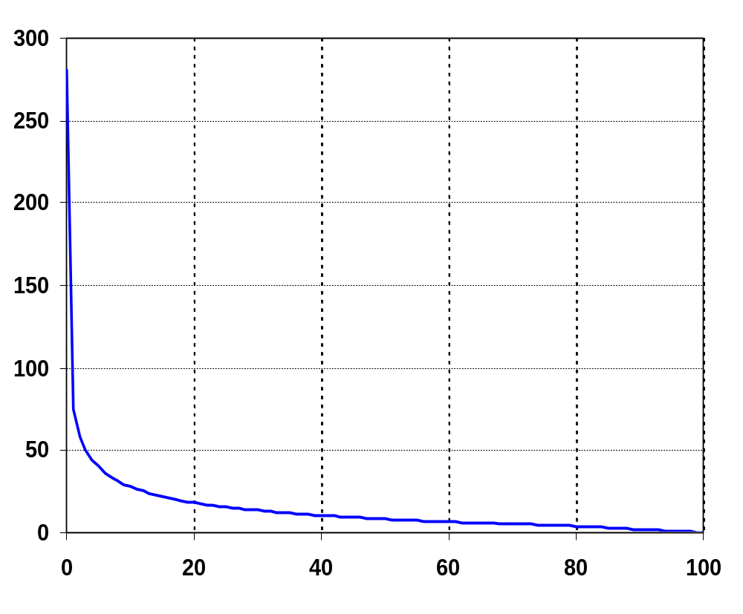
Flow (m³/s)
Percentage Greater

Figure depicting Percentage Exceedance graph.

Table Depicting Percentage Exceedence: Flow (m³/s).
 | 0 | 1 | 2 | 3 | 4 | 5 | 6 | 7 | 8 | 9
0 | 280.8 | 75.1 | 58.3 | 50.0 | 44.5 | 40.2 | 36.5 | 33.8 | 31.5 | 29.5
10 | 27.9 | 26.5 | 25.2 | 24.1 | 23.1 | 22.1 | 21.2 | 20.3 | 19.5 | 18.9
20 | 18.3 | 17.7 | 17.1 | 16.6 | 16.2 | 15.7 | 15.2 | 14.8 | 14.4 | 14.0
30 | 13.7 | 13.3 | 13.0 | 12.7 | 12.4 | 12.0 | 11.8 | 11.5 | 11.2 | 10.9
40 | 10.7 | 10.4 | 10.2 | 10.0 | 9.8 | 9.5 | 9.3 | 9.1 | 8.9 | 8.7
50 | 8.5 | 8.3 | 8.1 | 8.0 | 7.8 | 7.7 | 7.5 | 7.3 | 7.2 | 7.0
60 | 6.8 | 6.7 | 6.5 | 6.4 | 6.2 | 6.0 | 5.9 | 5.8 | 5.6 | 5.4
70 | 5.3 | 5.2 | 5.0 | 4.9 | 4.7 | 4.6 | 4.4 | 4.3 | 4.1 | 4.0
80 | 3.9 | 3.7 | 3.5 | 3.3 | 3.2 | 3.0 | 2.8 | 2.6 | 2.4 | 2.2
90 | 2.1 | 1.9 | 1.7 | 1.5 | 1.3 | 1.1 | 0.9 | 0.7 | 0.5 | 0.3
100 | 0
Note: 0% is the maximum flow and 100% is the minimum flow.

Summary Table: Flow (m³/s)
Record Length | Minimum | Mean | Median | Maximum
Jul 1931 to Jun 2005 | 0 | 13.02 | 8.5 | 280.8
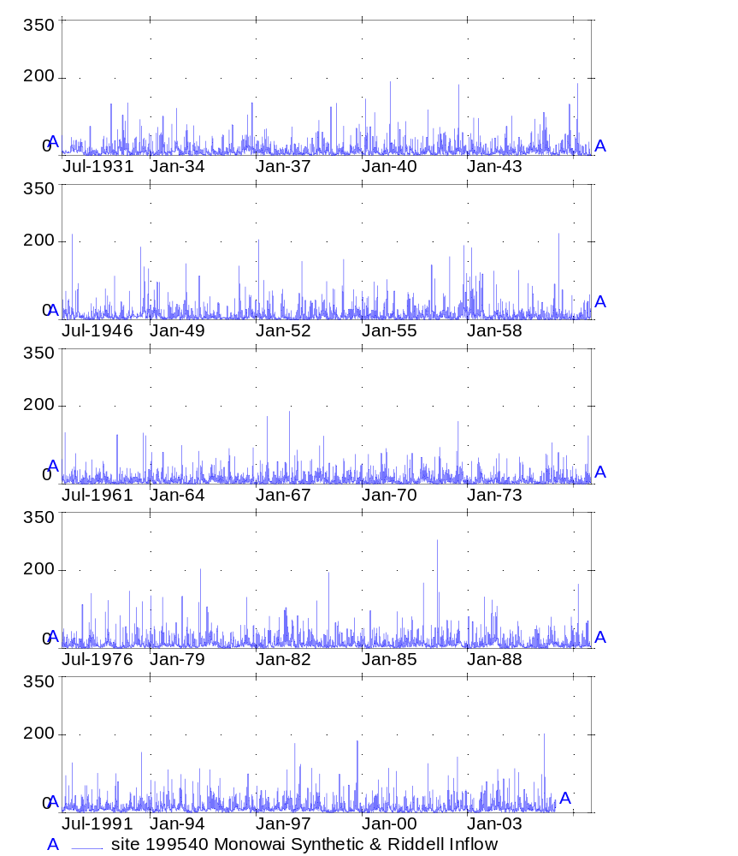
Monowai Inflow, 1931-2005

